IPS/X

Business flows and message samples

Instant Payments System
for
Central Bank of Paraguay

CMA Small Systems AB
2021

Document control section

Document information
Project: | IPS for Central Bank of Paraguay
Prepared by: | CMA Small Systems AB | Version number | 003
Name: | Business flows and message samples | Version date | 2021.10.12

Version history (in reversed order)
Version | Date | Author | Comments
003 | 2021.12.22 | CMA Small Systems AB | Keywords /BNF/ and /SMPL/ are removed from the examples in <InstrInf> tags.
002 | 2021.10.12 | CMA Small Systems AB | Item 3.6 is added. Changes in Chapter 6.
001 | 2021.09.03 | CMA Small Systems AB | First version.

© Copyright CMA Small Systems AB – 2021
No part of this publication may be reproduced, stored in a retrieval system or transmitted in any form or any means, electronic, photo static, recorded or otherwise without prior written permission of CMA Small Systems AB.

Table of Contents
Document control section 2
Document information 2
Version history (in reversed order) 2
Table of Contents 4
List of Figures 8
List of Tables 9
1. Introduction 12
1.1. Context 12
1.2. Related documents 12
1.3. Intended audience 12
1.4. Definitions and Abbreviations 12
1.5. Additional information 13
2. General information 14
2.1. MX Message structure description 14
2.2. Message format validation 19
2.3. Time indication rule 19
2.4. Messages reference generation rule 19
3. Participant and Customer identification 21
3.1. Participant types in IPS 21
3.2. Participant and Customer identification schemes in Direct Credit payment messages (pacs.008) 22
3.2.1. Payment initiator identification 22
3.2.2. Identification of Debtor Party 22
3.2.2.1. Subparticipant is not present in the payment chain 22
3.2.2.2. Subparticipant is present in the payment chain 23
3.2.3. Identification of Creditor Party 24
3.2.3.1. Subparticipant is not present in the payment chain 24
3.2.3.2. Creditor Subparticipant is present in the payment chain 25
3.3. Participant and Customer identification schemes in Return messages (pacs.004) 27
3.3.1. Payment initiator identification 27
3.3.2. Identification of Debtor Party 27
3.3.2.1. Subparticipant is not present in the payment chain 27
3.3.2.2. Subparticipant is present in the payment chain 28
3.3.3. Identification of Creditor Party 29
3.3.3.1. Subparticipant is not present in the payment chain 29
3.3.3.2. Creditor Subparticipant is present in the payment chain 30
3.4. Participant and Customer identification schemes in Request to Pay messages: pain.013 31
3.4.1. Payment initiator identification 31
3.4.2. Identification of Debtor Party 32
3.4.2.1. Debtor Subparticipant is not present in the payment chain 32
3.4.2.2. Subparticipant is present in the payment chain 32
3.4.3. Identification of Creditor Party 33
3.4.3.1. Subparticipant is not present in the payment chain 33
3.4.3.2. Subparticipant is present in the payment chain 34
3.5. Participant and Customer identification schemes in Payment Initiation messages: pain.001 35
3.5.1. Payment initiator identification 35
3.5.2. Identification of Debtor Party 35
3.5.2.1. Debtor Subparticipant is not present in the payment chain 36
3.5.2.2. Subparticipant is present in the payment chain 36
3.5.3. Identification of Creditor Party 38
3.5.3.1. Subparticipant is not present in the payment chain 38
3.5.3.2. Subparticipant is present in the payment chain 39
3.6. Additional Customer identification schemes in the messages: pacs.008, pacs.004, pain.013, pain.001 40
4. Message-based processing flows 41
4.1. Direct Credit payment with authorization between IPS Participants 41
4.1.1. Approved payment 41
4.1.2. Declined payment 50
4.1.3. Payment rejected after timeout 55
4.2. Payment without authorization between Direct Participants 57
4.3. Return payment 64
4.4. Request for return 70
4.4.1. Approved request for return 70
4.4.2. Declined request for return 78
4.5. Request to pay by Creditor 80
4.5.1. Approved Request to pay. Successful payment completion (payment is posted) 80
4.5.2. Approved Request to pay. Unsuccessful payment completion (payment is rejected for any reason) 89
4.5.3. Declined Request to pay 91
4.5.4. Timeout on Request to pay 94
4.6. Payment Initiation Request 95
4.6.1. Approved Payment Initiation Request. Payment processed successfully (payment is posted) 96
4.6.2. Approved Payment initiation request. Unsuccessful payment completion (payment is rejected for any reason) 105
4.6.3. Declined Payment initiation request 108
4.6.4. Timeout on Payment initiation request 113
4.7. Payment status request from Payment Sender 116
4.8. Payment copy request 119
4.9. Limit management operations 124
4.9.1. Set limit for own IPS position account 124
4.9.2. Set limit for managed Indirect Participant IPS position account 128
4.10. Get limit request 131
4.11. Account report request 135
4.12. Business day information report 139
4.13. Account Limit Notification on Direct Participant IPS position account 143
4.14. Account Limit Notification on Indirect Participant IPS position account 146
4.15. Account Limit Notification on Direct Participant Settlement Limit account 148
4.16. Account balance report generated by IPS at the End-of-session 150
4.17. Business day information report 154
4.18. System event notifications from IPS 157
5. Rejection notification issued by IPS 159
5.1. Rejection of Direct Credit or Return payment 159
5.1.1. Administrative error message and Validation error message: admi.002 160
5.1.2. Business validation error payment status message: pacs.002/RJCT 161
5.1.3. Liquidity check failure payment status message: pacs.002/RJCT 162
5.2. Rejection of Payment authorization request 164
5.2.1. Administrative error message: admi.002 165
5.2.2. Validation error and Business validation error message: camt.025/ERRC 165
5.3. Rejection of Request for return and Rejection of Decline for Request for return 165
5.3.1. Administrative error message: admi.002 166
5.3.2. Validation error and Business validation error message: camt.025/ERRC 166
5.4. Rejection of Request to pay 166
5.4.1. Administrative error message and Validation error message: admi.002 167
5.4.2. Business Validation error message: pain.014 167
5.5. Rejection of Rejection for Request to pay 169
5.5.1. Administrative error message: admi.002 169
5.5.2. Validation error and Business validation error message: camt.025/ERRC 169
5.6. Rejection of Payment initiation request 170
5.6.1. Administrative error message and Validation error message : admi.002 170
5.6.2. Business validation error message: pain.002 170
5.7. Rejection of Rejection for Payment initiation request 173
5.7.1. Administrative error message: admi.002 173
5.7.2. Validation error and Business validation error message: camt.025/ERRC 173
5.8. Rejection of Set limit request 174
5.8.1. Administrative error message: admi.002 175
5.8.2. Validation error message and Business validation error message: camt.025/ERRC 175
5.8.3. Liqudity check failure message: camt.025/ERRC 175
5.9. Rejection of Get limit request, Account report request, Business Day information request, Payment status request, Payment copy request 176
5.9.1. Administrative error message: admi.002 177
5.9.2. Validation error message and Business validation error message: camt.025/ERRC 177
6. Technical and validation error notifications 178
6.1. Critical technical error notification admi.002 178
6.2. Error notification camt.025 178

List of Figures
Figure 1. Payment without between IPS Participants – approved 41
Figure 2. Payment without between IPS Participants – declined 50
Figure 3. Payment between IPS Participants – timeout 55
Figure 4. Payment without authorization between IPS Participants 58
Figure 5. Return payment between IPS Participants 64
Figure 6. Request for return approved by IPS Participant 2 – Receiver of Request for return 71
Figure 7. Request for return declined by IPS Participant 2 – Receiver of Request for return 78
Figure 8. Single Direct Credit payment based on the Request to pay – successful payment execution 80
Figure 9. Single Direct Credit payment based on the Request to pay – unsuccessful payment execution 89
Figure 10. Rejection for Request to pay by IPS Participant 1 - Receiver of Request to pay 91
Figure 11. Rejection for Request to pay by IPS Participant 1 - Timeout 94
Figure 12. Single Direct Credit payment based on the Payment initiation request – successful payment execution 96
Figure 13. Single Direct Credit payment based on the Payment initiation request – unsuccessful payment execution 105
Figure 14. Rejection for Payment initiation request by IPS Participant 1 - Receiver of Payment initiation request 108
Figure 15. Rejection for Payment initiation request by IPS Participant 1 – Timeout 113
Figure 16. Payment status request 116
Figure 17. Payment copy request 119
Figure 18. Set limit request for own IPS position account 124
Figure 19. Set limit request for managed Indirect Participant IPS position account 128
Figure 20. Get limit value request 132
Figure 21. Account report request 135
Figure 22. Business day information request 139
Figure 23. Account Limit Notification on Direct Participant IPS position account 144
Figure 24. Account Limit Notification on Indirect Participant IPS position account 146
Figure 25. Account Limit Notification on Direct Participant Settlement Limit account 148
Figure 26. Account balance report generated by IPS at the End-of-session 150
Figure 27. Business day information report 154
Figure 28. System event notifications from IPS 158
Figure 29. Rejection of Direct Credit or Return payment 160
Figure 30. Rejection of Payment authorization request 164
Figure 31. Rejection of Request for return and Rejection of Decline for Request for return 166
Figure 32. Rejection of Request to pay 167
Figure 33. Rejection of Rejection for Request to pay 169
Figure 34. Rejection of Payment initiation request 170
Figure 35. Rejection of Rejection for Payment initiation request 173
Figure 36. Rejection of Set limit request 174
Figure 37. Rejection of Get limit request, Account report request, Business Day information request, Payment status request, Payment copy request 176

List of Tables
Table 1. Definitions and Abbreviations 12
Table 2. Participant types in IPS 21
Table 3. Subparticipant is not present in the message 22
Table 4. Subparticipant is present in the message 23
Table 5. Subparticipant is not present in the message 24
Table 6. Creditor Subparticipant is present in the message 25
Table 7. Subparticipant is not present in the message 27
Table 8. Subparticipant is present in the message 28
Table 9. Subparticipant is not present in the message 29
Table 10. Creditor Subparticipant is not present in the message 30
Table 11. Debtor Subparticipant is not present in the message 32
Table 12. Subparticipant is present in the message 32
Table 13. Subparticipant is not present in the message 33
Table 14. Subparticipant is present in the message 34
Table 15. Debtor Subparticipant is not present in the message 36
Table 16. Subparticipant is present in the message 37
Table 17. Subparticipant is not present in the message 38
Table 18. Subparticipant is present in the message 39
Table 19. Customer identification in the message 40
Table 20. Instrument types for Direct Credit payments 41
Table 21. Diagram description. Payment between IPS Participants – approved 41
Table 22 Diagram description. Payment between IPS Participants – declined 50
Table 23. Diagram description. Payment between IPS Participants – timeout 55
Table 24. Diagram description. Payment without authorization between IPS Participants 58
Table 25. Instrument types for Return payments 64
Table 26. Diagram description. Return payment between IPS Participants 64
Table 27. Diagram description. Request for return approved by IPS Participant 2 – Receiver of Request for return 71
Table 28. Diagram description. Request for return declined by IPS Participant 2 – Receiver of Request for return 78
Table 29. Diagram description. Single Direct Credit payment based on the Request to pay – successful payment execution 80
Table 30. Diagram description. Single Direct Credit payment based on the Request to pay – unsuccessful payment execution 89
Table 31. Diagram description. Rejection for Request to pay by IPS Participant 1 - Receiver of Request to pay 91
Table 32.Diagram description. Rejection for Request to pay by IPS Participant 1 - Timeout 94
Table 33. Diagram description. Single Direct Credit payment based on the Payment initiation request – successful payment execution 96
Table 34.. Diagram description. Single Direct Credit payment based on the Payment initiation request – unsuccessful payment execution 105
Table 35.Diagram description. Rejection for Payment initiation request by IPS Participant 1 - Receiver of Payment initiation request 108
Table 36. Diagram description. Rejection for Payment initiation request by IPS Participant 1 – Timeout 113
Table 37. Diagram description. Payment status request 116
Table 38.Diagram description. Payment copy request 119
Table 39. Diagram description. Set limit request for own IPS position account 125
Table 40. Diagram description. Set limit request for managed Indirect Participant IPS position account 128
Table 41. Diagram description. Get limit value request 132
Table 42. Diagram description 135
Table 43. Diagram description. Business day information request 139
Table 44. Diagram description. Account Limit Notification on Direct Participant IPS position account 144
Table 45. Diagram description. Account Limit Notification on Indirect Participant IPS position account 146
Table 46. Diagram description. Account Limit Notification on Direct Participant Settlement Limit account 148
Table 47. Diagram description. Account balance report generated by IPS at the End-of-session 150
Table 48. Diagram description. Business day information report 154
Table 49. Diagram description. System event notifications from IPS 158
Table 50.Diagram description. Rejection of Direct Credit or Return payment 160
Table 51. Diagram description. Rejection of Payment authorization request 164
Table 52. Diagram description. Rejection of Request for return and Rejection of Decline for Request for return 166
Table 53. Diagram description. Rejection of Request to pay 167
Table 54. Diagram description. Rejection of Rejection for Request to pay 169
Table 55. Diagram description. Rejection of Payment initiation request 170
Table 56. Diagram description. Rejection of Rejection for Payment initiation request 173
Table 57. Diagram description. Rejection of Set limit request 174
Table 58. Diagram description. Rejection of Get limit request, Account report request, Business Day information request, Payment status request, Payment copy request 176

Introduction

Context
This document describes CMA IPS System business flows with samples of messages used in the process.
Messages samples may not contain all possible fields allowed by the message format and may be present in some variations when there may be another data present. Please refer to message formats document as primary handbook.
Messages are provided in ISO20022 format (MX) with additionally applied restrictions on non-used fields in scope of the project for simplification.
Within the document are illustrated basic business processes that may be part of more complex flow i.e. with external systems integration.

Related documents
This document was prepared based on the following documentation, providing more detailed use cases of business flows and message samples:
CBP IPS Functional design specification;
MX message formats package for CBP IPS: CBP IPS Message formats.

Intended audience
This document serves as help book for participants of IPS for better understanding of business flows and data exchanged between participants and central system.

Definitions and Abbreviations
Table 1. Definitions and Abbreviations
Accepted transaction | Transaction received by IPS after passing successfully validation checks (payment is registered in IPS).
Authorization | Process of received data validation with further response (positive or negative).
BIC | Bank Identification Code
Counterparty | The opposite party to a payment
Credit transfer | A payment order or possibly a sequence of payment orders initiated by the payer made for the purpose of placing funds at the disposal of the beneficiary. Both the payment instructions and the funds described therein move from the bank of the payer/originator to the bank of the beneficiary, possibly via several other banks as intermediaries and/or more than one credit transfer system.
Creditor agent | Participant, which according to the payment has to receive funds (via crediting its own account)
Debit cap | Quantitative limit on the net debit position
Debtor agent | Participant, which according to the payment has to pay funds (by debiting its own account)
Direct participant | Participant with open account at IPS and participating in RTGS. Settles his positions in IPS via own settlement account at RTGS.
Indirect participant | Participant with open account at IPS but not participating in RTGS. A direct participant serves as settlement agent for indirect participant.
Offline participant | Participant without technical possibility to perform online verification of incoming payments to authorize or refuse them.
Online participant | Participant with technical possibility to perform online verification of incoming payments to authorize or refuse them.
PYG | Paraguayan Guarani. National currency
Receiver | The participant receiving a message as identified by its registered address in the header of the message.
Refusal | Negative response on payment authorization sent by receiving party to sender party.
Sender | The party sending a message as identified by its registered address in the header of the message.
Settled transaction | Transaction becomes settled in IPS after synchronization process with RTGS is successfully finished for the session in which transaction was posted.
Settlement account | An account held by a direct participant in the RTGS system. Used for netting in IPS and synchronization with RTGS.
Settlement agent | Participant with open account at RTGS through which is performed netting in RTGS of positions in IPS.
Settlement date | Date when payment is requested to be posted in IPS

Additional information
In message samples within the document is used test data for Participant, account and Customer data identification.

General information

MX Message structure description
System works with messages exchange format represented by XML file starting with DataPDU tag, Body element inside and within Body there are two main sections: AppHdr (business application header head.001.001.02) and Document containing business message itself (pacs/pain/camt/etc).
Overall message structure looks like as follows:
<?xml version="1.0" encoding="UTF-8"?>
<DataPDU xmlns="urn:cma:stp:xsd:stp.1.0">
<!-- Application Header -->
<Body>
<AppHdr xmlns="urn:iso:std:iso:20022:tech:xsd:head.001.001.02">
<Fr>
<FIId>
<FinInstnId>
<BICFI>AAAAPYPX</BICFI>
</FinInstnId>
</FIId>
</Fr>
<To>
<FIId>
<FinInstnId>
<BICFI>BCPAPYPXIPS</BICFI>
</FinInstnId>
</FIId>
</To>
<BizMsgIdr>AAAAPYPXAXXX190929100120000001230</BizMsgIdr>
<MsgDefIdr>pacs.008.001.10</MsgDefIdr>
<BizSvc>bcp.ips.01</BizSvc>
<CreDt>2017-09-13T14:18:00-04:00</CreDt>
</AppHdr>

<!-- Document -->

<Document xmlns="urn:iso:std:iso:20022:tech:xsd:pacs.008.001.10">
<FIToFICstmrCdtTrf>
<GrpHdr>
<MsgId>AAAAPYPXAXXX190929100120000001230</MsgId>
<CreDtTm>2017-09-13T18:18:00.423-04:00</CreDtTm>
<NbOfTxs>1</NbOfTxs>
<SttlmInf>
<SttlmMtd>CLRG</SttlmMtd>
</SttlmInf>
</GrpHdr>
<CdtTrfTxInf>
<PmtId>
<EndToEndId>NOTPROVIDED</EndToEndId>
<TxId>AAAAPYPXAXXX190929100120000001230</TxId>
</PmtId>
<PmtTpInf>
<ClrChanl>RTNS</ClrChanl>
<LclInstrm>
<Prtry>CSCT</Prtry>
</LclInstrm>
</PmtTpInf>
<IntrBkSttlmAmt Ccy="PYG">71.12</IntrBkSttlmAmt>
<IntrBkSttlmDt>2019-09-29</IntrBkSttlmDt>
<ChrgBr>SLEV</ChrgBr>
<InstgAgt>
<FinInstnId>
<BICFI>AAAAPYPX</BICFI>
</FinInstnId>
</InstgAgt>
<InstdAgt>
<FinInstnId>
<BICFI>BBBBPYPX</BICFI>
</FinInstnId>
</InstdAgt>
<Dbtr>
<Nm>Albert Azimov</Nm>
<Id>
<PrvtId>
<Othr>
<Id>1282868</Id>
<SchmeNm>
<Prtry>NIDN</Prtry>
</SchmeNm>
</Othr>
<Othr>
<Id>41261533-6</Id>
<SchmeNm>
<Prtry>TXID</Prtry>
</SchmeNm>
</Othr>
</PrvtId>
</Id>
</Dbtr>
<DbtrAcct>
<Id>
<Othr>
<Id>CUST-A-ACNT-AT-AAAAPYPX</Id>
</Othr>
</Id>
</DbtrAcct>
<DbtrAgt>
<FinInstnId>
<BICFI>AAAAPYPX</BICFI>
</FinInstnId>
</DbtrAgt>
<DbtrAgtAcct>
<Id>
<Othr>
<Id>AAAAPYPX-ACCOUNT-AT-IPS</Id>
</Othr>
</Id>
</DbtrAgtAcct>
<CdtrAgt>
<FinInstnId>
<BICFI>BBBBPYPX</BICFI>
</FinInstnId>
</CdtrAgt>
<CdtrAgtAcct>
<Id>
<Othr>
<Id>BBBBPYPX-ACCOUNT-AT-IPS</Id>
</Othr>
</Id>
</CdtrAgtAcct>
<Cdtr>
<Nm>Boris Baker</Nm>
<Id>
<PrvtId>
<Othr>
<Id>3122656</Id>
<SchmeNm>
<Prtry>NIDN</Prtry>
</SchmeNm>
</Othr>
</PrvtId>
</Id>
</Cdtr>
<CdtrAcct>
<Id>
<Othr>
<Id>CUST-B-ACNT-AT-BBBBPYPX</Id>
</Othr>
</Id>
</CdtrAcct>
<InstrForCdtrAgt>
<InstrInf>Details</InstrInf>
</InstrForCdtrAgt>
<Purp>
<Prtry>741</Prtry>
</Purp>
<RgltryRptg>
<Dtls>
<Inf>SOMEINFORMATIONABOUTPAYMENT-1</Inf>
<Inf>SOMEINFORMATIONABOUTPAYMENT-2</Inf>
<Inf>SOMEINFORMATIONABOUTPAYMENT-3</Inf>
</Dtls>
</RgltryRptg>
<RmtInf>
<Ustrd>EDV UCUN ODENIR</Ustrd>
<Ustrd>EXTRA INFO</Ustrd>
</RmtInf>
</CdtTrfTxInf>
</FIToFICstmrCdtTrf>
</Document>
</Body>
</DataPDU>

Common description for Business Application Header is given below:
<AppHdr xmlns="urn:iso:std:iso:20022:tech:xsd:head.001.001.02">
<Fr>
<FIId>
<FinInstnId>
<!-- BIC/pseudo-BIC of participant who’s sending message to the system. -->
<BICFI>AAAAPYPX</BICFI>
</FinInstnId>
</FIId>
</Fr>
<To>
<FIId>
<FinInstnId>
<!-- BIC of participant who’s receiving message. For VPN V-shape it will be always system BIC/pseudo-BIC. -->
<BICFI>BCPAPYPXIPS</BICFI>
</FinInstnId>
</FIId>
</To>
<!-- Message user reference as generated by sending party. Can be used to link with replies received from the system in field AppHdr/Rltd/BizMsgIdr -->
<BizMsgIdr>AAAAPYPXAXXX190929100120000001230</BizMsgIdr>
<!-- MX message type of sent message in Document section -->
<MsgDefIdr>pacs.002.001.11</MsgDefIdr>
<!-- Business service -->
<BizSvc>bcp.ips.01</BizSvc>
<!-- Creation date time of the message -->
<CreDt>2017-09-13T14:18:00-04:00</CreDt>
<!-- Date time of payment settlement -->
<BizPrcgDt>2017-09-13T14:17:59-04:00</BizPrcgDt>
<!-- Used if status message is sent to participant other than message sender -->
<CpyDplct>COPY</CpyDplct>
<Rltd>
<!-- Copy of Application Header of a message which triggered the current one -->
…
</Rltd>
</AppHdr>

In further samples in this document AppHdr will be skipped as well DataPDU/Body tags. Only Document section will be described.
In messages received from Central System there is a section AppHdr/Rltd that contains values from AppHdr of original message on which the reply is generated (or related messages). This information can be used to link received messages with previously sent to the system.
For messages generated automatically by the system (some reports, notifications) AppHdr/Rltd section will be absent, because there is no incoming message related to them.

Message format validation
Message format validation checks ensures that a message format conforms to the message type rules.
The checks include, among others:
- presence of mandatory fields;
- absence of forbidden fields;
- field length restrictions;
- character restrictions.

Time indication rule
Any MX message contains fields for creation date-time indication. Recommended to specify it in local time with UTC offset format (YYYY-MM-DDThh:mm:ss.sss+/-hh:mm. These representation is defined in "XML Schema Part 2: Datatypes Second Edition - W3C Recommendation 28 October 2004" which is aligned with ISO 8601.
Note on the time format:
1) beginning / end of calendar day
00:00:00 = the beginning of a calendar day
24:00:00 = the end of a calendar day
2) fractions of second in time format
Decimal fractions of seconds may be included..

Messages reference generation rule
All messages sent by Participants to IPS systems must have unique incremental reference in order to uniquely identify message in IPS database.
At the same time the system checks (as mandatory requirement) uniqueness not only of payment messages, but also of queries such as camt, pain, pacs.002, etc. It means that reference generation rule is applied for both payments and queries with a separate sequence for them.
To increase usability, we suggest the following reference rules. Overall reference is split into two parts:
- “left” fixed within sender user, calendar day and session number. Total length is equal to 23 characters
- “right” changeable within a left part that must be an incremental sequence number (as a string), generated by participant. Right part of reference must be filled with +leading zeros+ to be strictly equal to 10 digits. In such way entire reference will increment during the day.

Same reference rule for both payments and queries:
“Left” part:
XXXXXXXXXXXX – User code (strictly equal to 12 chars)
YYMMDD - Creation Date [6]
XXXXX – Session [5] Unique session number (similar to SWIFT network rules), we strongly recommend to put here a number of seconds starting from the day but it is not a mandatory rule

“Right” part
XXXXXXXXXX – Sequence number [10 numeric chars]

Test sample:

Sender user code: BBBBPYPXAXXX
Creation date: 2018-03-17
Session id: 43200
Sequence number: 123

Generated reference: BBBBPYPXAXXX180317432000000000123

Participant and Customer identification

Participant types in IPS
The table below defines Participant types in IPS.
Table 2. Participant types in IPS
Type of participation | Participant Registration @ IPS | IPS account  (position account  @ IPS) | Direct connection with IPS | Settlement account and Reserve account  @ RTGS | Comment
Direct Participant  (Commercial Bank, Central Bank, Ministry of Finance-Treasury) | Yes | Yes | Yes | Yes
Indirect Participant  (online PSP, online Biller, etc.) | Yes | Yes | Yes | No | Settlement in RTGS accounts is done via Direct participant (Settlement Agent).
Payment Initiation Service Providers (PISPs) | Yes | No | Yes | No | PISP issues Payment Initiation Requests
Sub-participant  (offline PSP or Biller, etc.) | No | No | No | No | Uses IPS account of Direct or if applicable, Indirect participant.  Sub-participants are not registered in IPS

Participant and Customer identification schemes in Direct Credit payment messages (pacs.008)

Payment initiator identification
Initiator is IPS Participant which is Debtor Party.

Identification of Debtor Party
Participant identification if the message body is the same for Direct and Indirect Participants as Debtor Party.

Subparticipant is not present in the payment chain
Table below contains fields used for Identification of:
- Debtor Customer
- Debtor IPS Partricipant (Direct or Indirect).
Table 3. Subparticipant is not present in the message
Field name | XML Path | Sample data | Comment
Debtor Customer
Customer name | /Document/FIToFICstmrCdtTrf/CdtTrfTxInf/Dbtr/Nm | Ricardo Famous
Customer other Id | /Document/FIToFICstmrCdtTrf/CdtTrfTxInf/Dbtr/Id/… |  | Refer to item [3.6] below
Customer account at IPS Participant | /Document/FIToFICstmrCdtTrf/CdtTrfTxInf/DbtrAcct/Id/IBAN/Othr/Id | CUST-A-ACNT-AT-AAAAPYPX
Debtor IPS Partricipant (Direct or Indirect)
Debtor Agent  (BIC/pseudo-BIC) | /Document/FIToFICstmrCdtTrf/CdtTrfTxInf/DbtrAgt/FinInstnId/[BICFI | ClrSysMmbId/MmbId] | AAAAPYPX | BICFI – SWIFT registered  MmbId – Not SWIFT registered
Debtor Agent Account  (Account code in IPS) | /Document/FIToFICstmrCdtTrf/CdtTrfTxInf/DbtrAgtAcct/Id/Othr/Id | AAAAPYPX-ACCOUNT-AT-IPS | Mandatory if more than one IPS account is registered for Payment type
Instructing Agent  (BIC/pseudo-BIC) | Document/FIToFICstmrCdtTrf/CdtTrfTxInf/InstgAgt/FinInstnId/[BICFI | ClrSysMmbId/MmbId] | AAAAPYPX | BICFI – SWIFT registered  MmbId – Not SWIFT registered Same value as Debtor Agent field

Subparticipant is present in the payment chain
Table below contains fields used for Identification of:
- Debtor Sub-participant Customer
- Debtor Sub-participant
- Debtor IPS Partricipant (Direct or Indirect).
Table 4. Subparticipant is present in the message
Field name | XML Path | Sample data | Comment
Debtor Sub-participant Customer
Customer name | /Document/FIToFICstmrCdtTrf/CdtTrfTxInf/UltmtDbtr/Nm | Ricardo Famous
Customer other Id | /Document/FIToFICstmrCdtTrf/CdtTrfTxInf/UltmtDbtr/Id/… |  | Refer to item [3.6] below
Customer account at Sub-participant | /Document/FIToFICstmrCdtTrf/CdtTrfTxInf/UltmtDbtr/Id/PrvtId/Othr/Id | CUST-A-ACNT-AT-SPACODE | SchmeNm=ACNT
Debtor Sub-partricipant
Debtor Sub-participant code | /Document/FIToFICstmrCdtTrf/CdtTrfTxInf/Dbtr/Id/OrgId/Othr/Id | SPACODE | SchmeNm=SPID
Debtor Sub-participant Account  (Sub-participant account in Debtor IPS Participant) | /Document/FIToFICstmrCdtTrf/CdtTrfTxInf/DbtrAcct/Id/Othr/Id | SP-A-ACNT-AT-AAAAPYPX | Optional
Debtor IPS Partricipant (Direct or Indirect)
Debtor Agent  (BIC/pseudo-BIC) | /Document/FIToFICstmrCdtTrf/CdtTrfTxInf/DbtrAgt/FinInstnId/[BICFI | ClrSysMmbId/MmbId] | AAAAPYPX | BICFI – SWIFT registered  MmbId – Not SWIFT registered
Debtor Agent Account  (Account code in IPS) | /Document/FIToFICstmrCdtTrf/CdtTrfTxInf/DbtrAgtAcct/Id/Othr/Id | AAAAPYPX-ACCOUNT-AT-IPS | Mandatory if more than one IPS account is registered for Payment type
Instructing Agent  (BIC/pseudo-BIC) | Document/FIToFICstmrCdtTrf/CdtTrfTxInf/InstgAgt/FinInstnId/[BICFI | ClrSysMmbId/MmbId] | AAAAPYPX | BICFI – SWIFT registered  MmbId – Not SWIFT registered  Same value as Debtor Agent field

Identification of Creditor Party
Participant identification if the message body is the same for Direct and Indirect Participants as Creditor Party.

Subparticipant is not present in the payment chain
Table below contains fields used for Identification of:
- Creditor Customer
- Creditor IPS Partricipant (Direct or Indirect).

Table 5. Subparticipant is not present in the message
Field name | XML Path | Sample data | Comment
Creditor IPS Partricipant (Direct or Indirect)
Creditor Agent  (BIC/pseudo-BIC) | /Document/FIToFICstmrCdtTrf/CdtTrfTxInf/CdtrAgt/FinInstnId//[BICFI | ClrSysMmbId/MmbId] | BBBBPYPX | BICFI – SWIFT registered  MmbId – Not SWIFT registered
Creditor Agent Account  (Account code in IPS) | /Document/FIToFICstmrCdtTrf/CdtTrfTxInf/CdtrAgtAcct/Id/Othr/Id | BBBBPYPX-ACCOUNT-AT-IPS | Mandatory if more than one IPS account is registered for Payment type
Instructed Agent  (BIC/pseudo-BIC) | Document/FIToFICstmrCdtTrf/CdtTrfTxInf/InstdAgt/FinInstnId/[BICFI | ClrSysMmbId/MmbId] | BBBBPYPX | BICFI – SWIFT registered  MmbId – Not SWIFT registered  Same value as Creditor Agent field
Creditor Customer
Customer name | /Document/FIToFICstmrCdtTrf/CdtTrfTxInf/Cdtr/Nm | Boris Baker
Customer other Id | /Document/FIToFICstmrCdtTrf/CdtTrfTxInf/Cdtr/Id/… |  | Refer to item [3.6] below
Customer account at IPS Participant | /Document/FIToFICstmrCdtTrf/CdtTrfTxInf/CdtrAcct/Id/Othr/Id | CUST-B-ACNT-AT-BBBBPYPX

Creditor Subparticipant is present in the payment chain
Table below contains fields used for Identification of:
- Creditor Sub-participant Customer
- Creditor Sub-participant
- Creditor IPS Partricipant (Direct or Indirect).
Table 6. Creditor Subparticipant is present in the message
Field name | XML Path | Sample data | Comment
Creditor IPS Partricipant (Direct or Indirect)
Creditor Agent  (BIC/pseudo-BIC) | /Document/FIToFICstmrCdtTrf/CdtTrfTxInf/CdtrAgt/FinInstnId//[BICFI | ClrSysMmbId/MmbId] | BBBBPYPX | BICFI – SWIFT registered  MmbId – Not SWIFT registered
Creditor Agent Account  (Account code in IPS) | /Document/FIToFICstmrCdtTrf/CdtTrfTxInf/CdtrAgtAcct/Id/Othr/Id | BBBBPYPX-ACCOUNT-AT-IPS | Mandatory if more than one IPS account is registered for Payment type
Instructed Agent  (BIC/pseudo-BIC) | Document/FIToFICstmrCdtTrf/CdtTrfTxInf/InstdAgt/FinInstnId/[BICFI | ClrSysMmbId/MmbId] | BBBBPYPX | BICFI – SWIFT registered  MmbId – Not SWIFT registered  Same value as Creditor Agent field
Creditor Sub-partricipant
Creditor Sub-participant code | /Document/FIToFICstmrCdtTrf/CdtTrfTxInf/Cdtr/Id/OrgId/Othr/Id | SPBCODE | SchmeNm=SPID
Creditor Sub-participant Account  (Sub-participant account in Creditor IPS Participant) | /Document/FIToFICstmrCdtTrf/CdtTrfTxInf/CdtrAgtAcct/Id/Othr/Id | SP-B-ACNT-AT-BBBBPYPX | Optional
Creditor Customer
Customer name | /Document/FIToFICstmrCdtTrf/CdtTrfTxInf/UltmtCdtr/Nm | Boris Baker
Customer other Id | /Document/FIToFICstmrCdtTrf/CdtTrfTxInf/UltmtCdtr/Id/… |  | Refer to item [3.6] below
Customer account at IPS Participant | /Document/FIToFICstmrCdtTrf/CdtTrfTxInf/UltmtCdtr/Id/PrvtId/Othr/Id | CUST-B-ACNT-AT-SPBCODE | SchmeNm=ACNT

Participant and Customer identification schemes in Return messages (pacs.004)

Payment initiator identification
Initiator is IPS Participant which is Creditor Party in original payment. Pacs.004 contains the copy of payment parties from the original payment.
Debiting party in pacs.004 – Creditor IPS Participant
Crediting party in pacs.004 – Debtor IPS Participant

Identification of Debtor Party
Participant identification if the message body is the same for Direct and Indirect Participants as Debtor Party.

Subparticipant is not present in the payment chain
Table below contains fields used for Identification of:
- Debtor Customer
- Debtor IPS Partricipant (Direct or Indirect).
Table 7. Subparticipant is not present in the message
Field name | XML Path | Sample data | Comment
Debtor Customer
Customer name | /Document/PmtRtr/TxInf/OrgnlTxRef/Dbtr/Pty/Nm | Ricardo Famous
Customer other Id | /Document/PmtRtr/TxInf/OrgnlTxRef/Dbtr/Pty/Id/… |  | Refer to item [3.6] below
Customer account at IPS Participant | /Document/PmtRtr/TxInf/OrgnlTxRef/DbtrAcct/Id/Othr/Id | CUST-A-ACNT-AT-AAAAPYPX
Debtor IPS Partricipant (Direct or Indirect)
Debtor Agent  (BIC/pseudo-BIC) | /Document/PmtRtr/TxInf/OrgnlTxRef/DbtrAgt/FinInstnId/[BICFI | ClrSysMmbId/MmbId] | AAAAPYPX | BICFI – SWIFT registered  MmbId – Not SWIFT registered
Debtor Agent Account  (Account code in IPS) | /Document/PmtRtr/TxInf/OrgnlTxRef/DbtrAgtAcct/Id/Othr/Id | AAAAPYPX-ACCOUNT-AT-IPS | Mandatory if more than one IPS account is registered for Payment type
Instructing Agent  (BIC/pseudo-BIC) | /Document/PmtRtr/TxInf/InstgAgt/FinInstnId/[BICFI | ClrSysMmbId/MmbId] | BBBBPYPX | BICFI – SWIFT registered  MmbId – Not SWIFT registered Same value as Creditor Agent field

Subparticipant is present in the payment chain
Table below contains fields used for Identification of:
- Debtor Sub-participant Customer
- Debtor Sub-participant
- Debtor IPS Partricipant (Direct or Indirect).
Table 8. Subparticipant is present in the message
Field name | XML Path | Sample data | Comment
Debtor Sub-participant Customer
Customer name | /Document/PmtRtr/TxInf/OrgnlTxRef/UltmtDbtr/Pty/Nm | Ricardo Famous
Customer other Id | /Document/PmtRtr/TxInf/OrgnlTxRef/UltmtDbtr/Pty/Id/… |  | Refer to item [3.6] below
Customer account at Sub-participant | /Document/PmtRtr/TxInf/OrgnlTxRef/UltmtDbtr/Pty/Id/PrvtId/Othr/Id | CUST-A-ACNT-AT-SPACODE | SchmeNm=ACNT
Debtor Sub-partricipant
Debtor Sub-participant code | /Document/PmtRtr/TxInf/OrgnlTxRef/Dbtr/Agt/FinInstnId/ClrSysMmbId/MmbId | SPACODE
Debtor Sub-participant Account  (Sub-participant account in Debtor IPS Participant) | /Document/PmtRtr/TxInf/OrgnlTxRef/DbtrAcct/Id/Othr/Id | SP-A-ACNT-AT-AAAAPYPX | Optional
Debtor IPS Partricipant (Direct or Indirect)
Debtor Agent  (BIC/pseudo-BIC) | /Document/PmtRtr/TxInf/OrgnlTxRef/DbtrAgt/FinInstnId[BICFI | ClrSysMmbId/MmbId] | AAAAPYPX | BICFI – SWIFT registered  MmbId – Not SWIFT registered
Debtor Agent Account  (Account code in IPS) | /Document/PmtRtr/TxInf/OrgnlTxRef/DbtrAgtAcct/Id/Othr/Id | AAAAPYPX-ACCOUNT-AT-IPS | Mandatory if more than one IPS account is registered for Payment type
Instructing Agent  (BIC/pseudo-BIC) | /Document/PmtRtr/TxInf/InstgAgt/FinInstnId/[BICFI | ClrSysMmbId/MmbId] | BBBBPYPX | BICFI – SWIFT registered  MmbId – Not SWIFT registered  Same value as Creditor Agent field

Identification of Creditor Party
Participant identification if the message body is the same for Direct and Indirect Participants as Creditor Party.

Subparticipant is not present in the payment chain
Table below contains fields used for Identification of:
- Creditor Customer
- Creditor IPS Partricipant (Direct or Indirect).
Table 9. Subparticipant is not present in the message
Field name | XML Path | Sample data | Comment
Creditor IPS Partricipant (Direct or Indirect)
Creditor Agent  (BIC/pseudo-BIC) | /Document/PmtRtr/TxInf/OrgnlTxRef/CdtrAgt/FinInstnId/[BICFI | ClrSysMmbId/MmbId] | BBBBPYPX | BICFI – SWIFT registered  MmbId – Not SWIFT registered
Creditor Agent Account  (Account code in IPS) | /Document/PmtRtr/TxInf/OrgnlTxRef/CdtrAgtAcct/Id/Othr/Id | BBBBPYPX-ACCOUNT-AT-IPS | Mandatory if more than one IPS account is registered for Payment type
Instructed Agent  (BIC/pseudo-BIC) | /Document/PmtRtr/TxInf/InstdAgt/FinInstnId/[BICFI | ClrSysMmbId/MmbId] | AAAAPYPX | BICFI – SWIFT registered  MmbId – Not SWIFT registered  Same value as Debtor Agent field
Creditor Customer
Customer name | /Document/PmtRtr/TxInf/OrgnlTxRef/Cdtr/Pty/Nm | Boris Baker
Customer other Id | /Document/PmtRtr/TxInf/OrgnlTxRef/Cdtr/Pty/Id/… |  | Refer to item [3.6] below
Customer account at IPS Participant | /Document/PmtRtr/TxInf/OrgnlTxRef/CdtrAcct/Id/Othr/Id | CUST-B-ACNT-AT-BBBBPYPX

Creditor Subparticipant is present in the payment chain
Table below contains fields used for Identification of:
- Creditor Sub-participant Customer
- Creditor Sub-participant
- Creditor IPS Partricipant (Direct or Indirect).
Table 10. Creditor Subparticipant is not present in the message
Field name | XML Path | Sample data | Comment
Creditor IPS Partricipant (Direct or Indirect)
Creditor Agent  (BIC/pseudo-BIC) | /Document/PmtRtr/TxInf/OrgnlTxRef/CdtrAgt/FinInstnId/[BICFI | ClrSysMmbId/MmbId] | BBBBPYPX | BICFI – SWIFT registered  MmbId – Not SWIFT registered
Creditor Agent Account  (Account code in IPS) | /Document/PmtRtr/TxInf/OrgnlTxRef/CdtrAgtAcct/Id/Othr/Id | BBBBPYPX-ACCOUNT-AT-IPS | Mandatory if more than one IPS account is registered for Payment type
Instructed Agent  (BIC/pseudo-BIC) | /Document/PmtRtr/TxInf/InstdAgt/FinInstnId/[BICFI | ClrSysMmbId/MmbId] | AAAAPYPX | BICFI – SWIFT registered  MmbId – Not SWIFT registered  Same value as Creditor Agent field
Creditor Sub-partricipant
Creditor Sub-participant code | /Document/PmtRtr/TxInf/OrgnlTxRef/Cdtr/Agt/FinInstnId/ClrSysMmbId/MmbId | SPBCODE
Creditor Sub-participant Account  (Sub-participant account in Creditor IPS Participant) | /Document/PmtRtr/TxInf/OrgnlTxRef/CdtrAcct/Id/Othr/Id | SP-B-ACNT-AT-BBBBPYPX | Optional
Creditor Customer
Customer name | /Document/PmtRtr/TxInf/OrgnlTxRef/UltmtCdtr/Pty/Nm | Boris Baker
Customer other Id | /Document/PmtRtr/TxInf/OrgnlTxRef/UltmtCdtr/Pty/Id/… |  | Refer to item [3.6] below
Customer account at Sub-participant | /Document/PmtRtr/TxInf/OrgnlTxRef/UltmtCdtr/Pty/Id/PrvtId/Othr/Id | CUST-B-ACNT-AT-SPBCODE | SchmeNm=ACNT

Participant and Customer identification schemes in Request to Pay messages: pain.013

Payment initiator identification
Initiator is IPS Participant which is Creditor Party.

Identification of Debtor Party
Participant identification if the message body is the same for Direct and Indirect Participants as Debtor Party.

Debtor Subparticipant is not present in the payment chain
Table below contains fields used for Identification of:
- Debtor Customer
- Debtor IPS Partricipant (Direct or Indirect).
Table 11. Debtor Subparticipant is not present in the message
Field name | XML Path | Sample data | Comment
Debtor Customer
Customer name | /Document/CdtrPmtActvtnReq/PmtInf/Dbtr/Nm | Ricardo Famous
Customer other Id | /Document/CdtrPmtActvtnReq/PmtInf/Dbtr/Id/… |  | Refer to item [3.6] below
Customer account at IPS Participant | /Document/CdtrPmtActvtnReq/PmtInf/DbtrAcct/Id/Othr/Id | CUST-A-ACNT-AT-AAAAPYPX
Debtor IPS Partricipant (Direct or Indirect)
Debtor Agent  (BIC/pseudo-BIC) | /Document/CdtrPmtActvtnReq/PmtInf/DbtrAgt/FinInstnId/[BICFI | ClrSysMmbId/MmbId] | AAAAPYPX | BICFI – SWIFT registered  MmbId – Not SWIFT registered

Subparticipant is present in the payment chain
Table below contains fields used for Identification of:
- Debtor Sub-participant Customer
- Debtor Sub-participant
- Debtor IPS Partricipant (Direct or Indirect).
Table 12. Subparticipant is present in the message
Field name | XML Path | Sample data | Comment
Debtor Sub-participant Customer
Customer name | /Document/CdtrPmtActvtnReq/PmtInf/UltmtDbtr/Nm | Ricardo Famous
Customer other Id | /Document/CdtrPmtActvtnReq/PmtInf/UltmtDbtr/Id/… |  | Refer to item [3.6] below
Customer account at Sub-participant | /Document/CdtrPmtActvtnReq/PmtInf/UltmtDbtr/Id/OrgId/Othr/Id | CUST-A-ACNT-AT-SPACODE | SchmeNm=ACNT
Debtor Sub-partricipant
Debtor Sub-participant code | /Document/CdtrPmtActvtnReq/PmtInf/Dbtr/Id/OrgId/Othr/Id | SPACODE | SchmeNm=SPID
Debtor Sub-participant Account  (Sub-participant account in Debtor IPS Participant) | /Document/CdtrPmtActvtnReq/PmtInf/DbtrAcct/Id/Othr/Id | SP-A--ACNT-AT-AAAAPYPX | Optional
Debtor IPS Partricipant (Direct or Indirect)
Debtor Agent  (BIC/pseudo-BIC) | /Document/CdtrPmtActvtnReq/PmtInf/DbtrAgt/FinInstnId/[BICFI | ClrSysMmbId/MmbId] | AAAAPYPX | BICFI – SWIFT registered  MmbId – Not SWIFT registered

Identification of Creditor Party
Participant identification if the message body is the same for Direct and Indirect Participants as Creditor Party.

Subparticipant is not present in the payment chain
Table below contains fields used for Identification of:
- Creditor Customer
- Creditor IPS Partricipant (Direct or Indirect).
Table 13. Subparticipant is not present in the message
Field name | XML Path | Sample data | Comment
Creditor IPS Partricipant (Direct or Indirect)
Creditor Agent  (BIC/pseudo-BIC) | /Document/CdtrPmtActvtnReq/PmtInf/CdtTrfTx/CdtrAgt/FinInstnId//[BICFI | ClrSysMmbId/MmbId] | BBBBPYPX | BICFI – SWIFT registered  MmbId – Not SWIFT registered
Initiating Party  (BIC/pseudo-BIC) | /Document/CdtrPmtActvtnReq/PmtInf/CdtTrfTx/CdtrAgt/FinInstnId//[AnyBIC | Othr/Id] | BBBBPYPX | AnyBIC – SWIFT registered  Othr/Id – Not SWIFT registered  Same value as Creditor Agent field
Creditor Customer
Customer name | /Document/CdtrPmtActvtnReq/PmtInf/CdtTrfTx/Cdtr/Nm | Boris Baker
Customer other Id | /Document/CdtrPmtActvtnReq/PmtInf/CdtTrfTx/Cdtr/Id/… |  | Refer to item [3.6] below
Customer account at IPS Participant | /Document/CdtrPmtActvtnReq/PmtInf/CdtTrfTx/CdtrAcct/Id/Othr/Id | CUST-B-ACNT-AT-BBBBPYPX

Subparticipant is present in the payment chain
Table below contains fields used for Identification of:
- Creditor Sub-participant Customer
- Creditor Sub-participant
- Creditor IPS Partricipant (Direct or Indirect).
Table 14. Subparticipant is present in the message
Field name | XML Path | Sample data | Comment
Creditor IPS Partricipant (Direct or Indirect)
Creditor Agent  (BIC/pseudo-BIC) | /Document/CdtrPmtActvtnReq/PmtInf/CdtTrfTx/CdtrAgt/FinInstnId/[BICFI | ClrSysMmbId/MmbId] | BBBBPYPX | BICFI – SWIFT registered  MmbId – Not SWIFT registered
Initiating Party  (BIC/pseudo-BIC) | /Document/CdtrPmtActvtnReq/PmtInf/CdtTrfTx/CdtrAgt/FinInstnId/[AnyBIC | Othr/Id] | BBBBPYPX | AnyBIC – SWIFT registered  Othr/Id – Not SWIFT registered  Same value as Creditor Agent field
Creditor Sub-partricipant
Creditor Sub-participant code | /Document/CdtrPmtActvtnReq/PmtInf/CdtTrfTx/Cdtr/Id/OrgId/Othr/Id | SPBCODE | SchmeNm=SPID
Creditor Sub-participant Account  (Sub-participant account in Creditor IPS Participant) | /Document/CdtrPmtActvtnReq/PmtInf/CdtTrfTx/CdtrAcct/Id/Othr/Id | SP-B--ACNT-AT-BBBBPYPX | Optional
Creditor Customer
Customer name | /Document/CdtrPmtActvtnReq/PmtInf/CdtTrfTx/UltmtCdtr/Nm | Boris Baker
Customer other Id | /Document/CdtrPmtActvtnReq/PmtInf/CdtTrfTx/UltmtCdtr/Id/… |  | Refer to item [3.6] below
Customer account at Sub-participant | /Document/CdtrPmtActvtnReq/PmtInf/CdtTrfTx/UltmtCdtr/Id/PrvtId/Othr/Id | CUST-B-ACNT-AT-BBBBPYPX | SchmeNm=ACNT

Participant and Customer identification schemes in Payment Initiation messages: pain.001

Payment initiator identification
Initiator is IPS Participant which is neither Debiting nor Crediting Party.

Identification of Debtor Party
Participant identification if the message body is the same for Direct and Indirect Participants as Debtor Party.

Debtor Subparticipant is not present in the payment chain
Table below contains fields used for Identification of:
- Debtor Customer
- Debtor IPS Partricipant (Direct or Indirect).
Table 15. Debtor Subparticipant is not present in the message
Field name | XML Path | Sample data | Comment
Debtor Customer
Customer name | /Document/CstmrCdtTrfInitn/PmtInf/Dbtr/Nm | Ricardo Famous
Customer other Id | /Document/CstmrCdtTrfInitn/PmtInf/Dbtr/Id/… |  | Refer to item [3.6] below
Customer account at IPS Participant | /Document/CstmrCdtTrfInitn/PmtInf/DbtrAcct/Id/Othr/Id | CUST-A-ACNT-AT-AAAAPYPX
Debtor IPS Partricipant (Direct or Indirect)
Debtor Agent  (BIC/pseudo-BIC) | /Document/CstmrCdtTrfInitn/PmtInf/DbtrAgt/FinInstnId/[BICFI | ClrSysMmbId/MmbId] | AAAAPYPX | BICFI – SWIFT registered  MmbId – Not SWIFT registered
Debtor Agent Account  (Account code in IPS) | /Document/CstmrCdtTrfInitn/PmtInf/DbtrAgtAcct/Id/Othr/Id | AAAAPYPX-ACCOUNT-AT-IPS | Mandatory if more than one IPS account is registered for Payment type
Initiating Party  (BIC/pseudo-BIC) | /Document/CstmrCdtTrfInitn/GrpHdr/InitgPty/Id/OrgId/[AnyBIC | Othr/Id] | CCCCPYPX | AnyBIC – SWIFT registered  Othr/Id – Not SWIFT registered

Subparticipant is present in the payment chain
Table below contains fields used for Identification of:
- Debtor Sub-participant Customer
- Debtor Sub-participant
- Debtor IPS Partricipant (Direct or Indirect).
Table 16. Subparticipant is present in the message
Field name | XML Path | Sample data | Comment
Debtor Sub-participant Customer
Customer name | /Document/CstmrCdtTrfInitn/PmtInf/UltmtDbtr/Nm | Ricardo Famous
Customer other Id | /Document/CstmrCdtTrfInitn/PmtInf/UltmtDbtr/Id/… |  | Refer to item [3.6] below
Customer account at Sub-participant | /Document/CstmrCdtTrfInitn/PmtInf/UltmtDbtr/Id/PrvtId/Othr/Id | CUST-A-ACNT-AT-SPACODE | SchmeNm=  ACNT
Debtor Sub-partricipant
Debtor Sub-participant code | /Document/CstmrCdtTrfInitn/PmtInf/Dbtr/Id/OrgId/Othr/Id | SPACODE | SchmeNm=  SPID
Debtor Sub-participant Account  (Sub-participant account in Debtor IPS Participant) | /Document/CstmrCdtTrfInitn/PmtInf/DbtrAcct/Id/Othr/Id | SP-A-ACNT-AT-AAAAPYPX
Debtor IPS Partricipant (Direct or Indirect)
Debtor Agent  (BIC/pseudo-BIC) | /Document/CstmrCdtTrfInitn/PmtInf/DbtrAgt/FinInstnId/[BICFI | ClrSysMmbId/MmbId] | AAAAPYPX | BICFI – SWIFT registered  MmbId – Not SWIFT registered
Debtor Agent Account  (Account code in IPS) | /Document/CstmrCdtTrfInitn/PmtInf/DbtrAgtAcct/Id/Othr/Id | AAAAPYPX-ACCOUNT-AT-IPS | Mandatory if more than one IPS account is registered for Payment type
Initiating Party  (BIC/pseudo-BIC) | /Document/CstmrCdtTrfInitn/GrpHdr/InitgPty/Id/OrgId/[AnyBIC | Othr/Id] | CCCCPYPX | AnyBIC – SWIFT registered  Othr/Id – Not SWIFT registered

Identification of Creditor Party
Participant identification if the message body is the same for Direct and Indirect Participants as Creditor Party.

Subparticipant is not present in the payment chain
Table below contains fields used for Identification of:
- Creditor IPS Partricipant (Direct or Indirect).
- Creditor Customer.
Table 17. Subparticipant is not present in the message
Field name | XML Path | Sample data | Comment
Creditor IPS Partricipant (Direct or Indirect)
Creditor Agent  (BIC/pseudo-BIC) | /Document/CstmrCdtTrfInitn/PmtInf/CdtTrfTxInf/CdtrAgt/FinInstnId/[BICFI | ClrSysMmbId/MmbId] | BBBBPYPX | BICFI – SWIFT registered  MmbId – Not SWIFT registered
Creditor Agent Account  (Account code in IPS) | /Document/CstmrCdtTrfInitn/PmtInf/CdtTrfTxInf/CdtrAgtAcct/Id/Othr/Id | BBBBPYPX-ACCOUNT-AT-IPS | Mandatory if more than one IPS account is registered for Payment type
Initiating Party  (BIC/pseudo-BIC) | /Document/CstmrCdtTrfInitn/GrpHdr/InitgPty/Id/OrgId/[AnyBIC | Othr/Id] | CCCCPYPX | AnyBIC – SWIFT registered  Othr/Id – Not SWIFT registered
Creditor Customer
Customer name | /Document/CstmrCdtTrfInitn/PmtInf/CdtTrfTxInf/Cdtr/Nm | Boris Baker
Customer other Id | /Document/CstmrCdtTrfInitn/PmtInf/CdtTrfTxInf/Cdtr/Id/… |  | Refer to item [3.6] below
Customer account at IPS Participant | /Document/CstmrCdtTrfInitn/PmtInf/CdtTrfTxInf/CdtrAcct/Id/Othr/Id | CUST-B-ACNT-AT-BBBBPYPX

Subparticipant is present in the payment chain
Table below contains fields used for Identification of:
- Creditor Sub-participant Customer
- Creditor Sub-participant
- Creditor IPS Partricipant (Direct or Indirect).
Table 18. Subparticipant is present in the message
Field name | XML Path | Sample data | Comment
Creditor IPS Partricipant (Direct or Indirect)
Creditor Agent  (BIC/pseudo-BIC) | /Document/CstmrCdtTrfInitn/PmtInf/CdtTrfTxInf/CdtrAgt/FinInstnId/[BICFI | ClrSysMmbId/MmbId] | BBBBPYPX | BICFI – SWIFT registered  MmbId – Not SWIFT registered
Creditor Agent Account  (Account code in IPS) | /Document/CstmrCdtTrfInitn/PmtInf/CdtTrfTxInf/CdtrAgtAcct/Id/Othr/Id | BBBBPYPX-ACCOUNT-AT-IPS | Mandatory if more than one IPS account is registered for Payment type
Initiating Party  (BIC/pseudo-BIC) | /Document/CstmrCdtTrfInitn/GrpHdr/InitgPty/Id/OrgId/[AnyBIC | Othr/Id] | CCCCPYPX | AnyBIC – SWIFT registered  Othr/Id – Not SWIFT registered
Creditor Sub-partricipant
Creditor Sub-participant code | /Document/CstmrCdtTrfInitn/PmtInf/CdtTrfTxInf/Cdtr/Id/OrgId/Othr/Id | SPBCODE | SchmeNm=SPID
Creditor Sub-participant Account  (Sub-participant account in Creditor IPS Participant) | /Document/CstmrCdtTrfInitn/PmtInf/CdtTrfTxInf/CdtrAcct/Id/Othr/Id | SP-B--ACNT-AT-BBBBPYPX | Optional
Creditor Customer
Customer name | /Document/CstmrCdtTrfInitn/PmtInf/CdtTrfTxInf/UltmtCdtr/Nm | Boris Baker
Customer other Id | /Document/CstmrCdtTrfInitn/PmtInf/CdtTrfTxInf/UltmtCdtr /Id/… |  | Refer to item [3.6] below
Customer account at IPS Participant | /Document/CstmrCdtTrfInitn/PmtInf/CdtTrfTxInf/UltmtCdtr/Id/PrvtId/Othr/Id | CUST-B-ACNT-AT-BBBBPYPX | SchmeNm=ACNT

Additional Customer identification schemes in the messages: pacs.008, pacs.004, pain.013, pain.001
Customer (Organization or Person) can be specified in the messages as:
- Debtor,
- Creditor,
- Ultimate Debtor;
- Ultimate Creditor.
Besides customer name, other identifications can be used (Table 19). There is no restriction on the number of alternative identificators in the message.
Table 19. Customer identification in the message
Field description | XML Path (continuation) | Sample data | Comment
Organization
Customer’s BIC | …/Id/OrgId/AnyBIC | RRRRPYPX | For bank and non-bank organizations which have SWIFT-registered BIC
Customer Id | …/Id/OrgId/Othr/Id | 6787259-7 | Id number
Type of Customer Id | …  /Id/OrgId/Othr/SchmeNm/Prtry | TXID | TXID – Tax Id, COID – Country Identification Code, etc.
Person
Customer Id | …/Id/PrvtId/Othr/Id | 3122656 | Id number
Type of Customer Id | …  /Id/PrvtId/Othr/SchmeNm/Prtry | NIDN | TXID – Tax Id,  NIDN – National Identity Number, etc.

Message-based processing flows
Scenarios when incoming messages are rejected by IPS due to technical, business validation or liquidity check failures are described in dedicated chapter 5 in this document.

Direct Credit payment with authorization between IPS Participants
Following instrument types are used in the payment messages:
Table 20. Instrument types for Direct Credit payments
# | Instrument code | Instrument
1 | CSCT | Customer Single Credit Transfer
2 | CTBP | Bill Payment

Instrument type is specified in the tag:
/Document/FIToFICstmrCdtTrf/CdtTrfTxInf/PmtTpInf/LclInstrm/Prtry
of the payment message.

This flow is applicable only if IPS Participant 2 – Creditor Party works in online mode.

Approved payment
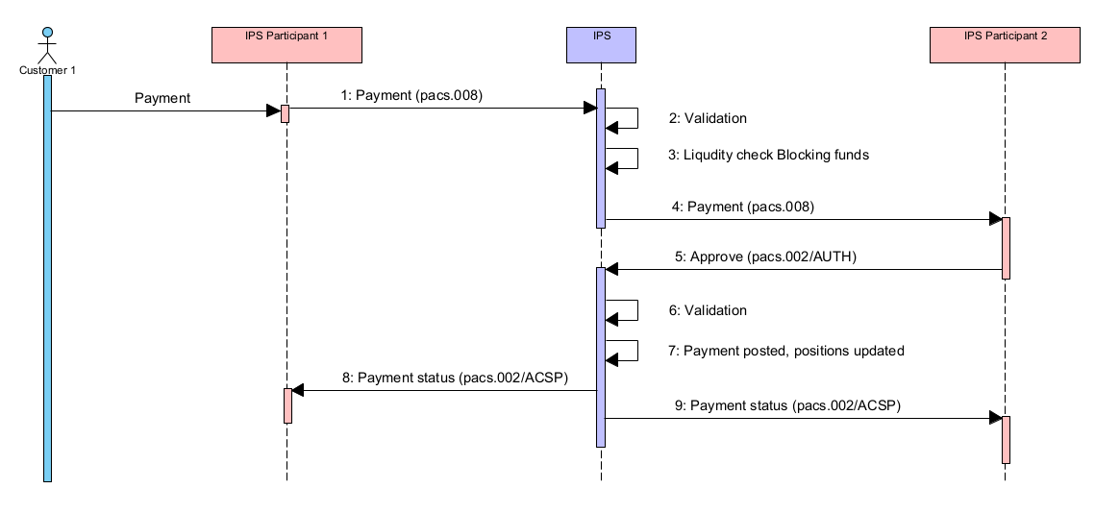
Figure 1. Payment without between IPS Participants – approved
Table 21. Diagram description. Payment between IPS Participants – approved
## | Description | Message type | Sample item
1 | IPS Participant 1 prepares a payment in the form of pacs.008 message, signs it and delivers to IPS | pacs.008 | 4.1.1.1
2 | IPS performs validation that includes:  - Message format validation  - Security check  - Access rights check  - Status of Debit/Credit accounts.  If any validation is failed, then the message is rejected. | See IPS rejection section | 5.1
3 | IPS perfroms Liquidiy check:  - Available position on IPS Participant 1 (Debtor) account  - Available position on settlement limit account linked to IPS account.  If Liquidity check fails, then the message is rejected.  IPS blocks funds on IPS Participant 1 (Debtor Party) position account.  IPS blocks funds on settlement limit account linked to IPS account. | See IPS rejection section | 5.1
4 | IPS delivers payment (pacs.008) to IPS Participant 2 (Creditor Party) | pacs.008 | 4.1.1.1
5 | IPS Participant 2 (Creditor Party) verifies the payment (outside IPS) on their side and delivers authorization of the payment (pacs.002/AUTH) | pacs.002/AUTH | 4.1.1.2
6 | IPS system performs validation of the message received that includes:  - Message format validation  - Security check  - Access right check  - IPS system checks if related payment exists and waiting for authorization (i.e., not rejected, not posted).  If validation is failed then the message is rejected | See IPS rejection section | 5.2
7 | IPS system posts the payment
8 | IPS delivers status of the payment to IPS Participant 1 (Debtor Party).  IPS Participant 1 (Debtor Party) shall finalize the payment in its books after receiving of the payment status | pacs.002/ACSP (AcceptedSettlementInProcess) | 4.1.1.3
9 | IPS delivers status of the payment to IPS Participant 2 (Creditor Party).  IPS Participant 2 (Creditor Party) shall finalize the payment in its books after receiving of the payment status | pacs.002/ACSP | 4.1.1.3

In samples below IPS Participant 1 (Debtor agent) = AAAAPYPX, IPS Participant 2 (Creditor agent) = BBBBPYPX.
      - Direct Credit payment: pacs.008
NOTE: Some optional fields are skipped in the sample. Please refer to the full message format description.
<!-- Document -->
<Document xmlns="urn:iso:std:iso:20022:tech:xsd:pacs.008.001.10">
<FIToFICstmrCdtTrf>
<GrpHdr>
<!-- Unique message reference as generated by sending party.-->
<MsgId>AAAAPYPXAXXX190929100120000001230</MsgId>
<!-- Document creation local date-time -->
<CreDtTm>2019-09-29T10:40:40.232-04:00</CreDtTm>
<!-- Number of payment instructions. Fixed value = 1 -->
<NbOfTxs>1</NbOfTxs>
<!-- Fixed value – settlement done via clearing -->
<SttlmInf>
<SttlmMtd>CLRG</SttlmMtd>
</SttlmInf>
</GrpHdr>
<CdtTrfTxInf>
<PmtId>
<!-- Optional field. Instruction identifier. May be filled with internal sender reference or with same value as TxId. -->
<InstrId>20190929-1818001</InstrId>
<!-- End-to-End reference. Not verified for uniqueness. Field can be used for indication of related payment reference. If no related reference, must be filled with NOTPROVIDED -->
<EndToEndId>NOTPROVIDED</EndToEndId>
<!-- Unique transaction identifier. Fill with the same value as MsgId if there is no internal payment id to be used -->
<TxId>AAAAPYPXAXXX190929100120000001230</TxId>
</PmtId>
<PmtTpInf>
<!-- Fixed value RTNS for IPS payments -->
<ClrChanl>RTNS</ClrChanl>
<!-- Local instrument code identifying business process of the payment. -->
<LclInstrm>
<Prtry>CSCT</Prtry>
</LclInstrm>
</PmtTpInf>
<!-- Payment amount and currency code -->
<IntrBkSttlmAmt Ccy="PYG">71.12</IntrBkSttlmAmt>
<!-- Requested payment settlement date -->
<IntrBkSttlmDt>2019-09-29</IntrBkSttlmDt>
<!-- Charges bearer indication. Fixed value SLEV. -->
<ChrgBr>SLEV</ChrgBr>
<!-- Instructing agent. Participant who is sending payment to the system. Typically, the same participant as in DebtorAgent tag.-->
<InstgAgt>
<FinInstnId>
<BICFI>AAAAPYPX</BICFI>
</FinInstnId>
</InstgAgt>
<!-- Instructed agent. Participant who is receiving payment. Typically, the same participant as in CreditorAgent tag. -->
<InstdAgt>
<FinInstnId>
<BICFI>BBBBPYPX</BICFI>
</FinInstnId>
</InstdAgt>
<!-- Debtor client information -->
<Dbtr>
<!-- Debtor client name -->
<Nm>ABC Automatic</Nm>
<Id>
<OrgId>
<Othr>
<Id>3 6787259-7</Id>
<SchmeNm>
<Prtry>TXID</Prtry>
</SchmeNm>
</Othr>
</OrgId>
</Id>
</Dbtr>
<!-- Debtor client account -->
<DbtrAcct>
<Id>
<Othr><Id>CUST-A-ACNT-AT-AAAAPYPX</Id></Othr>
</Id>
</DbtrAcct>
<!-- Debtor agent. Participant to be debited in IPS-->
<DbtrAgt>
<FinInstnId>
<BICFI>AAAAPYPX</BICFI>
</FinInstnId>
</DbtrAgt>
<!-- Debtor agent account. Account of participant to be debited in IPS (subcorrespondent account). -->
<DbtrAgtAcct>
<Id>
<Othr><Id>AAAAPYPX-ACCOUNT-AT-IPS</Id></Othr>
</Id>
</DbtrAgtAcct>
<!-- Creditor agent. Participant to be credited in IPS. BICFI for SWIFT-registered participants. -->
<CdtrAgt>
<FinInstnId>
<BICFI>BBBBPYPX</BICFI>
</FinInstnId>
</CdtrAgt>
<!-- Creditor agent account. Account of participant to be credited in IPS (subcorrespondent account).. -->
<CdtrAgtAcct>
<Id>
<Othr><Id>BBBBPYPX-ACCOUNT-AT-IPS</Id></Othr>
</Id>
</CdtrAgtAcct>
<!-- Creditor client information -->
<Cdtr>
<!-- Creditor client name -->
<Nm>GAS and OIL Company</Nm>
<Id>
<OrgId>
<Othr>
<Id>1 7982574-0</Id>
<SchmeNm>
<Prtry>TXID</Prtry>
</SchmeNm>
</Othr>
</OrgId>
</Id>
</Cdtr>
<!-- Creditor client account -->
<CdtrAcct>
<Id>
<Othr><Id>CUST-B-ACNT-AT-BBBBPYPX</Id></Othr>
</Id>
</CdtrAcct>
<!-- Additional information about payment -->
<InstrForCdtrAgt>
<InstrInf>Beneficiary info</InstrInf>
</InstrForCdtrAgt>
<InstrForCdtrAgt>
<InstrInf>Sample data</InstrInf>
</InstrForCdtrAgt>

<!-- Transaction type code as per defined in system dictionary of TTCs. -->
<Purp>
<Prtry>741</Prtry>
</Purp>
<!-- Regulatory reporting information -->
<RgltryRptg>
<Dtls>
<Inf>SOMEINFORMATIONABOUTPAYMENT-1</Inf>
<Inf>SOMEINFORMATIONABOUTPAYMENT-2</Inf>
<Inf>SOMEINFORMATIONABOUTPAYMENT-3</Inf>
</Dtls>
</RgltryRptg>
<!-- Remittance information -->
<RmtInf>
<Ustrd>EDV UCUN ODENIR</Ustrd>
<Ustrd>EXTRA INFO</Ustrd>
</RmtInf>
</CdtTrfTxInf>
</FIToFICstmrCdtTrf>
</Document>

      - Authorization message: pacs.002/AUTH
<!-- -Document--->
<Document xmlns="urn:iso:std:iso:20022:tech:xsd:pacs.002.001.12">
<FIToFIPmtStsRpt>
<GrpHdr>
<!-- Unique message identifier -->
<MsgId>BBBBPYPXAXXX190929000010000001230</MsgId>
<!-- Message creation local date-time -->
<CreDtTm>2019-09-29T10:40:43.231-04:00</CreDtTm>
</GrpHdr>
<OrgnlGrpInfAndSts>
<!-- As taken from pacs.008 FIToFICstmrCdtTrf/GrpHdr/MsgId -->
<OrgnlMsgId>AAAAPYPXAXXX190929100120000001230</OrgnlMsgId>
<!-- Type of original message to refer -->
<OrgnlMsgNmId>pacs.008.001.10</OrgnlMsgNmId>
<!-- As taken from pacs.008 FIToFICstmrCdtTrf/GrpHdr/CreDtTm -->
<OrgnlCreDtTm>2019-09-29T10:40:40.232-04:00</OrgnlCreDtTm>
<!-- Fixed value AUTH for authorization of the payment -->
<StsRsnInf>
<Rsn>
<Prtry>AUTH</Prtry>
</Rsn>
</StsRsnInf>
</OrgnlGrpInfAndSts>
<TxInfAndSts>
<!-- Instructing agent. Participant who sent the authorization message to the system. BICFI for swift-registered BICs. -->
<InstgAgt>
<FinInstnId>
<BICFI>BBBBPYPX</BICFI>
</FinInstnId>
</InstgAgt>
<!-- Instructed agent. Participant who sent original payment to the system. BICFI for swift-registered BICs. -->
<InstdAgt>
<FinInstnId>
<BICFI>AAAAPYPX</BICFI>
</FinInstnId>
</InstdAgt>
<OrgnlTxRef>
<!-- Settlement date of original payment -->
<IntrBkSttlmDt>2019-09-29</IntrBkSttlmDt>
</OrgnlTxRef>
</TxInfAndSts>
</FIToFIPmtStsRpt>
</Document>

      - Status message: pacs.002/ACSP
NOTE: The messages sent to both participants have the same <Document> tag; the difference is in <AppHdr> tag. See [2.1] for details.
<!-- -Document--->
<Document xmlns="urn:iso:std:iso:20022:tech:xsd:pacs.002.001.12">
<FIToFIPmtStsRpt>
<GrpHdr>
<!-- Unique message identifier generated by IPS -->
<MsgId>BCPAPYPXAIPS190929000010000001230</MsgId>
<!-- Message creation local date time -->
<CreDtTm>2019-09-29T10:40:44.199-04:00</CreDtTm>
</GrpHdr>
<OrgnlGrpInfAndSts>
<!-- As taken from pacs.008 FIToFICstmrCdtTrf/GrpHdr/MsgId -->
<OrgnlMsgId>AAAAPYPXAXXX190929100120000001230</OrgnlMsgId>
<!-- Type of original message to refer -->
<OrgnlMsgNmId>pacs.008.001.10</OrgnlMsgNmId>
<!-- As taken from pacs.008 FIToFICstmrCdtTrf/GrpHdr/CreDtTm -->
<OrgnlCreDtTm>2019-09-29T10:40:40.232-04:00</OrgnlCreDtTm>
<!-- Transaction processing result. ACSP – Accepted Settlement in process -->
<GrpSts>ACSP</GrpSts>
</OrgnlGrpInfAndSts>
<TxInfAndSts>
<!-- As taken from pacs.008 FIToFICstmrCdtTrf/CdtTrfTxInf/PmtId/EndToEndId -->
<OrgnlEndToEndId>NOTPROVIDED</OrgnlEndToEndId>
<!-- As taken from pacs.008 FIToFICstmrCdtTrf/CdtTrfTxInf/PmtId/TxId -->
<OrgnlTxId>AAAAPYPXAXXX190929100120000001230</OrgnlTxId>
<!-- Transaction processing result. ACSP – Accepted Settlement completed -->
<TxSts>ACSP</TxSts>
<!-- Session Id when payment has been posted or rejected in IPS. May be different with Session Id when finally settled. -->
<AcctSvcrRef>120</AcctSvcrRef>
<!-- Instructing agent. The IPS system. -->
<InstgAgt>
<FinInstnId>
<BICFI>BCPAPYPXIPS</BICFI>
</FinInstnId>
</InstgAgt>
<!-- Instructed agent. Participant who sent original payment to the system. -->
<InstdAgt>
<FinInstnId>
<BICFI>AAAAPYPX</BICFI>
</FinInstnId>
</InstdAgt>
<OrgnlTxRef>
<!-- Original payment amount and currency -->
<IntrBkSttlmAmt Ccy="PYG">71.12</IntrBkSttlmAmt>
<!-- Settlement date of original payment -->
<IntrBkSttlmDt>2019-09-29</IntrBkSttlmDt>
</OrgnlTxRef>
</TxInfAndSts>
</FIToFIPmtStsRpt>
</Document>

Declined payment
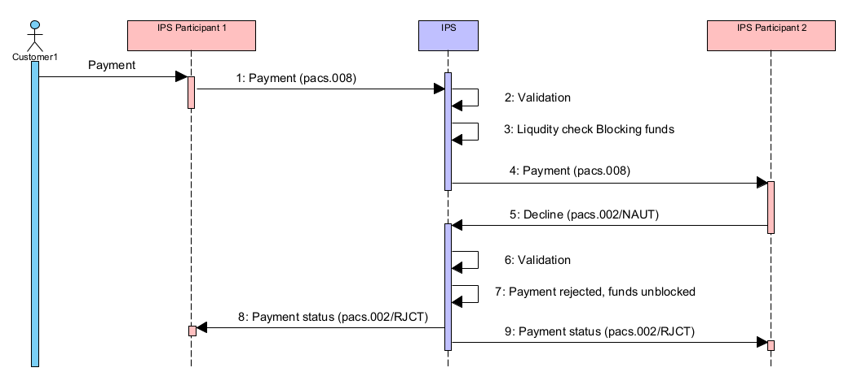
Figure 2. Payment without between IPS Participants – declined
Table 22 Diagram description. Payment between IPS Participants – declined
## | Description | Message type | Sample item
1-4 | Same as at the previous diagram above in section 4.1.1
5 | IPS Participant 2 (Creditor) verifies the payment on their side (outside IPS) and declines the payment in IPS by delivering pacs.002/NAUT with the reject reason specified. Reason code to be registered in IPS dictionaries in advance | pacs.002/NAUT | 4.1.2.1
6 | IPS system performs technical validation of the message received that includes:  - Message format validation  - Security check  - Access right check  - IPS system checks if related payment exists and waiting for authorization (i.e., not rejected, not posted).  If validation is failed then the message is rejected | See IPS rejection section | 5.2
7 | IPS system rejects the payment and unblocks the funds
8 | IPS delivers status of the payment to IPS Participant 2 (Creditor) | pacs.002/RJCT | 4.1.2.2
9 | IPS delivers status of the payment to IPS Participant 1 (Debtor). IPS Participant 1 (Debtor) shall finalize (reject) the payment in its books after receiving of the payment status | pacs.002/RJCT | 4.1.2.2
In samples below Payer Bank (Debtor agent) = AAAAPYPX, Payee Bank (Creditor agent) = BBBBPYPX.

      - Refusal message” pacs.002/NAUT
<Document xmlns="urn:iso:std:iso:20022:tech:xsd:pacs.002.001.12">
<FIToFIPmtStsRpt>
<GrpHdr>
<!-- Unique message identifier -->
<MsgId>BBBBPYPXAXXX190929100010000000250</MsgId>
<!-- Message creation local date time -->
<CreDtTm>2019-09-29T10:40:44.199-04:00</CreDtTm>
</GrpHdr>
<OrgnlGrpInfAndSts>
<!-- As taken from pacs.008 FIToFICstmrCdtTrf/GrpHdr/MsgId -->
<OrgnlMsgId>AAAAPYPXAXXX190929100120000001230</OrgnlMsgId>
<!-- Type of original message to refer -->
<OrgnlMsgNmId>pacs.008.001.10</OrgnlMsgNmId>
<!-- As taken from pacs.008 FIToFICstmrCdtTrf/GrpHdr/CreDtTm -->
<OrgnlCreDtTm>2017-09-14T10:40:40.232-04:00</OrgnlCreDtTm>
<StsRsnInf>
<Rsn>
<!-- Fixed value NAUT for authorization of the payment -->
<Prtry>NAUT</Prtry>
</Rsn>
</StsRsnInf>
</OrgnlGrpInfAndSts>
<TxInfAndSts>
<StsRsnInf>
<!-- Rejection reason as provided by counterparty -->
<!-- Code as per rejection reason codes dictionary in Central System -->
<Rsn>
<Prtry>AC01</Prtry>
</Rsn>
<!-- Additional refusal information -->
<AddtlInf>Wrong account number</AddtlInf>
</StsRsnInf>
<!-- Instructing agent. Participant who sent the authorization message to the system. BICFI for swift-registered BICs. -->
<InstgAgt>
<FinInstnId>
<BICFI>BBBBPYPX</BICFI>
</FinInstnId>
</InstgAgt>
<!-- Instructed agent. Participant who sent original payment to the system. BICFI for swift-registered BICs. -->
<InstdAgt>
<FinInstnId>
<BICFI>AAAAPYPX</BICFI>
</FinInstnId>
</InstdAgt>
<OrgnlTxRef>
<!-- Settlement date of original payment -->
<IntrBkSttlmDt>2017-01-14</IntrBkSttlmDt>
</OrgnlTxRef>
</TxInfAndSts>
</FIToFIPmtStsRpt>
</Document>

      - Status message: pacs.002/RJCT
<Document xmlns="urn:iso:std:iso:20022:tech:xsd:pacs.002.001.12">
<FIToFIPmtStsRpt>
<GrpHdr>
<!-- Unique message identifier generated by IPS -->
<MsgId>BCPAPYPXAIPS190929000010000001230</MsgId>
<!-- Message creation local date time -->
<CreDtTm>2019-09-29T10:40:45.100-04:00</CreDtTm>
</GrpHdr>
<OrgnlGrpInfAndSts>
<!-- As taken from pacs.008 FIToFICstmrCdtTrf/GrpHdr/MsgId -->
<OrgnlMsgId>AAAAPYPXAXXX190929100120000001230</OrgnlMsgId>
<!-- Type of original message to refer -->
<OrgnlMsgNmId>pacs.008.001.10</OrgnlMsgNmId>
<!-- As taken from pacs.008 FIToFICstmrCdtTrf/GrpHdr/CreDtTm -->
<OrgnlCreDtTm>2017-09-14T10:40:40.232-04:00</OrgnlCreDtTm>
<!-- Transaction processing result. RJCT – Rejected -->
<GrpSts>RJCT</GrpSts>
</OrgnlGrpInfAndSts>
<TxInfAndSts>
<!-- As taken from pacs.008 FIToFICstmrCdtTrf/CdtTrfTxInf/PmtId/InstrId -->
<OrgnlInstrId>20190929-18180001</OrgnlInstrId>
<!-- As taken from pacs.008 FIToFICstmrCdtTrf/CdtTrfTxInf/PmtId/EndToEndId -->
<OrgnlEndToEndId>NOTPROVIDED</OrgnlEndToEndId>
<!-- As taken from pacs.008 FIToFICstmrCdtTrf/CdtTrfTxInf/PmtId/TxId -->
<OrgnlTxId>AAAAPYPXAXXX190929100120000001230</OrgnlTxId>
<!-- Transaction processing result. RJCT – Rejected -->
<TxSts>RJCT</TxSts>
<!-- Error code and description generated by IPS -->
<StsRsnInf>
<Rsn>
<Prtry>EL201</Prtry>
</Rsn>
<AddtlInf>NRT/IPP - Rejected by authorizer</AddtlInf>
</StsRsnInf>
<StsRsnInf>
<!-- Rejection reason code and description as provided by counterparty -->
<Rsn>
<Prtry>AC01</Prtry>
</Rsn>
<AddtlInf>Wrong account number</AddtlInf>
</StsRsnInf>
<!-- Session Id when payment has been posted or rejected in IPS. May be different with Session Id when finally settled. -->
<AcctSvcrRef>120</AcctSvcrRef>
<!-- Instructing agent. The IPS system. -->
<InstgAgt>
<FinInstnId>
<BICFI>BCPAPYPXIPS</BICFI>
</FinInstnId>
</InstgAgt>
<!-- Instructed agent. Participant who sent original payment to the system. BICFI for swift-registered BICs. -->
<InstdAgt>
<FinInstnId>
<BICFI>AAAAPYPX</BICFI>
</FinInstnId>
</InstdAgt>
<OrgnlTxRef>
<!-- Original payment amount and currency -->
<IntrBkSttlmAmt Ccy="PYG">71.12</IntrBkSttlmAmt>
<!-- Settlement date of original payment -->
<IntrBkSttlmDt>2019-09-29</IntrBkSttlmDt>
</OrgnlTxRef>
</TxInfAndSts>
</FIToFIPmtStsRpt>
</Document>

Payment rejected after timeout
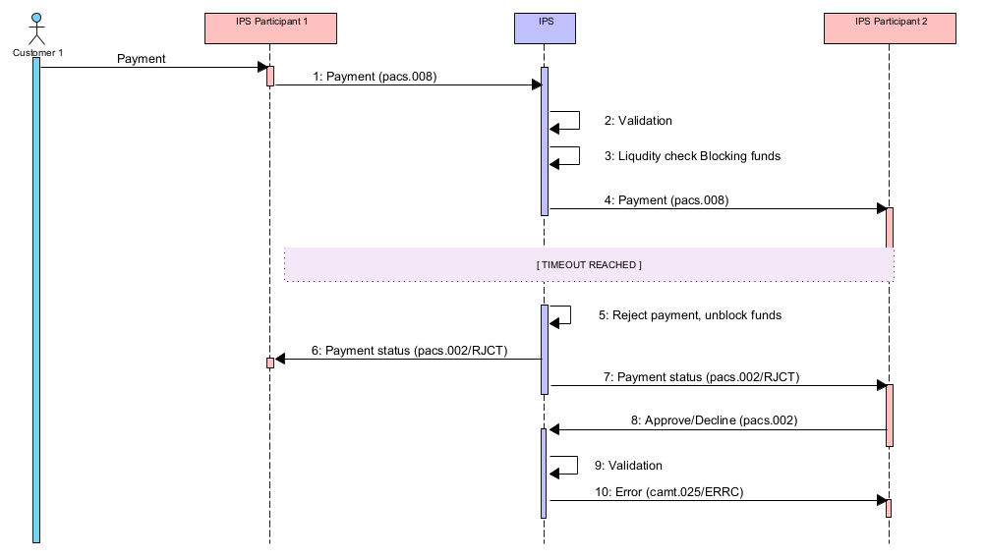

Figure 3. Payment between IPS Participants – timeout
Table 23. Diagram description. Payment between IPS Participants – timeout
## | Description | Message type | Sample item
1-4 | Same as at the previous diagram above in section 4.1.1
5 | After timeout expired IPS system rejects the payment and unblocks funds
6 | IPS delivers status of the payment to IPS Participant 1 (Debtor).  IPS Participant 1 (Debtor) shall finalize (reject) the payment in its books after receiving of the payment status.
7 | IPS delivers status of the payment to IPS Participant 1 (Debtor) shall finalize (reject) the payment in its books after receiving of the payment status. | pacs.002/RJCT | 4.1.3.1
8-10 | If accidently participant sends confirmation or rejection message for the payment to IPS after timeout then this confirmation or rejection message will be rejected by IPS | pacs.002/AUTH/NAUT  See IPS rejection section | 5.2

In samples below Payer Bank (Debtor agent) = AAAAPYPX, Payee Bank (Creditor agent) = BBBBPYPX.

      - Status message: pacs.002/RJCT
<Document xmlns="urn:iso:std:iso:20022:tech:xsd:pacs.002.001.12">
<FIToFIPmtStsRpt>
<GrpHdr>
<!-- Unique message identifier generated by IPS -->
<MsgId>BCPAPYPXAIPS190929000010000001230</MsgId>
<!-- Message creation local date time -->
<CreDtTm>2019-09-29T10:40:48.199-04:00</CreDtTm>
</GrpHdr>
<OrgnlGrpInfAndSts>
<!-- As taken from pacs.008 FIToFICstmrCdtTrf/GrpHdr/MsgId -->
<OrgnlMsgId>AAAAPYPXAXXX190929100120000001230</OrgnlMsgId>
<!-- Type of original message to refer -->
<OrgnlMsgNmId>pacs.008.001.10</OrgnlMsgNmId>
<!-- As taken from pacs.008 FIToFICstmrCdtTrf/GrpHdr/CreDtTm -->
<OrgnlCreDtTm>2017-09-14T10:40:40.232-04:00</OrgnlCreDtTm>
<!-- Transaction processing result. RJCT – Rejected -->
<GrpSts>RJCT</GrpSts>
</OrgnlGrpInfAndSts>
<TxInfAndSts>
<!-- As taken from pacs.008 FIToFICstmrCdtTrf/CdtTrfTxInf/PmtId/InstrId -->
<OrgnlInstrId>20190929-18180001</OrgnlInstrId>
<!-- As taken from pacs.008 FIToFICstmrCdtTrf/CdtTrfTxInf/PmtId/EndToEndId -->
<OrgnlEndToEndId>NOTPROVIDED</OrgnlEndToEndId>
<!-- As taken from pacs.008 FIToFICstmrCdtTrf/CdtTrfTxInf/PmtId/TxId -->
<OrgnlTxId>AAAAPYPXAXXX190929100120000001230</OrgnlTxId>
<!-- Transaction processing result. RJCT – Rejected -->
<TxSts>RJCT</TxSts>
<StsRsnInf>
<Rsn>
<Prtry>EL202</Prtry>
</Rsn>
<AddtlInf>NRT - Rejected by timeout</AddtlInf>
</StsRsnInf>
<!-- Instructing agent. The IPS system. -->
<InstgAgt>
<FinInstnId>
<BICFI>BCPAPYPXIPS</BICFI>
</FinInstnId>
</InstgAgt>
<!-- Instructed agent. Participant who sent original payment to the system. BICFI for swift-registered BICs. -->
<InstdAgt>
<FinInstnId>
<BICFI>AAAAPYPX</BICFI>
</FinInstnId>
</InstdAgt>
<OrgnlTxRef>
<!-- Original payment amount and currency -->
<IntrBkSttlmAmt Ccy="PYG">71.12</IntrBkSttlmAmt>
<!-- Settlement date of original payment -->
<IntrBkSttlmDt>2019-09-29</IntrBkSttlmDt>
</OrgnlTxRef>
</TxInfAndSts>
</FIToFIPmtStsRpt>
</Document>

Payment without authorization between Direct Participants
The same instrument types are used for payments without authorization is as those usedfor payments with authorization.
This flow is applicable only if one of conditions below is met:
- IPS Participant 2 – Creditor Party works in offline mode
- Direct Credit payment is issued as a response on Request to pay from IPS Participant – Creditor Party.
Identification of paymet processing mode is as follows:
- If a payment message is sent as a reply on incoming Request to Pay it shall contain a reference to original Request to Pay message (refer to section 4.5). If this reference is present, then payment is processed with authorization by Creditor Party
- If Creditor Party is marked as working in offline mode in IPS Participant directory then payment is processed with authorization by Creditor Party irrespectively of other tags in the payment message body.

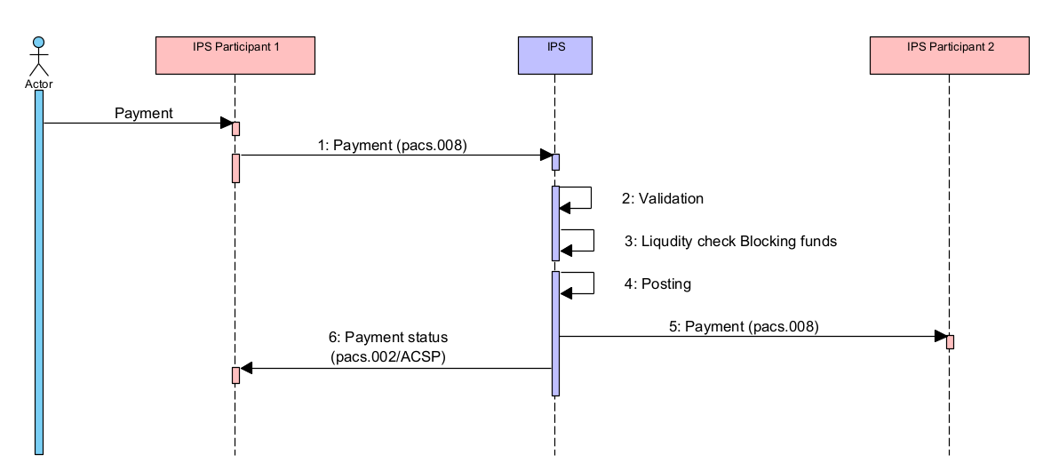
Figure 4. Payment without authorization between IPS Participants
Table 24. Diagram description. Payment without authorization between IPS Participants
## | Description | Message type | Sample item
1 | IPS Participant 1 prepares a payment in the form of pacs.008 message, signs it and delivers to IPS | pacs.008 | 4.2.1.1
2 | IPS performs technical validation that includes:  - Message format validation  - Security check  - Access rights check  - Status of Debit/Credit accounts.  If any validation is failed, then the message is rejected. | See IPS rejection section | 5.1
3 | IPS perfroms Liquidiy check:  - Available position on IPS Participant 1 (Debtor) account  - Available position on settlement limit account linked to IPS account.  If Liquidity check fails then the message is rejected | See IPS rejection section | 5.1
4 | IPS system posts the payment
5 | IPS delivers the payment to IPS Participant 2 (Creditor Party). | pacs.008 | 4.2.1.1
6 | IPS delivers status of the payment to IPS Participant 1 (Debtor Party).  IPS Participant 1 (Debtor Party) shall finalize the payment in its books after receiving of the payment status | pacs.002/ACSP (AcceptedSettlementInProcess) | 4.2.1.2

      - Direct Credit payment: pacs.008
NOTE. Some optional fields are skipped in the sample. Please refer to the full message format description.

<!-- Document -->
<Document xmlns="urn:iso:std:iso:20022:tech:xsd:pacs.008.001.10">
<FIToFICstmrCdtTrf>
<GrpHdr>
<!-- Unique message reference as generated by sending party.-->
<MsgId>AAAAPYPXAXXX190929100120000001230</MsgId>
<!-- Document creation local date-time -->
<CreDtTm>2019-09-29T10:40:40.232-04:00</CreDtTm>
<!-- Number of payment instructions. Fixed value = 1 -->
<NbOfTxs>1</NbOfTxs>
<!-- Fixed value – settlement done via clearing -->
<SttlmInf>
<SttlmMtd>CLRG</SttlmMtd>
</SttlmInf>
</GrpHdr>
<CdtTrfTxInf>
<PmtId>
<!-- Optional field. Instruction identifier. May be filled with internal sender reference or with same value as TxId. -->
<InstrId>20190929-1818001</InstrId>
<!-- End-to-End reference. Not verified for uniqueness. Field can be used for indication of related payment reference. If no related reference, must be filled with NOTPROVIDED -->
<EndToEndId>NOTPROVIDED</EndToEndId>
<!-- Unique transaction identifier. Fill with the same value as MsgId if there is no internal payment id to be used -->
<TxId>AAAAPYPXAXXX190929100120000001230</TxId>
</PmtId>
<PmtTpInf>
<!-- Fixed value RTNS for IPS payments -->
<ClrChanl>RTNS</ClrChanl>
<!-- Local instrument code identifying business process of the payment. -->
<LclInstrm>
<Prtry>CSCT</Prtry>
</LclInstrm>
</PmtTpInf>
<!-- Payment amount and currency code -->
<IntrBkSttlmAmt Ccy="PYG">71.12</IntrBkSttlmAmt>
<!-- Requested payment settlement date -->
<IntrBkSttlmDt>2019-09-29</IntrBkSttlmDt>
<!-- Charges bearer indication. Fixed value SLEV. -->
<ChrgBr>SLEV</ChrgBr>
<!-- Instructing agent. Participant who is sending payment to the system. Typically, the same participant as in DebtorAgent tag.-->
<InstgAgt>
<FinInstnId>
<BICFI>AAAAPYPX</BICFI>
</FinInstnId>
</InstgAgt>
<!-- Instructed agent. Participant who is receiving payment. Typically, the same participant as in CreditorAgent tag. -->
<InstdAgt>
<FinInstnId>
<BICFI>BBBBPYPX</BICFI>
</FinInstnId>
</InstdAgt>
<!-- Debtor client information -->
<Dbtr>
<!-- Debtor client name -->
<Nm>ABC Automatic</Nm>
</Dbtr>
<!-- Debtor client account -->
<DbtrAcct>
<Id>
<Othr><Id>CUST-A-ACNT-AT-AAAAPYPX</Id></Othr>
</Id>
</DbtrAcct>
<!-- Debtor agent. Participant to be debited in IPS-->
<DbtrAgt>
<FinInstnId>
<BICFI>AAAAPYPX</BICFI>
</FinInstnId>
</DbtrAgt>
<!-- Debtor agent account. Account of participant to be debited in IPS (subcorrespondent account). -->
<DbtrAgtAcct>
<Id>
<Othr><Id>AAAAPYPX-ACCOUNT-AT-IPS</Id></Othr>
</Id>
</DbtrAgtAcct>
<!-- Creditor agent. Participant to be credited in IPS. BICFI for SWIFT-registered participants. -->
<CdtrAgt>
<FinInstnId>
<BICFI>BBBBPYPX</BICFI>
</FinInstnId>
</CdtrAgt>
<!-- Creditor agent account. Account of participant to be credited in IPS (subcorrespondent account).. -->
<CdtrAgtAcct>
<Id>
<Othr><Id>BBBBPYPX-ACCOUNT-AT-IPS</Id></Othr>
</Id>
</CdtrAgtAcct>
<!-- Creditor client information -->
<Cdtr>
<!-- Creditor client name -->
<Nm>GAS and OIL Company</Nm>
</Cdtr>
<!-- Creditor client account -->
<CdtrAcct>
<Id>
<Othr><Id>CUST-B-ACNT-AT-BBBBPYPX</Id></Othr>
</Id>
</CdtrAcct>
<!-- Additional information about payment -->
<InstrForCdtrAgt>
<InstrInf>Beneficiary info</InstrInf>
</InstrForCdtrAgt>
<InstrForCdtrAgt>
<InstrInf>Sample data</InstrInf>
</InstrForCdtrAgt>

<!-- Transaction type code as per defined in system dictionary of TTCs. -->
<Purp>
<Prtry>741</Prtry>
</Purp>
<!-- Regulatory reporting information -->
<RgltryRptg>
<Dtls>
<Inf>SOMEINFORMATIONABOUTPAYMENT-1</Inf>
<Inf>SOMEINFORMATIONABOUTPAYMENT-2</Inf>
<Inf>SOMEINFORMATIONABOUTPAYMENT-3</Inf>
</Dtls>
</RgltryRptg>
<!-- Remittance information -->
<RmtInf>
<Ustrd>EDV UCUN ODENIR</Ustrd>
<Ustrd>EXTRA INFO</Ustrd>
</RmtInf>
</CdtTrfTxInf>
</FIToFICstmrCdtTrf>
</Document>

      - Status message: pacs.002/ACSP
NOTE: The messages sent to both participants have the same <Document> tag; the difference is in <AppHdr> tag. See [2.1] for details.
<!-- -Document--->
<Document xmlns="urn:iso:std:iso:20022:tech:xsd:pacs.002.001.12">
<FIToFIPmtStsRpt>
<GrpHdr>
<!-- Unique message identifier generated by IPS -->
<MsgId>BCPAPYPXAIPS190929000010000001230</MsgId>
<!-- Message creation local date time -->
<CreDtTm>2019-09-29T10:40:44.199-04:00</CreDtTm>
</GrpHdr>
<OrgnlGrpInfAndSts>
<!-- As taken from pacs.008 FIToFICstmrCdtTrf/GrpHdr/MsgId -->
<OrgnlMsgId>AAAAPYPXAXXX190929100120000001230</OrgnlMsgId>
<!-- Type of original message to refer -->
<OrgnlMsgNmId>pacs.008.001.10</OrgnlMsgNmId>
<!-- As taken from pacs.008 FIToFICstmrCdtTrf/GrpHdr/CreDtTm -->
<OrgnlCreDtTm>2019-09-29T10:40:40.232-04:00</OrgnlCreDtTm>
<!-- Transaction processing result. ACSP – Accepted Settlement in process -->
<GrpSts>ACSP</GrpSts>
</OrgnlGrpInfAndSts>
<TxInfAndSts>
<!-- As taken from pacs.008 FIToFICstmrCdtTrf/CdtTrfTxInf/PmtId/EndToEndId -->
<OrgnlEndToEndId>NOTPROVIDED</OrgnlEndToEndId>
<!-- As taken from pacs.008 FIToFICstmrCdtTrf/CdtTrfTxInf/PmtId/TxId -->
<OrgnlTxId>AAAAPYPXAXXX190929100120000001230</OrgnlTxId>
<!-- Transaction processing result. ACSP – Accepted Settlement completed -->
<TxSts>ACSP</TxSts>
<!-- Session Id when payment has been posted or rejected in IPS. May be different with Session Id when finally settled. -->
<AcctSvcrRef>120</AcctSvcrRef>
<!-- Instructing agent. The IPS system. -->
<InstgAgt>
<FinInstnId>
<BICFI>BCPAPYPXIPS</BICFI>
</FinInstnId>
</InstgAgt>
<!-- Instructed agent. Participant who sent original payment to the system. -->
<InstdAgt>
<FinInstnId>
<BICFI>AAAAPYPX</BICFI>
</FinInstnId>
</InstdAgt>
<OrgnlTxRef>
<!-- Original payment amount and currency -->
<IntrBkSttlmAmt Ccy="PYG">71.12</IntrBkSttlmAmt>
<!-- Settlement date of original payment -->
<IntrBkSttlmDt>2019-09-29</IntrBkSttlmDt>
</OrgnlTxRef>
</TxInfAndSts>
</FIToFIPmtStsRpt>
</Document>

Return payment
Table 25. Instrument types for Return payments
# | Instrument code | Instrument
1 | RTCT | Return payment

Return payment doesn’t require authorization of counterparty (IPS Participant 1 which is a Dbtor Party in original payment and Creditor Party in Return payment).
Return payment shall contain a reference to original payment (see an example below).
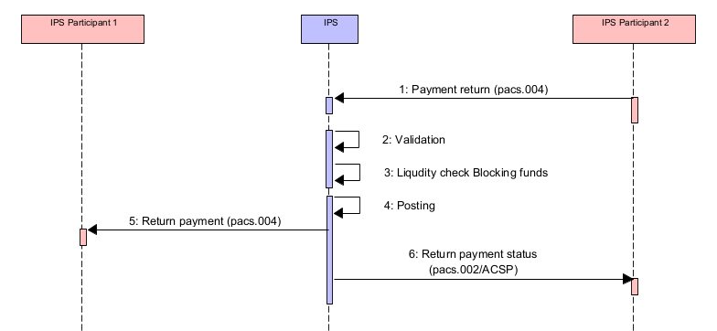
Figure 5. Return payment between IPS Participants
Table 26. Diagram description. Return payment between IPS Participants
## | Description | Message type | Sample item
1 | IPS Participant 2 (Creditor Party in original payment) prepares return payment in the form of pacs.004 message, signs it and delivers to IPS.  Return payment contains the fields from original payment and the return reason. Return (reject) reason has to be registered in IPS dictionaries in advance | pacs.004 | 4.3.1.1
2 | IPS performs validation that includes:  - Message format validation  - Security check  - Access rights check  - Status of Debit/Credit accounts.  In addition, IPS validates that:  - Original payment exists and posted  - Amount set for return does not exceed amount in original payment  - No other return payments are registered against the original payment  - IPS performs financial (or business) validation of the return payment that includes:  - Status of accounts.  If any validation is failed, then the message is rejected | See IPS rejection section | 5.1
3 | IPS perfroms Liquidiy check:  - Available position on IPS Participant 2 account  - Available position on settlement limit account linked to IPS account.  If Liquidity check fails then the message is rejected | See IPS rejection section | 5.1
4 | IPS system posts the payment | IPS system posts the payment
5 | IPS delivers return payment (pacs.004) to IPS Participant 1 (Debtor Party in original payment).  IPS Participant 1 (Debtor Party in original payment) shall finalize the payment in its books after receiving of the Return payment | pacs.004 | 4.3.1.1
6 | IPS delivers status of the payment to IPS Participant 2 (Creditor Party in original payment) | pacs.002/ACSP | 4.3.1.2

      - Return payment: pacs.004
NOTE 1: Some optional fields are skipped in the sample. Please refer to the full message format description.

<Document xmlns="urn:iso:std:iso:20022:tech:xsd:pacs.004.001.11">
<PmtRtr>
<GrpHdr>
<!-- Message reference -->
<MsgId>BBBBPYPXAXXX190929100010000000250</MsgId>
<!-- Message creation local date time -->
<CreDtTm>2019-09-29T12:50:40.243-04:00-</CreDtTm>
<NbOfTxs>1</NbOfTxs>
<SttlmInf>
<SttlmMtd>CLRG</SttlmMtd>
</SttlmInf>
</GrpHdr>
<OrgnlGrpInf>
<!-- Original message reference -->
<OrgnlMsgId>AAAAPYPXAXXX190929100120000001230</OrgnlMsgId>
<!-- Original message type -->
<OrgnlMsgNmId>pacs.008.001.10</OrgnlMsgNmId>
<!-- Original message creation date time -->
<OrgnlCreDtTm>2019-09-29T10:40:40.232-04:00</OrgnlCreDtTm>
</OrgnlGrpInf>
<TxInf>
<!-- Return Id. Fill with the same value as MsgId -->
<RtrId>BBBBPYPXAXXX190929100010000000250</RtrId>
<!-- Original Instruction Id. As present in pacs.008 -->
<OrgnlInstrId>20190929-1818001</OrgnlInstrId>
<!-- Original EndToEndId. As present in pacs.008 -->
<OrgnlEndToEndId>NOTPROVIDED</OrgnlEndToEndId>
<!-- Original Transaction Id. As present in pacs.008 -->
<OrgnlTxId>AAAAPYPXAXXX190929100120000001230</OrgnlTxId>
<!-- Original settlement date. As present in pacs.008 -->
<OrgnlIntrBkSttlmDt>2019-09-29</OrgnlIntrBkSttlmDt>
<PmtTpInf>
<!-- Fixed value RTNS for IPS payments -->
<ClrChanl>RTNS</ClrChanl>
<!-- Local instrument code identifying business process of the payment. -->
<LclInstrm>
<Prtry>RTCT</Prtry>
</LclInstrm>
</PmtTpInf>

<!-- Returned amount and currency by pacs.004. Amount must not be greater than original settlement amount from pacs.008. Currencies must be identical. -->
<RtrdIntrBkSttlmAmt Ccy="PYG">70.00</RtrdIntrBkSttlmAmt>
<!-- Settlement date of return payment. -->
<IntrBkSttlmDt>2019-09-29</IntrBkSttlmDt>
<!-- Charges bearer indicator. Fixed value SLEV. -->
<ChrgBr>SLEV</ChrgBr>
<!-- Instructing agent. Participant who’s sending payment to the system. Typically, the same participant as in OrgnlTxRef/CreditorAgent tag. BICFI for swift-registered BICs. -->
<InstgAgt>
<FinInstnId>
<BICFI>BBBBPYPX</BICFI>
</FinInstnId>
</InstgAgt>
<!-- Instructed agent. Participant who’s receiving the payment and the sender of original transfer. Typically, the same participant as in OrgnlTxRef/DebtorAgent tag. BICFI for swift-registered BICs. -->
<InstdAgt>
<FinInstnId>
<BICFI>AAAAPYPX</BICFI>
</FinInstnId>
</InstdAgt>
<!-- Return reason information section -->
<RtrRsnInf>
<!-- Optional field. BIC/pseudo-BIC of participant who initiated the return -->
<Orgtr>
<Id>
<OrgId>
<AnyBIC>BBBBPYPX</AnyBIC>
</OrgId>
</Id>
</Orgtr>
<!-- Return reason code. As per dictionary defined in central system -->
<Rsn>
<Prtry>AC04</Prtry>
</Rsn>
<!-- Additional information about return reason -->
<AddtlInf>Closed account number</AddtlInf>
</RtrRsnInf>
<!-- Following section contains data in the same way as it is present in original pacs.008 (not all fields are required to be taken from original message) -->
<OrgnlTxRef>
<IntrBkSttlmAmt Ccy="PYG">71.12</IntrBkSttlmAmt>
<PmtTpInf>
<ClrChanl>RTNS</ClrChanl>
<LclInstrm>
<Prtry>CSCT</Prtry>
</LclInstrm>
</PmtTpInf>
<RmtInf>
<Ustrd>EDV UCUN ODENIR</Ustrd>
<Ustrd>EXTRA INFO</Ustrd>
</RmtInf>
<Dbtr>
<Pty>
<Nm>ABC Automatic</Nm>
</Pty>
</Dbtr>
<DbtrAcct>
<Id>
<Othr><Id>CUST-A-ACNT-AT-AAAAPYPX</Id></Othr>
</Id>
</DbtrAcct>
<DbtrAgt>
<FinInstnId>
<BICFI>AAAAPYPX</BICFI>
</FinInstnId>
</DbtrAgt>
<DbtrAgtAcct>
<Id>
<Othr><Id>AAAAPYPX-ACCOUNT-AT-IPS</Id></Othr>
</Id>
</DbtrAgtAcct>
<CdtrAgt>
<FinInstnId>
<BICFI>BBBBPYPX</BICFI>
</FinInstnId>
</CdtrAgt>
<CdtrAgtAcct>
<Id>
<Othr><Id>BBBBPYPX-ACCOUNT-AT-IPS</Id></Othr>
</Id>
</CdtrAgtAcct>
<Cdtr>
<Pty>
<Nm>GAS and OIL Company</Nm>
</Pty>
</Cdtr>
<CdtrAcct>
<Id>
<Othr><Id>CUST-B-ACNT-AT-BBBBPYPX</Id></Othr>
</Id>
</CdtrAcct>
<Purp>
<Prtry>741</Prtry>
</Purp>
</OrgnlTxRef>
</TxInf>
</PmtRtr>
</Document>
      - Return payment status: pacs.002/ACSP
<!-- -Document--->
<Document xmlns="urn:iso:std:iso:20022:tech:xsd:pacs.002.001.12">
<FIToFIPmtStsRpt>
<GrpHdr>
<!-- Unique message identifier generated by IPS -->
<MsgId>BCPAPYPXAIPS190929000010000001237</MsgId>
<!-- Message creation local date time -->
<CreDtTm>2019-09-29T10:40:44.199-04:00</CreDtTm>
</GrpHdr>
<OrgnlGrpInfAndSts>
<!-- As taken from pacs.008 FIToFICstmrCdtTrf/GrpHdr/MsgId -->
<OrgnlMsgId>BBBBPYPXAXXX190929100010000000250</OrgnlMsgId>
<!-- Type of original message to refer -->
<OrgnlMsgNmId>pacs.004.001.11</OrgnlMsgNmId>
<!-- As taken from pacs.008 FIToFICstmrCdtTrf/GrpHdr/CreDtTm -->
<OrgnlCreDtTm>2019-09-29T12:50:40.243-04:00</OrgnlCreDtTm>
<!-- Transaction processing result. ACSP – Accepted Settlement in process -->
<GrpSts>ACSP</GrpSts>
</OrgnlGrpInfAndSts>
<TxInfAndSts>
<!-- As taken from pacs.008 FIToFICstmrCdtTrf/CdtTrfTxInf/PmtId/EndToEndId -->
<OrgnlEndToEndId>NOTPROVIDED</OrgnlEndToEndId>
<!-- As taken from pacs.008 FIToFICstmrCdtTrf/CdtTrfTxInf/PmtId/TxId -->
<OrgnlTxId>BBBBPYPXAXXX190929100010000000250</OrgnlTxId>
<!-- Transaction processing result. ACSP – Accepted Settlement completed -->
<TxSts>ACSP</TxSts>
<!-- Session Id when payment has been posted or rejected in IPS. May be different with Session Id when finally settled. -->
<AcctSvcrRef>120</AcctSvcrRef>
<!-- Instructing agent. The IPS system. -->
<InstgAgt>
<FinInstnId>
<BICFI>BCPAPYPXIPS</BICFI>
</FinInstnId>
</InstgAgt>
<!-- Instructed agent. Participant who sent return transfer to the system. -->
<InstdAgt>
<FinInstnId>
<BICFI>BBBBPYPX</BICFI>
</FinInstnId>
</InstdAgt>
<OrgnlTxRef>
<!-- Returned payment amount and currency -->
<IntrBkSttlmAmt Ccy="PYG">70.</IntrBkSttlmAmt>
<!-- Settlement date of return transfer -->
<IntrBkSttlmDt>2019-09-29</IntrBkSttlmDt>
</OrgnlTxRef>
</TxInfAndSts>
</FIToFIPmtStsRpt>
</Document>

Request for return
Participants have possibility to request a return for a payment that initially sent by it (debtor agent). As a successful result of the request processing is a return payment created and delivered to IPS from the creditor agent of the original payment. Counterparty also has rights to decline such request. Request for return is not available for the payment if Recall retention period is expired (defined as system parameter). Approved request for return

Approved request for return

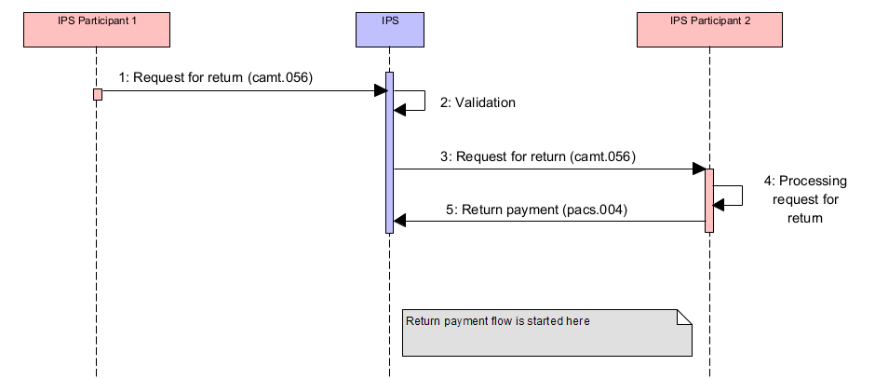
Figure 6. Request for return approved by IPS Participant 2 – Receiver of Request for return
Table 27. Diagram description. Request for return approved by IPS Participant 2 – Receiver of Request for return
## | Description | Message type
1 | IPS Participant 1 (Debtor Party in original payment) sends request for return to IPS. The request contains fields from the original payment:  - Payment reference  - Payment value date  - Debtor agent  - Creditor agent. | camt.056 | 4.4.1.1
2 | IPS validates the request:  - Message format validation  - Security check  - Access right check.  In addition, IPS checks:  - Existence of original payment in IPS database  - Retention period is not expired.  If any validation is failed, then the message is rejected | See IPS rejection section | 5.3
3 | IPS delivers the request to the Counterparty: IPS Participant 2 (Creditor Party in original payment) | camt.056 | 4.4.1.1
4 | IPS Participant 2 (Creditor Party in original payment) processes the request and decides to deliver return payment.  IPS validates Return payment as usual and checks that it comes to IPS in retention period defined for return | See IPS rejection section | 5.1
5 | Return payment processing flow is described in Section 4.3 above | pacs.004 | 4.4.1.2

      - Request for return: camt.056
<Document xmlns="urn:iso:std:iso:20022:tech:xsd:camt.056.001.10">
<FIToFIPmtCxlReq>
<Assgnmt>
<!-- Query message unique reference -->
<Id>AAAAPYPXAXXX190929100120000001235</Id>
<Assgnr>
<!-- Query message sender BIC/pseudo-BIC. BICFI for SWIFT-registered participants. -->
<Agt>
<FinInstnId>
<BICFI>AAAAPYPX</BICFI>
</FinInstnId>
</Agt>
</Assgnr>
<Assgne>
<!-- Query message receiver BIC/pseudo-BIC. BICFI for SWIFT-registered participants. -->
<Agt>
<FinInstnId>
<BICFI>BBBBPYPX</BICFI>
</FinInstnId>
</Agt>
</Assgne>
<!-- Query creation local date time -->
<CreDtTm>2019-09-29T09:30:32.323-04:00</CreDtTm>
</Assgnmt>
<Undrlyg>
<TxInf>
<OrgnlGrpInf>
<!-- Original message id of payment to be cancelled/returned-->
<OrgnlMsgId>AAAAPYPXAXXX190929100120000001230</OrgnlMsgId>
<!-- Original message type of payment to be cancelled/returned-->
<OrgnlMsgNmId>pacs.008.001.10</OrgnlMsgNmId>
<!-- Original message creation date-time of payment to be cancelled/returned-->
<OrgnlCreDtTm>2019-09-29T10:40:40.232-04:00</OrgnlCreDtTm>
</OrgnlGrpInf>
<!-- Original payment settlement date -->
<OrgnlIntrBkSttlmDt>2019-09-29</OrgnlIntrBkSttlmDt>
<Assgnr>
<!-- BIC/pseudo-BIC of original transfer sender . BICFI for SWIFT-registered participants. -->
<FinInstnId>
<BICFI>AAAAPYPX</BICFI>
</FinInstnId>
</Assgnr>
<CxlRsnInf>
<!-- Return reason code as per cancellation reasons list defined in central system.-->
<Rsn>
<Prtry>AC03</Prtry>
</Rsn>
<!-- Return reason information in free text format -->
<AddtlInf>Wrong creditor client account</AddtlInf>
<!-- For partial return request specify amount to request for return after codeword /PRA/ -->
<AddtlInf>/PRA/300.12</AddtlInf>
</CxlRsnInf>
</TxInf>
</Undrlyg>
</FIToFIPmtCxlReq>
</Document>

      - Return payment: pacs.004
NOTE 1: Some optional fields are skipped in the sample. Please refer to the full message format description.
NOTE 2: Tags related to Request for Return request are highlighted in green in the message below.

<Document xmlns="urn:iso:std:iso:20022:tech:xsd:pacs.004.001.11">
<PmtRtr>
<GrpHdr>
<!-- Message reference -->
<MsgId>BBBBPYPXAXXX190929100010000000250</MsgId>
<!-- Message creation local date time -->
<CreDtTm>2019-09-29T14:20:11.321-04:00</CreDtTm>
<NbOfTxs>1</NbOfTxs>
<SttlmInf>
<SttlmMtd>CLRG</SttlmMtd>
</SttlmInf>
</GrpHdr>
<OrgnlGrpInf>
<!-- Original message reference -->
<OrgnlMsgId>AAAAPYPXAXXX190929100120000001230</OrgnlMsgId>
<!-- Original message type -->
<OrgnlMsgNmId>pacs.008.001.10</OrgnlMsgNmId>
<!-- Original message creation date time -->
<OrgnlCreDtTm>2019-09-29T10:40:40.232-04:00</OrgnlCreDtTm>
</OrgnlGrpInf>
<TxInf>
<!-- Return Id. Fill with the same value as MsgId if there is no internal id to be used -->
<RtrId>BBBBPYPXAXXX190929100010000000250</RtrId>
<!-- Original Instruction Id. As present in pacs.008 -->
<OrgnlInstrId>20190929-1818001</OrgnlInstrId>
<!-- Original EndToEndId. As present in pacs.008 -->
<OrgnlEndToEndId>NOTPROVIDED</OrgnlEndToEndId>
<!-- Original Transaction Id. As present in pacs.008 -->
<OrgnlTxId>AAAAPYPXAXXX190929100120000001230</OrgnlTxId>
<!-- Original settlement date. As present in pacs.008 -->
<OrgnlIntrBkSttlmDt>2019-09-29</OrgnlIntrBkSttlmDt>
<PmtTpInf>
<!-- Fixed value RTNS for IPS payments -->
<ClrChanl>RTNS</ClrChanl>
<!-- Local instrument code identifying business process of the payment. -->
<LclInstrm>
<Prtry>RTAA</Prtry>
</LclInstrm>
</PmtTpInf>
<!-- Returned amount and currency by pacs.004. Amount must not be greater than original settlement amount from pacs.008. Currencies must be identical. -->
<RtrdIntrBkSttlmAmt Ccy="PYG">70.00</RtrdIntrBkSttlmAmt>
<!-- Settlement date of return payment. -->
<IntrBkSttlmDt>2019-09-29</IntrBkSttlmDt>
<!-- Charges bearer indicator. Fixed value SLEV. -->
<ChrgBr>SLEV</ChrgBr>
<!-- Instructing agent. Participant who’s sending payment to the system. Typically, the same participant as in OrgnlTxRef/CreditorAgent tag. BICFI for swift-registered BICs. -->
<InstgAgt>
<FinInstnId>
<BICFI>BBBBPYPX</BICFI>
</FinInstnId>
</InstgAgt>
<!-- Instructed agent. Participant who’s receiving payment. Typically, the same participant as in OrgnlTxRef/DebtorAgent tag. BICFI for swift-registered BICs. -->
<InstdAgt>
<FinInstnId>
<BICFI>AAAAPYPX</BICFI>
</FinInstnId>
</InstdAgt>
<!-- Return reason information section -->
<RtrRsnInf>
<!-- BIC/pseudo-BIC of participant who initiated the return. camt.056 sender -->
<Orgtr>
<Id>
<OrgId>
<AnyBIC>AAAAPYPX</AnyBIC>
</OrgId>
</Id>
</Orgtr>
<!-- Return reason code. FOCR - return initiated by cancellation request -->
<Rsn>
<Prtry>FOCR</Prtry>
</Rsn>
<!-- Cancellation request message reference of camt.056 -->
<AddtlInf>AAAAPYPXAXXX190929100120000001235</AddtlInf>
</RtrRsnInf>
<!-- Next Return reason information section is optional. May contain additional info about return -->
<RtrRsnInf>
<!-- Return reason code. As per dictionary defined in central system -->
<Rsn>
<Prtry>CUST</Prtry>
</Rsn>
<!-- Additional information about return reason -->
<AddtlInf>Client does not exist 1</AddtlInf>
</RtrRsnInf>
<!-- Following section contains data in the same way as it is present in original pacs.008 (not all fields are required to be taken from original message) -->
<OrgnlTxRef>
<IntrBkSttlmAmt Ccy="PYG">71.12</IntrBkSttlmAmt>
<PmtTpInf>
<ClrChanl>RTNS</ClrChanl>
<LclInstrm>
<Prtry>CSCT</Prtry>
</LclInstrm>
</PmtTpInf>
<RmtInf>
<Ustrd>EDV UCUN ODENIR</Ustrd>
<Ustrd>EXTRA INFO</Ustrd>
</RmtInf>
<Dbtr>
<Pty>
<Nm>ABC Automatic</Nm>
</Pty>
</Dbtr>
<DbtrAcct>
<Id>
<Othr><Id>CUST-A-ACNT-AT-AAAAPYPX</Id></Othr>
</Id>
</DbtrAcct>
<DbtrAgt>
<FinInstnId>
<BICFI>AAAAPYPX</BICFI>
</FinInstnId>
</DbtrAgt>
<DbtrAgtAcct>
<Id>
<Othr><Id>AAAAPYPX-ACCOUNT-AT-IPS</Id></Othr>
</Id>
</DbtrAgtAcct>
<CdtrAgt>
<FinInstnId>
<BICFI>BBBBPYPX</BICFI>
</FinInstnId>
</CdtrAgt>
<CdtrAgtAcct>
<Id>
<Othr><Id>BBBBPYPX-ACCOUNT-AT-IPS</Id></Othr>
</Id>
</CdtrAgtAcct>
<Cdtr>
<Pty>
<Nm>GAS and OIL Company</Nm>
</Pty>
</Cdtr>
<CdtrAcct>
<Id>
<Othr><Id>CUST-B-ACNT-AT-BBBBPYPX</Id></Othr>
</Id>
</CdtrAcct>
<Purp>
<Prtry>741</Prtry>
</Purp>
</OrgnlTxRef>
</TxInf>
</PmtRtr>
</Document>

Declined request for return
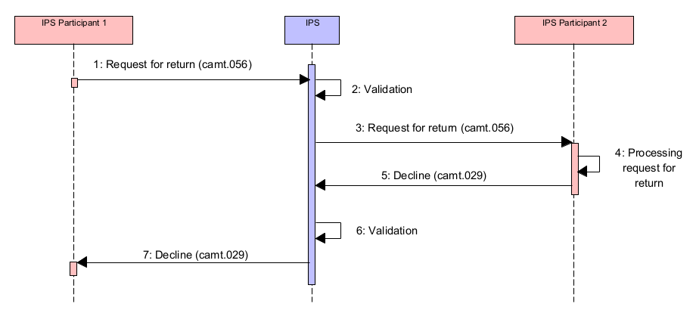
Figure 7. Request for return declined by IPS Participant 2 – Receiver of Request for return
Table 28. Diagram description. Request for return declined by IPS Participant 2 – Receiver of Request for return
## | Description | Message type | Sample item
1-3 | Same as at the previous diagram above in section 0
4 | IPS Participant 2 (Creditor Party in original payment) processes the request and decides to reject a request fro return payment.
5 | IPS Participant 2 (Creditor Party in original payment) sends Request for return Decline message to IPS | camt.029 | 4.4.2.1
6 | IPS validates Request for return Decline message | See IPS rejection section | 5.3
7 | IPS delivers response on request for return to IPS Participant 1 (Sender of Request fro return and Debtor Party in original payment) | camt.029 | 4.4.2.1

      - Decline of payment return request: camt.029
Participant BBBBPYPX decides to reject received return request by generating camt.029 message.
<Document xmlns="urn:iso:std:iso:20022:tech:xsd:camt.029.001. 11">
<RsltnOfInvstgtn>
<Assgnmt>
<!-- Query message unique reference -->
<Id>BBBBPYPXAXXX190929100010000000255</Id>
<Assgnr>
<!-- Query message sender BIC/pseudo-BIC. BICFI for SWIFT-registered participants. -->
<Agt>
<FinInstnId>
<BICFI>BBBBPYPX</BICFI>
</FinInstnId>
</Agt>
</Assgnr>
<Assgne>
<!-- Query message receiver BIC/pseudo-BIC. BICFI for SWIFT-registered participants. -->
<Agt>
<FinInstnId>
<BICFI>AAAAPYPX</BICFI>
</FinInstnId>
</Agt>
</Assgne>
<!-- Query creation local date time -->
<CreDtTm>2019-09-29T09:30:34.232-04:00</CreDtTm>
</Assgnmt>
<!-- Fixed code word. RJCR - Cancellation rejected -->
<Sts>
<Conf>RJCR</Conf>
</Sts>
<CxlDtls>
<!-- References to original cancellation message -->
<OrgnlGrpInfAndSts>
<!-- Original cancellation message query reference as indicated in Assgnmt/Id of camt.056 -->
<OrgnlMsgId>AAAAPYPXAXXX190929100120000001235</OrgnlMsgId>
<!-- Original cancellation message type -->
<OrgnlMsgNmId>camt.056.001.10</OrgnlMsgNmId>
<CxlStsRsnInf>
<!-- Refusal reason as per list of rejection reasons registered in Central System -->
<Rsn>
<Prtry>AM04</Prtry>
</Rsn>
<!-- Additional information about rejection reason -->
<AddtlInf>Insufficient funds</AddtlInf>
</CxlStsRsnInf>
</OrgnlGrpInfAndSts>
</CxlDtls>
</RsltnOfInvstgtn>
</Document>

Request to pay by Creditor
Request to Pay function is initiated by a message pain.013 “Creditor Payment Activation Request”.
If a payment message is sent as a reply on incoming Request to Pay it shall contain a tag /Document/FIToFICstmrCdtTrf/CdtTrfTxInf/RmtInf/Strd/RfrdDocInf/Tp/CdOrPrtry/Prtry with a value ”CPAR”. If this field is present and if this field contains this value, then payment is processed with authorization by Creditor Party.

Approved Request to pay. Successful payment completion (payment is posted)
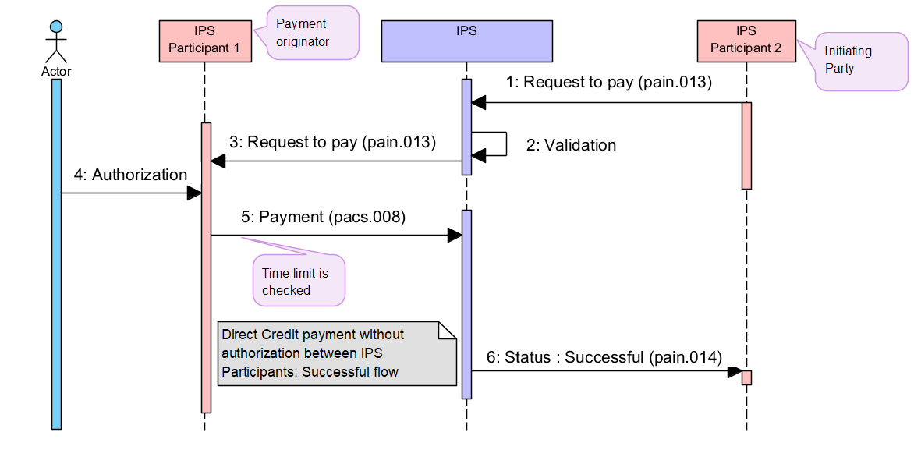
Figure 8. Single Direct Credit payment based on the Request to pay – successful payment execution
Table 29. Diagram description. Single Direct Credit payment based on the Request to pay – successful payment execution
## | Description | Message type | Sample item
1 | IPS Participant 2 as Initiating party, (which will be a Creditor Party in requested payment) sends a Request to pay to IPS to request funds from IPS Participant 1 (which will be a Debtor Party in requested payment). | pain.013 | 4.5.1.1
2 | IPS validates the Request to pay:  - Message format validation  - Security checks  - Access right check.  If any validation is failed, then the message is rejected | See IPS rejection section | 5.4
3 | IPS Participant 1 receives a copy of the request to pay | pain.013 | 4.5.1.1
4 | IPS Participant 1 perfroms authorization with Customer
5 | IPS Participant 1 has decided pay and sends a Direct Credit payment which is processed without authorization | pacs.008 | 4.5.1.2
 | Payment processing flow is described in Section 4.2 above. Payment is processed without authorization by Creditor. Payment is processed successfully
6 | After successful payment completion IPS sends Request to pay status response to IPS Participant 3 informing that payment is successfully processed (Initiator of Payment initiating request). | pain.014 | 4.5.1.3
      - Request to pay: pain.013
<!-- Document -->
<Document xmlns="urn:iso:std:iso:20022:tech:xsd:pain.013.001.09">
<CdtrPmtActvtnReq>
<GrpHdr>
<!-- Unique message reference -->
<MsgId>BBBBPYPXAXXX190929100010000000101</MsgId>
<!-- Message creation date time -->
<CreDtTm>2019-09-29T09:30:47-04:00</CreDtTm>
<!-- Number of transactions to generate. Fixed value = 1 -->
<NbOfTxs>1</NbOfTxs>
<!--Initiating party. Participant who’s sending request for payment to the system.
AnyBIC for swift-registered BICs. Othr/Id – for pseudo-BIC codes (non-swift registered)-->
<InitgPty>
<Id>
<OrgId>
<AnyBIC>BBBBPYPX</AnyBIC>
</OrgId>
</Id>
</InitgPty>
</GrpHdr>
<PmtInf>
<!-- Payment information Id. -->
<PmtInfId>1432423</PmtInfId>
<!-- Payment method: TRF - Credit transfer -->
<PmtMtd>TRF</PmtMtd>
<!-- Requested execution date for payment -->
<ReqdExctnDt>
<Dt>2019-09-29</Dt>
</ReqdExctnDt>

<!--Debtor client information -->
<Dbtr>
<!--Debtor client name -->
<Nm>OPEN SYSTEMS LTD</Nm>
</Dbtr>
<!--Debtor client account -->
<DbtrAcct>
<Id>
<Othr>
<Id>3734500000</Id>
</Othr>
</Id>
</DbtrAcct>

<!--Debtor agent. Participant to be debited in IPS. BICFI for SWIFT-registered participants. ClrSysMmbId/MmbId – for pseudo-BIC codes (non-swift registered)-->
<DbtrAgt>
<FinInstnId>
<BICFI>AAAAPYPX</BICFI>
</FinInstnId>
</DbtrAgt>

<CdtTrfTx>
<!-- Payment identification (to be included into pacs.008) -->
<PmtId>
<EndToEndId>PAYM0001</EndToEndId>
<UETR>b7f1244e-6c96-4c9d-b51e-c420b679a1dc</UETR>
</PmtId>
<!-- Payment type information (to be included into pacs.008) -->
<PmtTpInf>
<!-- Instrument code -->
<LclInstrm>
<Prtry>CSCT</Prtry>
</LclInstrm>
</PmtTpInf>
<!-- Amount in currency to be paid -->
<Amt>
<InstdAmt Ccy="PYG">798771.12</InstdAmt>
</Amt>
<ChrgBr>SLEV</ChrgBr>
<!-- Creditor Agent. BICFI for swift-registered BICs. ClrSysMmbId/MmbId – for pseudo-BIC codes (non-swift registered) -->
<CdtrAgt>
<FinInstnId>
<BICFI>BBBBPYPX</BICFI>
</FinInstnId>
</CdtrAgt>
<!--Creditor client information -->
<Cdtr>
<!--Creditor client name -->
<Nm>GLOBAL CELL 5G</Nm>
</Cdtr>
<!--Creditor client account -->
<CdtrAcct>
<Id>
<Othr>
<Id>Z95A00000000000146403815</Id>
</Othr>
</Id>
</CdtrAcct>
<!-- Ultimate creditor information -->
<UltmtCdtr>
<!-- Customer identification in creditor organization. No MT equivalent -->
<Id>
<PrvtId>
<Othr>
<Id>59581345435454</Id>
<SchmeNm>
<Prtry>ACNT</Prtry>
</SchmeNm>
</Othr>
</PrvtId>
</Id>
</UltmtCdtr>
<!-- Transaction type code, as per list of defined TTCs in Central System -->
<Purp>
<Prtry>020</Prtry>
</Purp>
<!-- Regulatory reporting information -->
<RgltryRptg>
<Dtls>
<Inf>INFORMATIONABOUTPAYMENT-1</Inf>
<Inf>INFORMATIONABOUTPAYMENT-2</Inf>
<Inf>INFORMATIONABOUTPAYMENT-3</Inf>
</Dtls>
</RgltryRptg>
<!-- Remittance information -->
<RmtInf>
<Ustrd>Payment for October 2020</Ustrd>
<Ustrd>EXTRA INFO</Ustrd>
</RmtInf>
</CdtTrfTx>
</PmtInf>
</CdtrPmtActvtnReq>
</Document>

      - Direct Credit payment: pacs.008
NOTE 1: Creditor payment activationrequest message details used for identification are highlighted in brown.

<Document xmlns="urn:iso:std:iso:20022:tech:xsd:pacs.008.001.10">
<FIToFICstmrCdtTrf>
<GrpHdr>
<!--Unique message reference as generated by sending party -->
<MsgId>AAAAPYPXAXXX190929100010000000111</MsgId>
<!-- Message creation date-time -->
<CreDtTm>2019-09-29T09:02:00-04:00</CreDtTm>
<!-- Fixed value <<1>> -->
<NbOfTxs>1</NbOfTxs>
<!-- In this message version: Fixed value CLRG -->
<SttlmInf>
<SttlmMtd>CLRG</SttlmMtd>
</SttlmInf>
</GrpHdr>

<CdtTrfTxInf>
<PmtId>
<!--End-to-End reference. NOTPROVIDED if there no such reference -->
<EndToEndId>PAYM0001</EndToEndId>
<!-- Unique transaction reference as generated by sending party. The same as MsgId in this message version -->
<TxId>AAAAPYPXAXXX190929100010000000111</TxId>
<!-- UETR-->
<UETR>b7f1244e-6c96-4c9d-b51e-c420b679a1dc</UETR>
</PmtId>
<PmtTpInf>
<!--Fixed value RTNS in this message version -->
<ClrChanl>RTNS</ClrChanl>
<!--Local instrument code identifying business process of the payment. Fixed value -->
<LclInstrm>
<Prtry> SCYF-SCCT-RQPY </Prtry>
</LclInstrm>
</PmtTpInf>
<!--Payment amount and currency code -->
<IntrBkSttlmAmt Ccy="PYG">888.</IntrBkSttlmAmt>
<!--Requested payment settlement date -->
<IntrBkSttlmDt>2019-09-29</IntrBkSttlmDt>
<!--Charges bearer indication. -->
<ChrgBr>SLEV</ChrgBr>
<!--Instructing agent. DP who is sending the payment and debited in IPS. BICFI for swift-registered BICs. ClrSysMmbId/MmbId for pseudo-BIC codes (non-swift registered)-->
<InstgAgt>
<FinInstnId>
<BICFI>AAAAPYPX</BICFI>
</FinInstnId>
</InstgAgt>
<!--Instructed agent. DP who is receiving the payment and credited in IPS. BICFI for swift-registered BICs. ClrSysMmbId/MmbId for pseudo-BIC codes (non-swift registered)-->
<InstdAgt>
<FinInstnId>
<BICFI>BBBBPYPX</BICFI>
</FinInstnId>
</InstdAgt>
<!-- Sender of pain.013 -->
<InitgPty>
<Id>
<OrgId>
<AnyBIC>BBBBPYPX></AnyBIC>
</OrgId>
</Id>
</InitgPty>

<!--Debtor client information -->
<Dbtr>
<!--Debtor client name -->
<Nm>OPEN SYSTEMS LTD</Nm>
</Dbtr>

<!--Debtor client account -->
<DbtrAcct>
<Id>
<Othr>
<Id>3734500000</Id>
</Othr>
</Id>
</DbtrAcct>
<!--Debtor agent -->
<DbtrAgt>
<FinInstnId>
<BICFI>AAAAPYPX</BICFI>
</FinInstnId>
</DbtrAgt>
<!--Debtor agent account. -->
<DbtrAgtAcct>
<Id>
<Othr>
<Id>523014000990</Id>
</Othr>
</Id>
</DbtrAgtAcct>
<!--Creditor agent. BICFI for SWIFT-registered participants. ClrSysMmbId/MmbId for pseudo-BIC codes (non-swift registered) -->
<CdtrAgt>
<FinInstnId>
<BICFI>BBBBPYPX</BICFI>
</FinInstnId>
</CdtrAgt>
<!--Creditor agent account. -->
<CdtrAgtAcct>
<Id>
<Othr>
<Id>520008000990</Id>
</Othr>
</Id>
</CdtrAgtAcct>
<!--Creditor client information -->
<Cdtr>
<!--Creditor client name -->
<Nm>Telecom Systems Ltd</Nm>
</Cdtr>
<!--Creditor client account -->
<CdtrAcct>
<Id>
<Othr>
<Id>3854300000</Id>
</Othr>
</Id>
</CdtrAcct>
<!-- Ultimate Creditor client information -->
<UltmtCdtr>
<!-- Ultimate Creditor client name -->
<Nm>Astrid Lungrem</Nm>
<!-- Ultimate Creditor client postal address -->
<Id>
<PrvtId>
<Othr>
<Id>+59523213424</Id>
<SchmeNm>
<Prtry>Phone number</Prtry>
</SchmeNm>
</Othr>
</PrvtId>
</Id>
</UltmtCdtr>

<!--Additional information about payment. -->
<InstrForCdtrAgt>
<InstrInf>Pre-paid payment </InstrInf>
</InstrForCdtrAgt>
<InstrForCdtrAgt>
<InstrInf>according to tariff</InstrInf>
</InstrForCdtrAgt>
<!--Transaction type code as per defined in system dictionary of the codes -->
<Purp>
<Prtry>101</Prtry>
</Purp>
<!--Regulatory reporting -->
<RgltryRptg>
<Dtls>
<Inf>PERIEWRJIWEK</Inf>
</Dtls>
</RgltryRptg>

<!--Remittance information -->
<RmtInf>
<Ustrd>/INV/52</Ustrd>
<Strd>
<RfrdDocInf>
<!-- Fixed code word CPAR in case the transfer is based on pain.013-->
<Tp>
<CdOrPrtry>
<Prtry>CPAR</Prtry>
</CdOrPrtry>
</Tp>
<!-- Reference of pain.013. -->
<Nb>BBBBPYPXAXXX190929100010000000101</Nb>
<!-- Requested execution date of pain.013 -->
<RltdDt>2019-09-29</RltdDt>
</RfrdDocInf>
</Strd>
</RmtInf>
</CdtTrfTxInf>
</FIToFICstmrCdtTrf>
</Document>
      - Request to Pay status report (related payment is successfully processed): pain.014

<!-- Document -->
<Document xmlns="urn:iso:std:iso:20022:tech:xsd:pain.014.001.09">
<CdtrPmtActvtnReqStsRpt>
<GrpHdr>
<!--Unique message identifier generated by IPS -->
<MsgId>BCPAPYPXAIPS190929100010000000144</MsgId>
<!--Message creation date time -->
<CreDtTm>2019-09-29T18:18:01.015-04:00</CreDtTm>
<!-- Party which sent pain.013. AnyBIC for swift-registered BICs. Othr/Id – for pseudo-BIC codes (non-swift registered)-->
<InitgPty>
<Id>
<OrgId>
<AnyBIC>BBBBPYPX</AnyBIC>
</OrgId>
</Id>
</InitgPty>

</GrpHdr>
<!-- References to original pain.013 request -->
<OrgnlGrpInfAndSts>
<!-- Original Message Id from pain.013 -->
<OrgnlMsgId>BBBBPYPXAXXX190929100010000000101</OrgnlMsgId>
<!-- pain.013 full message type -->
<OrgnlMsgNmId>pain.013.001.09</OrgnlMsgNmId>
<!-- pain.013 creation date/time -->
<OrgnlCreDtTm>2019-09-29T09:30:47-04:00</OrgnlCreDtTm>
<!--status of pain.013 -->
<GrpSts>ACSP</GrpSts>
</OrgnlGrpInfAndSts>
</CdtrPmtActvtnReqStsRpt>
</Document>

Approved Request to pay. Unsuccessful payment completion (payment is rejected for any reason)
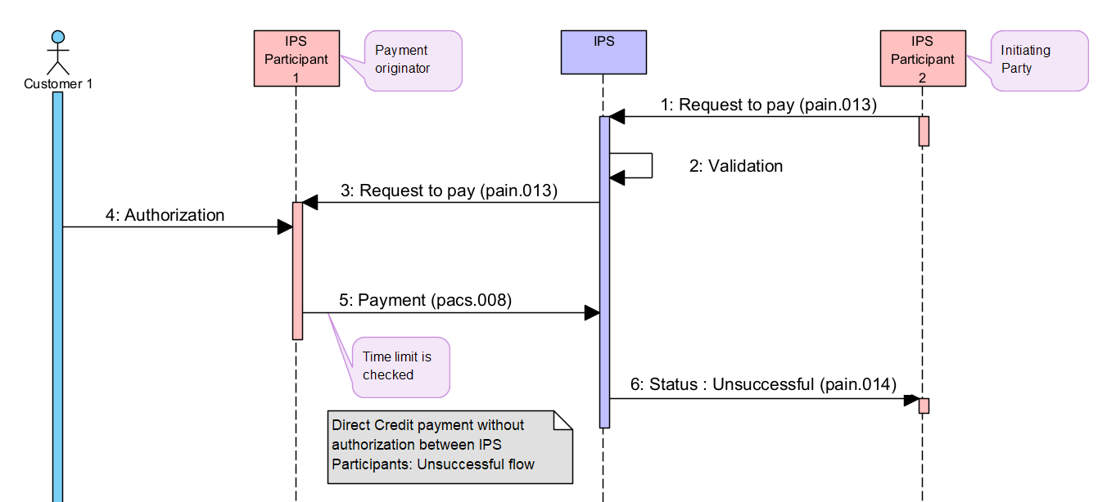

Figure 9. Single Direct Credit payment based on the Request to pay – unsuccessful payment execution
Table 30. Diagram description. Single Direct Credit payment based on the Request to pay – unsuccessful payment execution
## | Description | Message type | Sample item
1-5 | Same as at the previous diagram above in section 4.5.1
 | Payment processing flow is described in Section 4.2 above. Payment is processed without authorization by Creditor. Payment is rejected
6 | After payment rejection IPS sends Request to pay rejection status response to IPS Participant 3 informing that payment is rejected (Initiator of Payment initiating request). | pain.014 | 4.5.2.1
      - Request to pay status report (related payment is rejected): pain.014

<!-- Document -->
<Document xmlns="urn:iso:std:iso:20022:tech:xsd:pain.014.001.09">
<CdtrPmtActvtnReqStsRpt>
<GrpHdr>
<!--Unique message identifier generated by IPS -->
<MsgId> BCPAPYPXAIPS190929100010000000144</MsgId>
<!--Message creation date time -->
<CreDtTm>2019-09-29T18:18:01.015-04:00</CreDtTm>
<!-- Party which sent pain.013. AnyBIC for swift-registered BICs. Othr/Id – for pseudo-BIC codes (non-swift registered)-->
<InitgPty>
<Id>
<OrgId>
<AnyBIC>BBBBPYPX</AnyBIC>
</OrgId>
</Id>
</InitgPty>

</GrpHdr>
<!-- References to original pain.013 request -->
<OrgnlGrpInfAndSts>
<!-- Original Message Id from pain.013 -->
<OrgnlMsgId>BBBBPYPXAXXX190929100010000000101</OrgnlMsgId>
<!-- pain.013 full message type -->
<OrgnlMsgNmId>pain.013.001.09</OrgnlMsgNmId>
<!-- pain.013 creation date/time -->
<OrgnlCreDtTm>2019-09-29T09:30:47-04:00</OrgnlCreDtTm>
<!--status of pain.013 -->
<GrpSts>RJCT</GrpSts>

<StsRsnInf>
<Orgtr>
<Id>
<OrgId>
<AnyBIC>AAAAPYPX</AnyBIC>
</OrgId>
</Id>
</Orgtr>
<!--Reason of rejection -->
<Rsn>
<Prtry>RR01</Prtry>
</Rsn>
<!--Description of rejection -->
<AddtlInf>Missing Debtor Account or</AddtlInf>
<AddtlInf>Identification</AddtlInf>
</StsRsnInf>
</OrgnlGrpInfAndSts>
</CdtrPmtActvtnReqStsRpt>
</Document>

Declined Request to pay
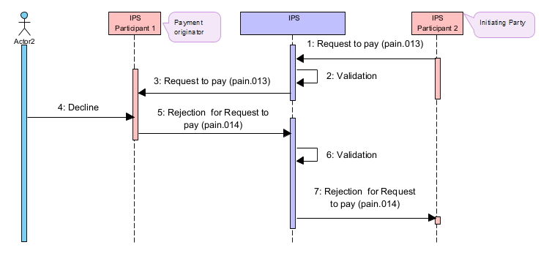
Figure 10. Rejection for Request to pay by IPS Participant 1 - Receiver of Request to pay
Table 31. Diagram description. Rejection for Request to pay by IPS Participant 1 - Receiver of Request to pay
## | Description | Message type | Sample item
1-3 | Same as at the previous diagram above in section 4.5.1
4 | Customer of Participant 1 has decided not to pay and informs Participant 1 about this decision
5 | IPS Participant 1 sends rejection message for Request to pay | pain.014 | 4.5.3.1
6 | IPS validates the Rejection message:  - Message format validation  - Security check  - Access right check.  In addition, IPS checks:  - Existence of Request to pay in IPS database  - Retention period is not expired.  If any validation is failed, then the message is rejected | See IPS rejection section | 5.4
7 | In case of successful validation of Rejection message, IPS Participant 2 receives a rejection status of Request to pay | pain.014 | 4.5.3.2

      - Decline of Request to pay sent by IPS Participant 1 to IPS: pain.014
<!-- Document -->
<Document xmlns="urn:iso:std:iso:20022:tech:xsd:pain.014.001.09">
<CdtrPmtActvtnReqStsRpt>
<GrpHdr>
<!--Unique message identifier generated by IPS -->
<MsgId>BCPAPYPXAIPS190929100010000000144</MsgId>
<!--Message creation date time -->
<CreDtTm>2019-09-29T18:18:01.015-04:00</CreDtTm>
<!-- Party which sent pain.013. AnyBIC for swift-registered BICs. Othr/Id – for pseudo-BIC codes (non-swift registered)-->
<InitgPty>
<Id>
<OrgId>
<AnyBIC>BBBBPYPX</AnyBIC>
</OrgId>
</Id>
</InitgPty>

</GrpHdr>
<!-- References to original pain.013 request -->
<OrgnlGrpInfAndSts>
<!-- Original Message Id from pain.013 -->
<OrgnlMsgId>BBBBPYPXAXXX190929100010000000101</OrgnlMsgId>
<!-- pain.013 full message type -->
<OrgnlMsgNmId>pain.013.001.09</OrgnlMsgNmId>
<!-- pain.013 creation date/time -->
<OrgnlCreDtTm>2019-09-29T09:30:47-04:00</OrgnlCreDtTm>
<!--status of pain.013 -->
<GrpSts>RJCT</GrpSts>
<StsRsnInf>
<Orgtr>
<Id>
<OrgId>
<AnyBIC>AAAAPYPX</AnyBIC>
</OrgId>
</Id>
</Orgtr>
<!--Reason of rejection -->
<Rsn>
<Prtry>RR01</Prtry>
</Rsn>
<!--Description of rejection -->
<AddtlInf>Missing Debtor Account or</AddtlInf>
<AddtlInf>Identification</AddtlInf>
</StsRsnInf>
</OrgnlGrpInfAndSts>
</CdtrPmtActvtnReqStsRpt>
</Document>

      - Decline of Request to pay sent by IPS to IPS Participant 2: pain.014
<!-- Document -->
<Document xmlns="urn:iso:std:iso:20022:tech:xsd:pain.014.001.09">
<CdtrPmtActvtnReqStsRpt>
<GrpHdr>
<!--Unique message identifier generated by IPS -->
<MsgId>BCPAPYPXAIPS190929100010000000144</MsgId>
<!--Message creation date time -->
<CreDtTm>2019-09-29T18:18:01.015-04:00</CreDtTm>
<!-- Party which sent pain.013. AnyBIC for swift-registered BICs. Othr/Id – for pseudo-BIC codes (non-swift registered)-->
<InitgPty>
<Id>
<OrgId>
<AnyBIC>BBBBPYPX</AnyBIC>
</OrgId>
</Id>
</InitgPty>

</GrpHdr>
<!-- References to original pain.013 request -->
<OrgnlGrpInfAndSts>
<!-- Original Message Id from pain.013 -->
<OrgnlMsgId>BBBBPYPXAXXX190929100010000000101</OrgnlMsgId>
<!-- pain.013 full message type -->
<OrgnlMsgNmId>pain.013.001.09</OrgnlMsgNmId>
<!-- pain.013 creation date/time -->
<OrgnlCreDtTm>2019-09-29T09:30:47-04:00</OrgnlCreDtTm>
<!--status of pain.013 -->
<GrpSts>RJCT</GrpSts>
<StsRsnInf>
<Orgtr>
<Id>
<OrgId>
<AnyBIC>AAAAPYPX</AnyBIC>
</OrgId>
</Id>
</Orgtr>
<!--Reason of rejection -->
<Rsn>
<Prtry>RR01</Prtry>
</Rsn>
<!--Description of rejection -->
<AddtlInf>Missing Debtor Account or</AddtlInf>
<AddtlInf>Identification</AddtlInf>
</StsRsnInf>
</OrgnlGrpInfAndSts>
</CdtrPmtActvtnReqStsRpt>
</Document>

Timeout on Request to pay
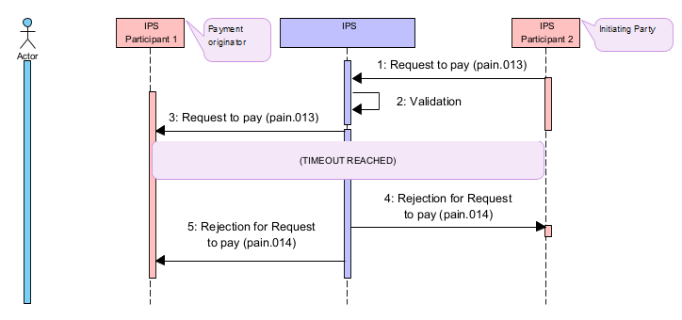
Figure 11. Rejection for Request to pay by IPS Participant 1 - Timeout
Table 32.Diagram description. Rejection for Request to pay by IPS Participant 1 - Timeout
## | Description | Message type | Sample item
1-3 | Same as at the previous diagram above in section 4.5.1
4 | After timeout IPS Participant 1 receives a rejection message of Request to pay | pain.014 | 4.5.4.1
5 | IPS Participant 2 receives a rejection status of Request to pay | pain.014 | 4.5.4.1

      - Decline of Return to Pay: pain.014
<!-- Document -->
<Document xmlns="urn:iso:std:iso:20022:tech:xsd:pain.014.001.09">
<CdtrPmtActvtnReqStsRpt>
<GrpHdr>
<!--Unique message identifier generated by IPS -->
<MsgId>BCPAPYPXAIPS190929100010000000144</MsgId>
<!--Message creation date time -->
<CreDtTm>2019-09-29T18:18:01.015-04:00</CreDtTm>
<!-- Party which sent pain.013. AnyBIC for swift-registered BICs. Othr/Id – for pseudo-BIC codes (non-swift registered)-->
<InitgPty>
<Id>
<OrgId>
<AnyBIC>BBBBPYPX</AnyBIC>
</OrgId>
</Id>
</InitgPty>

</GrpHdr>
<!-- References to original pain.013 request -->
<OrgnlGrpInfAndSts>
<!-- Original Message Id from pain.013 -->
<OrgnlMsgId>BBBBPYPXAXXX190929100010000000101</OrgnlMsgId>
<!-- pain.013 full message type -->
<OrgnlMsgNmId>pain.013.001.09</OrgnlMsgNmId>
<!-- pain.013 creation date/time -->
<OrgnlCreDtTm>2019-09-29T09:30:47-04:00</OrgnlCreDtTm>
<GrpSts>RJCT</GrpSts>
<StsRsnInf>
<Orgtr>
<Id>
<OrgId>
<AnyBIC>BCPAPYPXIPS</AnyBIC>
</OrgId>
</Id>
</Orgtr>
<!--Reason of rejection -->
<Rsn>
<Prtry>EL202</Prtry>
</Rsn>
<!--Description of rejection -->
<AddtlInf>NRT - Rejected by timeout</AddtlInf>
</StsRsnInf>
</OrgnlGrpInfAndSts>
</CdtrPmtActvtnReqStsRpt>
</Document>

Payment Initiation Request
Payment inititation request function is initiated by pain.001 “Customer Credit Transfer Initiation” message.
If a payment message is sent as a reply on incoming Payment initiation request it shall contain a tag /Document/FIToFICstmrCdtTrf/CdtTrfTxInf/RmtInf/Strd/RfrdDocInf/Tp/CdOrPrtry/Prtry with a value ”PAIN”.

Approved Payment Initiation Request. Payment processed successfully (payment is posted)
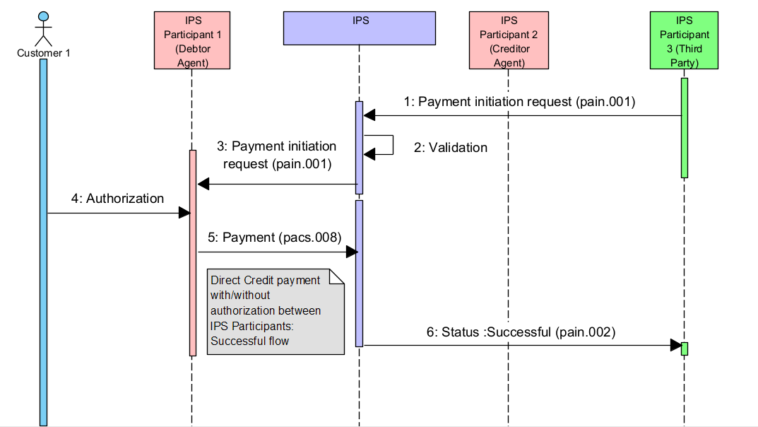
Figure 12. Single Direct Credit payment based on the Payment initiation request – successful payment execution
Table 33. Diagram description. Single Direct Credit payment based on the Payment initiation request – successful payment execution
## | Description | Message type | Sample item
1 | IPS Participant 3 (PISP) as Initiating party sends Payment initiation Request to IPS to request funds from IPS Participant 1 (which will be a Debtor Party in requested payment) | pain.001 | 4.6.1.1
2 | IPS validates payment initiation request:  - Message format validation  - Security check  - Access right check.  If any validation is failed, then the message is rejected | See IPS rejection section | 5.6
3 | IPS routes Payment initiation request to IPS Participant 1.  IPS Participant 1 shall issue a Direct Credit payment after Payment initiation request internal approval | pain.001 | 4.6.1.1
4 | IPS Participant 1 perfroms authorization with Customer
5 | IPS Participant 1 has decided pay and sends a Direct Credit payment which is processed with authorization in case of IPS Participant 2 (Creditor Party) works in online mode or without authorization in case of IPS Participant 2 works in offline mode | pacs.008 | 4.6.1.2
 | Payment processing flow is described in Sections 4.1.1 (Direct Credit payment with authorization) or 4.2 (Direct Credit payment without authorization) above. Payment is processed successfully
6 | After successful payment completion IPS sends payment inirtiation status response to IPS Participant 3 (Third Party) informing that payment is successfully processed (Initiator of Payment initiation request). | pain.002 | 4.6.1.3

      - Payment initiation request: pain.001
<Document xmlns="urn:iso:std:iso:20022:tech:xsd:pain.001.001.11">
<CstmrCdtTrfInitn>
<GrpHdr>
<!-- Unique message reference -->
<MsgId>FFFFPYPXAXXX190929100120000001235</MsgId>
<!-- Message creation date time -->
<CreDtTm>2019-09-29T09:30:47.432-04:00</CreDtTm>
<!-- Number of transactions to generate. Fixed value = 1 -->
<NbOfTxs>1</NbOfTxs>
<!-- Initiating party. Participant who’s sending request for payment to the system. AnyBIC for swift-registered BICs. Othr/Id – for pseudo-BIC codes (non-swift registered)-->
<InitgPty>
<Id>
<OrgId>
<AnyBIC>FFFFPYPX</AnyBIC>
</OrgId>
</Id>
</InitgPty>
</GrpHdr>
<PmtInf>
<!-- Payment information Id. Same as Message Id -->
<PmtInfId>FFFFPYPXAXXX190929100120000001235</PmtInfId>
<!-- Payment method: TRF - Credit transfer -->
<PmtMtd>TRF</PmtMtd>
<!-- Requested execution date for payment -->
<ReqdExctnDt>
<Dt>2019-09-29</Dt>
</ReqdExctnDt>
<!-- Debtor client information -->
<Dbtr>
<!-- Debtor name -->
<Nm>Albert Azimov</Nm>
</Dbtr>
<!-- Debtor account code -->
<DbtrAcct>
<Id>
<Othr><Id>PERS-ACNT-AT-BBBBPYPX</Id></Othr>
</Id>
</DbtrAcct>
<!-- Debtor Agent. BICFI for swift-registered BICs. -->
<DbtrAgt>
<FinInstnId>
<BICFI>BBBBPYPX</BICFI>
</FinInstnId>
</DbtrAgt>
<!-- Debtor agent account code (position account). -->
<DbtrAgtAcct>
<Id>
<Othr><Id>BBBBPYPX-ACCOUNT-AT-IPS</Id></Othr>
</Id>
</DbtrAgtAcct>
<ChrgBr>SLEV</ChrgBr>
<!-- Credit transfer transaction information section -->
<CdtTrfTxInf>
<!-- Payment identification (to be included into pacs.008) -->
<PmtId>
<InstrId>PAYMFROMMERCHANT</InstrId>
<EndToEndId>PAYM0001</EndToEndId>
</PmtId>
<!-- Payment type information (to be included into pacs.008) -->
<PmtTpInf>
<!-- Instrument code -->
<LclInstrm>
<Prtry>CSCT</Prtry>
</LclInstrm>
</PmtTpInf>
<!-- Amount in currency to be paid -->
<Amt>
<InstdAmt Ccy="PYG">850.5</InstdAmt>
</Amt>
<!-- Creditor Agent. BICFI for swift-registered BICs. -->
<CdtrAgt>
<FinInstnId>
<BICFI>AAAAPYPX</BICFI>
</FinInstnId>
</CdtrAgt>
<!-- Creditor agent account code (position account) -->
<CdtrAgtAcct>
<Id>
<Othr><Id>AAAAPYPX-ACCOUNT-AT-IPS</Id></Othr>
</Id>
</CdtrAgtAcct>
<!-- Creditor information -->
<Cdtr>
<!-- Creditor name -->
<Nm>Flowers and Gifts Co</Nm>
</Cdtr>
<!-- Creditor account code -->
<CdtrAcct>
<Id>
<Othr><Id>PY02AAAA00000000000181013795</Id></Othr>
</Id>
</CdtrAcct>
<!-- Transaction type code, as per list of defined TTCs in Central System -->
<Purp>
<Prtry>741</Prtry>
</Purp>
<!-- Regulatory reporting information -->
<RgltryRptg>
<Dtls>
<Inf>TAX IS INCLUDED</Inf>
</Dtls>
</RgltryRptg>
<!-- Remittance information. See Data Fields section for more information. -->
<RmtInf>
<Ustrd>Payment for goods</Ustrd>
</RmtInf>
</CdtTrfTxInf>
</PmtInf>
</CstmrCdtTrfInitn>
</Document>

      - Direct Credit payment: pacs.008
NOTE 1: Referenced data to original request to pay message are highlighted in brown.

<Document xmlns="urn:iso:std:iso:20022:tech:xsd:pacs.008.001.10">
<FIToFICstmrCdtTrf>
<GrpHdr>
<!-- Unique message reference as generated by sending party.-->
<MsgId>BBBBPYPXAXXX190929100010000000123</MsgId>
<!-- Document creation date-time -->
<CreDtTm>2019-09-29T18:18:00.432-04:00</CreDtTm>
<!-- Number of payment instructions. Fixed value = 1 -->
<NbOfTxs>1</NbOfTxs>
<!-- Fixed value – settlement done via clearing -->
<SttlmInf>
<SttlmMtd>CLRG</SttlmMtd>
</SttlmInf>
</GrpHdr>
<CdtTrfTxInf>
<PmtId>
<!-- Optional field. Instruction identifier. -->
<InstrId>PAYMFROMMERCHANT</InstrId>
<!-- End-to-End reference. Not verified for uniqueness. -->
<EndToEndId>PAYM0001</EndToEndId>
<!-- Unique transaction identifier. Fill with the same value as MsgId -->
<TxId>BBBBPYPXAXXX190929100010000000123</TxId>
</PmtId>
<PmtTpInf>
<!-- Fixed value RTNS for IPS payments -->
<ClrChanl>RTNS</ClrChanl>
<!-- Local instrument code as specified in pain.001-->
<LclInstrm>
<Prtry>CSCT</Prtry>
</LclInstrm>
</PmtTpInf>
<!-- Payment amount and currency code -->
<IntrBkSttlmAmt Ccy="PYG">850.5</IntrBkSttlmAmt>
<!-- Requested payment settlement date -->
<IntrBkSttlmDt>2019-09-29</IntrBkSttlmDt>
<!-- Charges bearer indication. Fixed value SLEV. -->
<ChrgBr>SLEV</ChrgBr>
<!-- Instructing agent. Participant who’s sending payment to the system. Typically, the same participant as in DebtorAgent tag. BICFI for swift-registered BICs.-->
<InstgAgt>
<FinInstnId>
<BICFI>BBBBPYPX</BICFI>
</FinInstnId>
</InstgAgt>
<!-- Instructed agent. Participant who’s receiving payment. Typically, the same participant as in CreditorAgent tag. BICFI for swift-registered BICs. -->
<InstdAgt>
<FinInstnId>
<BICFI>AAAAPYPX</BICFI>
</FinInstnId>
</InstdAgt>
<!-- Sender of pain.001 -->
<InitgPty>
<Id>
<OrgId>
<AnyBIC>FFFFPYPX</AnyBIC>
</OrgId>
</Id>
</InitgPty>
<Dbtr>
<!-- Debtor client name as specified in pain.001 -->
<Nm>Albert Azimov</Nm>
</Dbtr>
<!-- Debtor client account as specified in pain.001 -->
<DbtrAcct>
<Id>
<Othr><Id>PERS-ACNT-AT-BBBBPYPX</Id></Othr>
</Id>
</DbtrAcct>
<!-- Debtor agent. Participant to be debited in IPS. BICFI for SWIFT-registered participants.-->
<DbtrAgt>
<FinInstnId>
<BICFI>BBBBPYPX</BICFI>
</FinInstnId>
</DbtrAgt>
<!-- Debtor agent account (position account). -->
<DbtrAgtAcct>
<Id>
<Othr><Id>BBBBPYPX-ACCOUNT-AT-IPS</Id></Othr>
</Id>
</DbtrAgtAcct>
<!-- Creditor agent. Participant to be credited in IPS. BICFI for SWIFT-registered participants.-->
<CdtrAgt>
<FinInstnId>
<BICFI>AAAAPYPX</BICFI>
</FinInstnId>
</CdtrAgt>
<!-- Creditor agent account. Account of participant to be credited in IPS. -->
<CdtrAgtAcct>
<Id>
<Othr><Id>AAAAPYPX-ACCOUNT-AT-IPS</Id></Othr>
</Id>
</CdtrAgtAcct>
<!-- Creditor client information as specified in pain.001 -->
<Cdtr>
<!-- Creditor client name as specified in pain.001 -->
<Nm>Flowers and Gifts Co</Nm>
</Cdtr>
<!-- Creditor client account as specified in pain.001 -->
<CdtrAcct>
<Id>
<Othr><Id>PY02AAAA00000000000181013795</Id></Othr>
</Id>
</CdtrAcct>
<!-- Additional information about payment -->
<InstrForCdtrAgt>
<InstrInf>NONE</InstrInf>
</InstrForCdtrAgt>
<!-- Transaction type code as specified in pain.001 -->
<Purp>
<Prtry>741</Prtry>
</Purp>
<!-- Regulatory reporting information as specified in pain.001 -->
<RgltryRptg>
<Dtls>
<Inf>TAX IS INCLUDED</Inf>
</Dtls>
</RgltryRptg>
<RmtInf>
<!-- Unstructured remittance information as specified in pain.001 -->
<Ustrd>Payment for goods</Ustrd>
<Strd>
<!-- Structured remittance information with reference to pain.001 -->
<RfrdDocInf>
<Tp>
<!-- Fixed code word PAIN in case the transfer is based on pain.001-->
<CdOrPrtry>
<Prtry>PAIN</Prtry>
</CdOrPrtry>
</Tp>
<!-- Reference of pain.001 taken from Document/CstmrCdtTrfInitn/GrpHdr/MsgId -->
<Nb>FFFFPYPXAXXX190929100120000001235</Nb>
<RltdDt>2019-09-29</RltdDt>
</RfrdDocInf>
</Strd>
</RmtInf>
</CdtTrfTxInf>
</FIToFICstmrCdtTrf>
</Document>
      - Payment initiation status report (related payment is successfully processed): pain.002
<Document xmlns="urn:iso:std:iso:20022:tech:xsd:pain.002.001.12">
<CstmrPmtStsRpt>
<GrpHdr>
<!-- Unique message identifier generated by IPS -->
<MsgId>BCPAPYPXAIPS190929100010000000123</MsgId>
<!-- Message creation date time -->
<CreDtTm>2019-09-29T18:18:00.543-04:00</CreDtTm>
<!-- Party who is sending pain.001 -->
<InitgPty>
<Id>
<OrgId>
<AnyBIC>FFFFPYPX</AnyBIC>
</OrgId>
</Id>
</InitgPty>
</GrpHdr>
<!-- References to original pain.001 request -->
<OrgnlGrpInfAndSts>
<!-- Original Message Id from pain.001 -->
<OrgnlMsgId>FFFFPYPXAXXX190929100120000001235</OrgnlMsgId>
<!-- pain.001 full message type -->
<OrgnlMsgNmId>pain.001.001.11</OrgnlMsgNmId>
<!-- pain.001 creation date/time -->
<OrgnlCreDtTm>2019-09-29T09:30:47.432-04:00</OrgnlCreDtTm>
<!-- Status of pain.001 request. ACSP - Accepted Settlement is Pending, RJCT - Rejected -->
<GrpSts>ACSP</GrpSts>
</OrgnlGrpInfAndSts>
<OrgnlPmtInfAndSts>
<!-- From the same element of the original message to which the pain.002 is in response. -->
<OrgnlPmtInfId>FFFFPYPXAXXX190929100120000001235</OrgnlPmtInfId>
<TxInfAndSts>
<!-- Original instruction identification from related pacs.008 payment -->
<OrgnlInstrId>PAYMFROMMERCHANT</OrgnlInstrId>
<!-- Original end-to-end identification from related pacs.008 payment -->
<OrgnlEndToEndId>PAYM0001</OrgnlEndToEndId>
<!-- Status of payment related to pain.001 request.
ACSP - Accepted Settlement is Pending, RJCT - Rejected -->
<TxSts>ACSP</TxSts>
<OrgnlTxRef>
<!-- Effective payment amount and currency related to pain.001 -->
<IntrBkSttlmAmt Ccy="PYG">850.5</IntrBkSttlmAmt>
<!-- Requested payment execution date as specified in pain.001 -->
<ReqdExctnDt>
<Dt>2019-09-29</Dt>
</ReqdExctnDt>
<!-- Requested payment instrument type as specified in pain.001 -->
<PmtTpInf>
<LclInstrm>
<Prtry>CSCT</Prtry>
</LclInstrm>
</PmtTpInf>
<!-- Payment method: TRF - Credit transfer -->
<PmtMtd>TRF</PmtMtd>
</OrgnlTxRef>
</TxInfAndSts>
</OrgnlPmtInfAndSts>
</CstmrPmtStsRpt>
</Document>

Approved Payment initiation request. Unsuccessful payment completion (payment is rejected for any reason)
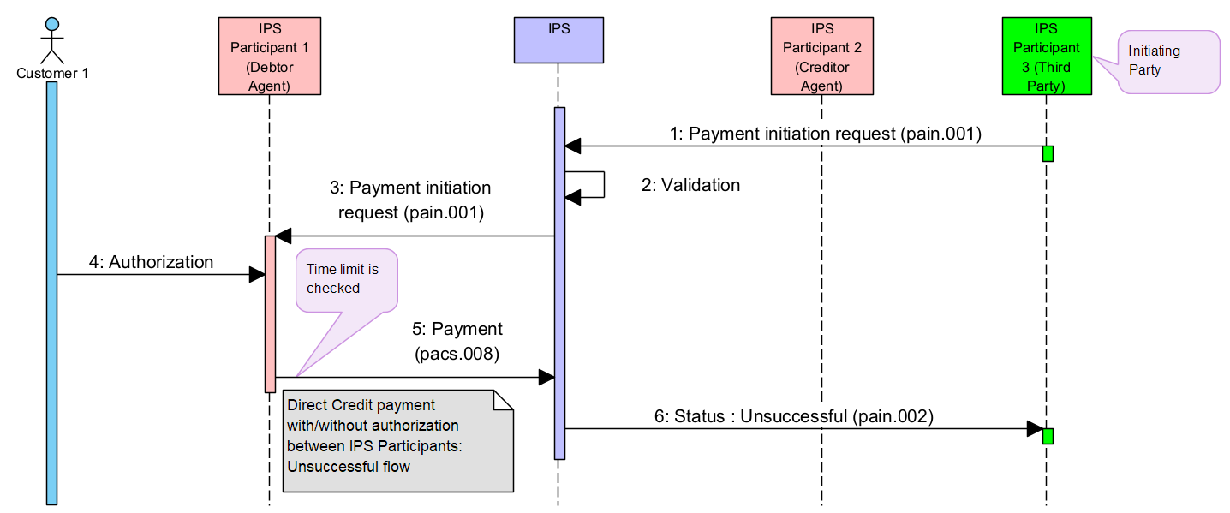
Figure 13. Single Direct Credit payment based on the Payment initiation request – unsuccessful payment execution
Table 34.. Diagram description. Single Direct Credit payment based on the Payment initiation request – unsuccessful payment execution
## | Description | Message type | Sample item
1-5 | Same as at the previous diagram above in section 4.6.1
 | Payment processing flow is described in Sections 4.1.2, 4.1.3 (Direct Credit payment with authorization) or 4.2 (Direct Credit payment without authorization) above. Payment is rejected
6 | After payment rejection IPS sends payment initiation rejection status response to IPS Participant 3 (Third Party) informing that payment is rejected (Initiator of Payment initiation request) | pain.002 | 4.6.2.1

      - Payment initiation status report (realted payment is rejected): pain.002
<Document xmlns="urn:iso:std:iso:20022:tech:xsd:pain.002.001.12">
<CstmrPmtStsRpt>
<GrpHdr>
<!-- Unique message identifier generated by IPS -->
<MsgId>BCPAPYPXAIPS190929100010000000123</MsgId>
<!-- Message creation date time -->
<CreDtTm>2019-09-29T18:18:00.543-04:00</CreDtTm>
<!-- Party whos sending pain.001 -->
<InitgPty>
<Id>
<OrgId>
<AnyBIC>FFFFPYPX</AnyBIC>
</OrgId>
</Id>
</InitgPty>
</GrpHdr>
<!-- References to original pain.001 request -->
<OrgnlGrpInfAndSts>
<!-- Original Message Id from pain.001 -->
<OrgnlMsgId>FFFFPYPXAXXX190929100120000001235</OrgnlMsgId>
<!-- pain.001 full message type -->
<OrgnlMsgNmId>pain.001.001.11</OrgnlMsgNmId>
<!-- pain.001 creation date/time -->
<OrgnlCreDtTm>2019-09-29T09:30:47.432-04:00</OrgnlCreDtTm>
<!-- Status of pain.001 request. ACSP - Accepted Settlement is Pending, RJCT - Rejected -->
<GrpSts>RJCT</GrpSts>
<StsRsnInf>
<Orgtr>
<Id>
<OrgId>
<AnyBIC>BCPAPYPXIPS</AnyBIC>
</OrgId>
</Id>
</Orgtr>
<!-- Reject reason code as per agreed between participants and registered in Central systems dictionary -->
<Rsn>
<Prtry>EA15</Prtry>
</Rsn>
<!-- Reject reason additional information -->
<AddtlInf>Account code not found</AddtlInf>
</StsRsnInf>
</OrgnlGrpInfAndSts>
<OrgnlPmtInfAndSts>
<!-- From the same element of the original message to which the pain.002 is in response. -->
<OrgnlPmtInfId>FFFFPYPXAXXX190929100120000001235</OrgnlPmtInfId>
<TxInfAndSts>
<!-- Original instruction identification from related pacs.008 payment -->
<OrgnlInstrId>PAYMFROMMERCHANT</OrgnlInstrId>
<!-- Original end-to-end identification from related pacs.008 payment -->
<OrgnlEndToEndId>PAYM0001</OrgnlEndToEndId>
<!-- Status of payment related to pain.001 request. ACSP - Accepted Settlement is Pending, RJCT - Rejected -->
<TxSts>RJCT</TxSts>
<StsRsnInf>
<Orgtr>
<Id>
<OrgId>
<AnyBIC>BCPAPYPXIPS</AnyBIC>
</OrgId>
</Id>
</Orgtr>
<!-- Reject reason code as per agreed between participants and registered in Central systems dictionary -->
<Rsn>
<Prtry>EA15</Prtry>
</Rsn>
<!-- Reject reason additional information -->
<AddtlInf>Account code not found</AddtlInf>
</StsRsnInf>
<OrgnlTxRef>
<!-- Effective payment amount and currency related to pain.001 -->
<IntrBkSttlmAmt Ccy="PYG">850.5</IntrBkSttlmAmt>
<!-- Requested payment execution date as specified in pain.001 -->
<ReqdExctnDt>
<Dt>2019-09-29</Dt>
</ReqdExctnDt>
<!-- Requested payment instrument type as specified in pain.001 -->
<PmtTpInf>
<LclInstrm>
<Prtry>CSCT</Prtry>
</LclInstrm>
</PmtTpInf>
<!-- Payment method: TRF - Credit transfer -->
<PmtMtd>TRF</PmtMtd>
</OrgnlTxRef>
</TxInfAndSts>
</OrgnlPmtInfAndSts>
</CstmrPmtStsRpt>
</Document>

Declined Payment initiation request
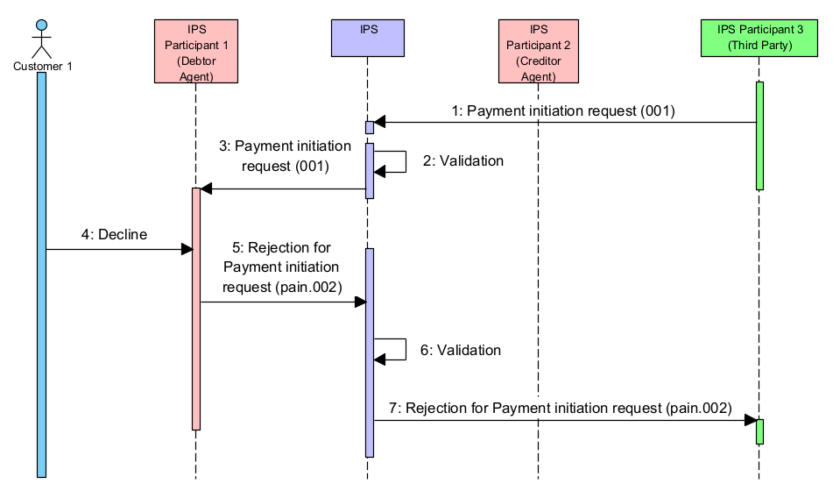
Figure 14. Rejection for Payment initiation request by IPS Participant 1 - Receiver of Payment initiation request
Table 35.Diagram description. Rejection for Payment initiation request by IPS Participant 1 - Receiver of Payment initiation request
## | Description | Message type | Sample item
1-3 | Same as at the previous diagram above in section 4.6.1
4 | Customer of Participant 1 has decided not to pay and informs Participant 1 about this decision
5 | Based on Decline from its Customer 1, IPS Participant 1 has decided not to pay and sends rejection message for Payment Initiation request | pain.002 | 4.6.3.1
6 | IPS validates the Rejection message:  - Message format validation  - Security check  - Access right check.  In addition, IPS checks:  - Existence of Payment initiation request in IPS database  - Retention period is not expired.  If any validation is failed, then the message is rejected | See IPS rejection section | 5.6
7 | In case of successful validation of Rejection message, IPS Participant 3 (Third Party) receives a rejection message of Payment Initiation request | pain.002 | 4.6.3.2

      - Decline of Payment Initiation request sent by IPS Participant 1 to IPS: pain.002
<Document xmlns="urn:iso:std:iso:20022:tech:xsd:pain.002.001.12">
<CstmrPmtStsRpt>
<GrpHdr>
<!-- Unique message identifier -->
<MsgId>BBBBPYPXAXXX190929100010000000250</MsgId>
<!-- Message creation date time -->
<CreDtTm>2019-09-29T18:18:00.543-04:00</CreDtTm>
<!-- Party whos sending pain.001 -->
<InitgPty>
<Id>
<OrgId>
<AnyBIC>FFFFPYPX</AnyBIC>
</OrgId>
</Id>
</InitgPty>

</GrpHdr>
<!-- References to original pain.001 request -->
<OrgnlGrpInfAndSts>
<!-- Original Message Id from pain.001 -->
<OrgnlMsgId>FFFFPYPXAXXX190929100120000001235</OrgnlMsgId>
<!-- pain.001 full message type -->
<OrgnlMsgNmId>pain.001.001.11</OrgnlMsgNmId>
<!-- pain.001 creation date/time -->
<OrgnlCreDtTm>2019-09-29T09:30:47.232-04:00</OrgnlCreDtTm>
<StsRsnInf>
<!-- Fixed codeword NAUT indicating that this message is a refusal -->
<Rsn>
<Prtry>NAUT</Prtry>
</Rsn>
</StsRsnInf>
</OrgnlGrpInfAndSts>
<OrgnlPmtInfAndSts>
<!-- From the same element of the original message to which the pain.002 is in response. -->
<OrgnlPmtInfId>FFFFPYPXAXXX190929100120000001235</OrgnlPmtInfId>
<TxInfAndSts>
<StsRsnInf>
<!-- Reject reason code as per agreed between participants and registered in Central systems dictionary -->
<Rsn>
<Prtry>AM04</Prtry>
</Rsn>
<!-- Reject reason additional information -->
<AddtlInf>Wrong amount</AddtlInf>
</StsRsnInf>
<OrgnlTxRef>
<!-- Requested payment execution date as specified in pain.001 -->
<ReqdExctnDt>
<Dt>2019-09-29</Dt>
</ReqdExctnDt>
</OrgnlTxRef>
</TxInfAndSts>
</OrgnlPmtInfAndSts>
</CstmrPmtStsRpt>
</Document>

      - Decline of Request to pay sent by IPS to IPS Participant 3 (Third Party): pain.002
<Document xmlns="urn:iso:std:iso:20022:tech:xsd:pain.002.001.12">
<CstmrPmtStsRpt>
<GrpHdr>
<!-- Unique message identifier generated by IPS -->
<MsgId>BCPAPYPXAIPS190929100010000000250</MsgId>
<!-- Message creation date time -->
<CreDtTm>2019-09-29T18:18:01.223-04:00</CreDtTm>
<!-- Party whos sending pain.001 -->
<InitgPty>
<Id>
<OrgId>
<AnyBIC>FFFFPYPX</AnyBIC>
</OrgId>
</Id>
</InitgPty>
</GrpHdr>
<OrgnlGrpInfAndSts>
<!-- Original Message Id from pain.001 -->
<OrgnlMsgId>FFFFPYPXAXXX190929100120000001235</OrgnlMsgId>
<!-- pain.001 full message type -->
<OrgnlMsgNmId>pain.001.001.11</OrgnlMsgNmId>
<!-- pain.001 creation date/time -->
<OrgnlCreDtTm>2019-09-29T09:30:47.432-04:00</OrgnlCreDtTm>
<!-- Status of pain.001 request. ACSP - Accepted Settlement is Pending, RJCT - Rejected -->
<GrpSts>RJCT</GrpSts>
</OrgnlGrpInfAndSts>
<OrgnlPmtInfAndSts>
<!-- From the same element of the original message to which the pain.002 is in response. -->
<OrgnlPmtInfId>FFFFPYPXAXXX190929100120000001235</OrgnlPmtInfId>
<TxInfAndSts>
<!-- Original instruction identification from related pacs.008 payment -->
<OrgnlInstrId>PAYMFROMMERCHANT</OrgnlInstrId>
<!-- Original end-to-end identification from related pacs.008 payment -->
<OrgnlEndToEndId>PAYM0001</OrgnlEndToEndId>
<!-- Status of pain.001 request. ACSP - Accepted Settlement is Pending, RJCT - Rejected -->
<TxSts>RJCT</TxSts>
<StsRsnInf>
<!-- Error code generated by Central system -->
<Rsn>
<Prtry>EA178</Prtry>
</Rsn>
<!-- Reject reason additional information -->
<AddtlInf>Rejected by authorizer</AddtlInf>
</StsRsnInf>
<StsRsnInf>
<!-- Reject reason code as per agreed between participants and registered in Central systems dictionary -->
<Rsn>
<Prtry>AM04</Prtry>
</Rsn>
<!-- Reject reason additional information -->
<AddtlInf>Wrong amount</AddtlInf>
</StsRsnInf>
<OrgnlTxRef>
<!-- Effective payment amount and currency related to pain.001 -->
<IntrBkSttlmAmt Ccy="PYG">850.5</IntrBkSttlmAmt>
<!-- Requested payment execution date as specified in pain.001 -->
<ReqdExctnDt>
<Dt>2019-09-29</Dt>
</ReqdExctnDt>
<PmtTpInf>
<!-- Requested payment instrument type as specified in pain.001 -->
<LclInstrm>
<Prtry>CSCT</Prtry>
</LclInstrm>
</PmtTpInf>
<!-- Payment method: TRF - Credit transfer -->
<PmtMtd>TRF</PmtMtd>
</OrgnlTxRef>
</TxInfAndSts>
</OrgnlPmtInfAndSts>
</CstmrPmtStsRpt>
</Document>

Timeout on Payment initiation request
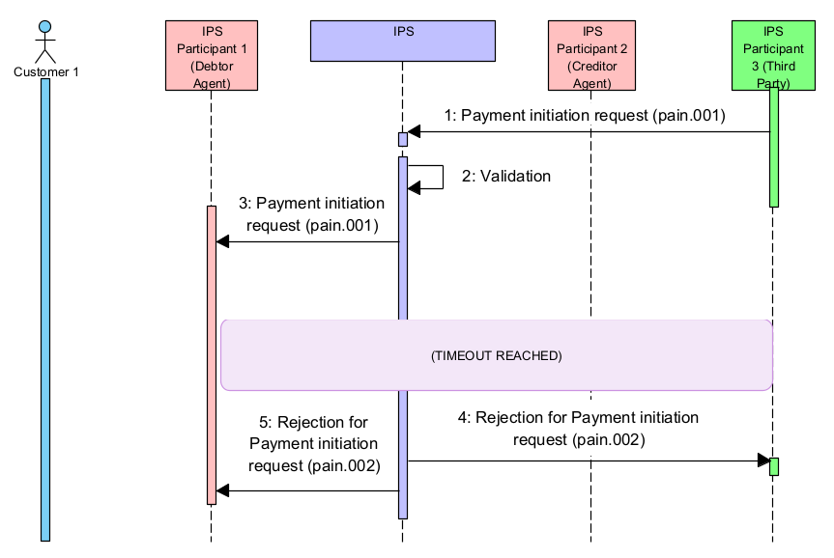
Figure 15. Rejection for Payment initiation request by IPS Participant 1 – Timeout
Table 36. Diagram description. Rejection for Payment initiation request by IPS Participant 1 – Timeout
## | Description | Message type | Sample item
1-3 | Same as at the previous diagram above in section 4.6.1
4 | After timeout IPS Participant 1 receives a rejection message of Payment Initiation request | pain.002 | 4.6.4.1
5 | IPS Participant 3 (Third Party) receives a rejection status of Payment Initiation request | pain.002 | 4.6.4.1

      - Decline of Payment Initiation request: pain.002
<Document xmlns="urn:iso:std:iso:20022:tech:xsd:pain.002.001.12">
<CstmrPmtStsRpt>
<GrpHdr>
<!-- Unique message identifier generated by IPS -->
<MsgId>BCPAPYPXAIPS190929100010000000250</MsgId>
<!-- Message creation date time -->
<CreDtTm>2019-09-29T18:18:01.223-04:00</CreDtTm>
<!-- Party whos sending pain.001 -->
<InitgPty>
<Id>
<OrgId>
<AnyBIC>FFFFPYPX</AnyBIC>
</OrgId>
</Id>
</InitgPty>
</GrpHdr>
<OrgnlGrpInfAndSts>
<!-- Original Message Id from pain.001 -->
<OrgnlMsgId>FFFFPYPXAXXX190929100120000001235</OrgnlMsgId>
<!-- pain.001 full message type -->
<OrgnlMsgNmId>pain.001.001.11</OrgnlMsgNmId>
<!-- pain.001 creation date/time -->
<OrgnlCreDtTm>2019-09-29T09:30:47.432-04:00</OrgnlCreDtTm>
<!-- Status of pain.001 request. ACSP - Accepted Settlement is Pending, RJCT - Rejected -->
<GrpSts>RJCT</GrpSts>
</OrgnlGrpInfAndSts>
<OrgnlPmtInfAndSts>
<!-- From the same element of the original message to which the pain.002 is in response. -->
<OrgnlPmtInfId>FFFFPYPXAXXX190929100120000001235</OrgnlPmtInfId>
<TxInfAndSts>
<!-- Original instruction identification from related pacs.008 payment -->
<OrgnlInstrId>PAYMFROMMERCHANT</OrgnlInstrId>
<!-- Original end-to-end identification from related pacs.008 payment -->
<OrgnlEndToEndId>PAYM0001</OrgnlEndToEndId>
<!-- Status of pain.001 request. ACSP - Accepted Settlement is Pending, RJCT - Rejected -->
<TxSts>RJCT</TxSts>
<StsRsnInf>
<!-- Reject reason code as per agreed between participants and registered in Central systems dictionary -->
<Rsn>
<Prtry>EL202</Prtry>
</Rsn>
<!-- Reject reason additional information -->
<AddtlInf>NRT - Rejected by timeout</AddtlInf>
</StsRsnInf>
<OrgnlTxRef>
<!-- Effective payment amount and currency related to pain.001 -->
<IntrBkSttlmAmt Ccy="PYG">850.5</IntrBkSttlmAmt>
<!-- Requested payment execution date as specified in pain.001 -->
<ReqdExctnDt>
<Dt>2019-09-29</Dt>
</ReqdExctnDt>
<PmtTpInf>
<!-- Requested payment instrument type as specified in pain.001 -->
<LclInstrm>
<Prtry>CSCT</Prtry>
</LclInstrm>
</PmtTpInf>
<!-- Payment method: TRF - Credit transfer -->
<PmtMtd>TRF</PmtMtd>
</OrgnlTxRef>
</TxInfAndSts>
</OrgnlPmtInfAndSts>
</CstmrPmtStsRpt>
</Document>

Payment status request from Payment Sender
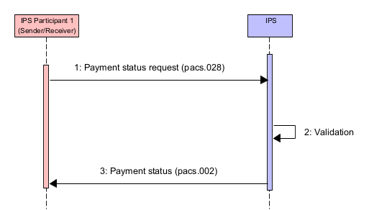
Figure 16. Payment status request
Table 37. Diagram description. Payment status request
## | Description | Message type | Sample item
1 | IPS Participant 1(Sender/Receiver) sends payment status request to IPS. The request to contain fields from the original payment:  - Payment reference  - Payment value date  - Debtor agent  - Creditor agent | pacs.028 | 4.7.1.1
2 | IPS performs validation that includes:  - Message format validation  - Security check  - Access right check.  In addition, IPS validates:  - Existence of original payment in IPS database.  If any validation is failed, then the message is rejected | See IPS rejection section | 5.9
3 | IPS delivers requested payment status to IPS Participant 1(Sender/Receiver) | pacs.002 | 4.7.1.2

      - Request to get payment status: pacs.028
<Document xmlns="urn:iso:std:iso:20022:tech:xsd:pacs.028.001.05">
<FIToFIPmtStsReq>
<GrpHdr>
<!-- Query message unique reference -->
<MsgId>AAAAPYPXAXXX190929100120000001235</MsgId>
<!-- Message creation local date time -->
<CreDtTm>2019-09-29T14:08:48.232-04:00</CreDtTm>
</GrpHdr>
<OrgnlGrpInf>
<!-- Original payment message unique reference -->
<OrgnlMsgId>AAAAPYPXAXXX190929100120000001230</OrgnlMsgId>
<!-- Original payment message type -->
<OrgnlMsgNmId>pacs.008.001.10</OrgnlMsgNmId>
<!-- Original payment message creation date time -->
<OrgnlCreDtTm>2019-09-29T10:40:40.232-04:00</OrgnlCreDtTm>
</OrgnlGrpInf>
<TxInf>
<!-- Transaction identifier as in original payment message -->
<OrgnlTxId>AAAAPYPXAXXX190929100120000001230</OrgnlTxId>
<InstgAgt>
<FinInstnId>
<!-- Original payment sender participant. BICFI for swift-registered BICs. -->
<BICFI>AAAAPYPX</BICFI>
</FinInstnId>
</InstgAgt>
<OrgnlTxRef>
<!-- Original payment settlement date -->
<IntrBkSttlmDt>2019-09-29</IntrBkSttlmDt>
</OrgnlTxRef>
</TxInf>
</FIToFIPmtStsReq>
</Document>

      - Successful reply on request to get payment status: pacs 002
<Document xmlns="urn:iso:std:iso:20022:tech:xsd:pacs.002.001.12">
<FIToFIPmtStsRpt>
<GrpHdr>
<!-- Unique message identifier generated by IPS -->
<MsgId>BCPAPYPXAIPS190929000010000001230</MsgId>
<!-- Message creation local date time -->
<CreDtTm>2019-09-29T14:08:49.232-04:00</CreDtTm>
<OrgnlBizQry>
<MsgId>AAAAPYPXAXXX190929100120000001235</MsgId>
<MsgNmId>028.001.05</MsgNmId>
</OrgnlBizQry>
</GrpHdr>
<OrgnlGrpInfAndSts>
<!-- As taken from pacs.008 FIToFICstmrCdtTrf/GrpHdr/MsgId -->
<OrgnlMsgId>AAAAPYPXAXXX190929100120000001230</OrgnlMsgId>
<!-- Type of original message to refer -->
<OrgnlMsgNmId>pacs.008.001.10</OrgnlMsgNmId>
<!-- As taken from pacs.008 FIToFICstmrCdtTrf/GrpHdr/CreDtTm -->
<OrgnlCreDtTm>2019-09-29T10:40:40.232-04:00</OrgnlCreDtTm>
<!-- Transaction processing result. ACSP – Settled -->
<GrpSts>ACSP</GrpSts>
</OrgnlGrpInfAndSts>
<TxInfAndSts>
<!-- As taken from pacs.008 FIToFICstmrCdtTrf/CdtTrfTxInf/PmtId/InstrId -->
<OrgnlInstrId>20190929-18180001</OrgnlInstrId>
<!-- As taken from pacs.008 FIToFICstmrCdtTrf/CdtTrfTxInf/PmtId/EndToEndId -->
<OrgnlEndToEndId>NOTPROVIDED</OrgnlEndToEndId>
<!-- As taken from pacs.008 FIToFICstmrCdtTrf/CdtTrfTxInf/PmtId/TxId -->
<OrgnlTxId>AAAAPYPXAXXX190929100120000001230</OrgnlTxId>
<!-- Transaction processing result. ACSP – Settled -->
<TxSts>ACSP</TxSts>
<!-- Instructing agent. The IPS system. -->
<InstgAgt>
<FinInstnId>
<BICFI>BCPAPYPXIPS</BICFI>
</FinInstnId>
</InstgAgt>
<!-- Instructed agent. Participant who sent original payment to the system. BICFI for swift-registered BICs. -->
<InstdAgt>
<FinInstnId>
<BICFI>AAAAPYPX</BICFI>
</FinInstnId>
</InstdAgt>
<OrgnlTxRef>
<!-- Original payment amount and currency -->
<IntrBkSttlmAmt Ccy="PYG">71.12</IntrBkSttlmAmt>
<!-- Settlement date of original payment -->
<IntrBkSttlmDt>2019-09-29</IntrBkSttlmDt>
</OrgnlTxRef>
</TxInfAndSts>
</FIToFIPmtStsRpt>
</Document>

Payment copy request
Payment copy request can be sent by any participant for own payments (sent or received by the participant).
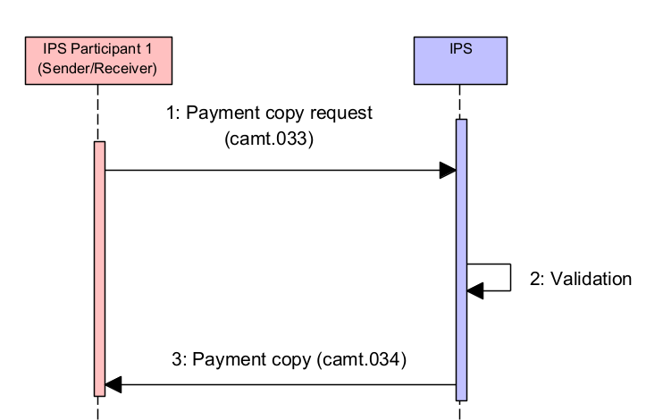
Figure 17. Payment copy request
Table 38.Diagram description. Payment copy request
## | Description | Message type | Sample item
1 | IPS Participant 1(Sender/Receiver) sends payment copy request to IPS. The request to contain fields from the original payment:  - Payment reference  - Payment value date  - Debtor agent  - Creditor agent | camt.033 | 4.8.1.1
2 | IPS performs validation that includes:  - Message format validation  - Security check  - Access right check.  In addition, IPS validates:  - Existence of original payment in IPS database.  If any validation is failed, then the message is rejected | See IPS rejection section | 5.9
3 | IPS delivers copy of the requested payment to IPS Participant 1(Sender/Receiver) | camt.034 | 4.8.1.2

      - Request to get payment copy: camt. 033

<Document xmlns="urn:iso:std:iso:20022:tech:xsd:camt.033.001.06">
<ReqForDplct>
<Assgnmt>
<!-- Query message unique reference -->
<Id>AMAMPYPAAXXX211013100120000001240</Id>
<Assgnr>
<!-- Query sender participant. BICFI for swift-registered BICs. -->
<Agt>
<FinInstnId>
<BICFI>AMAMPYPA</BICFI>
</FinInstnId>
</Agt>
</Assgnr>
<Assgne>
<!-- Query receiver participant. Must be system BIC.
BICFI for swift-registered BICs. -->
<Agt>
<FinInstnId>
<BICFI>BCPAPYPRIPS</BICFI>
</FinInstnId>
</Agt>
</Assgne>
<!-- Query creation local date-time -->
<CreDtTm>2021-10-13T00:27:25-04:00</CreDtTm>
</Assgnmt>
<Case>
<!-- Query message unique reference. Recommendation to indicate same value as in Assgnmt/Id if there is no any internal code to be used -->
<Id>AMAMPYPAAXXX211013100120000001240</Id>
<Cretr>
<!-- Query sender participant. BICFI for swift-registered BICs. -->
<Agt>
<FinInstnId>
<BICFI>AMAMPYPA</BICFI>
</FinInstnId>
</Agt>
</Cretr>
</Case>
<SplmtryData>
<PlcAndNm>cma.paymentSearch.001.02</PlcAndNm>
<Envlp>
<Document xmlns="urn:cma:xsd:cma.paymentSearch.001.02">
<PmtSch>
<!-- Original payment message unique reference -->
<MsgId>AMAMPYPADXXX180217100330000002060</MsgId>
<ShrtBizId>
<!-- Original payment settlement date -->
<IntrBkSttlmDt>2022-04-12</IntrBkSttlmDt>
<!-- Original payment sender participant. BICFI for swift-registered BICs. -->
<InstgAgt>
<FinInstnId>
<BICFI>AMAMPYPA</BICFI>
</FinInstnId>
</InstgAgt>
</ShrtBizId>
</PmtSch>
</Document>
</Envlp>
</SplmtryData>
</ReqForDplct>
</Document>

      - Successful reply on request to get payment copy: camt.034

<Document xmlns="urn:iso:std:iso:20022:tech:xsd:camt.034.001.06">
<Dplct>
<Assgnmt>
<Id>Q37403306/n96</Id>
<Assgnr>
<Agt>
<FinInstnId>
<BICFI>BCPAPYPRIPS</BICFI>
</FinInstnId>
</Agt>
</Assgnr>
<Assgne>
<Agt>
<FinInstnId>
<BICFI>AMAMPYPA</BICFI>
</FinInstnId>
</Agt>
</Assgne>
<CreDtTm>2022-04-15T16:56:46.860</CreDtTm>
</Assgnmt>
<Case>
<Id>AMAMPYPAAXXX211013100120000001240</Id>
<Cretr>
<Agt>
<FinInstnId>
<BICFI>AMAMPYPA</BICFI>
</FinInstnId>
</Agt>
</Cretr>
</Case>
<Dplct>
<Tp>pacs.008.001.10</Tp>
<Data>
<Any>
<Document xmlns="urn:iso:std:iso:20022:tech:xsd:pacs.008.001.10">
<FIToFICstmrCdtTrf>
<GrpHdr>
<MsgId>AMAMPYPADXXX180217100330000002060</MsgId>
<CreDtTm>2022-03-18T18:18:00.423</CreDtTm>
<NbOfTxs>1</NbOfTxs>
<SttlmInf>
<SttlmMtd>CLRG</SttlmMtd>
</SttlmInf>
</GrpHdr>
<CdtTrfTxInf>
<PmtId>
<EndToEndId>NOTPROVIDED</EndToEndId>
<TxId>AMAMPYPADXXX180217100330000002060</TxId>
</PmtId>
<PmtTpInf>
<ClrChanl>RTNS</ClrChanl>
<LclInstrm>
<Prtry>CSCT</Prtry>
</LclInstrm>
</PmtTpInf>
<IntrBkSttlmAmt Ccy="PYG">100</IntrBkSttlmAmt>
<IntrBkSttlmDt>2022-04-12</IntrBkSttlmDt>
<ChrgBr>SLEV</ChrgBr>
<InstgAgt>
<FinInstnId>
<ClrSysMmbId>
<MmbId>AMAMPYPA</MmbId>
</ClrSysMmbId>
</FinInstnId>
</InstgAgt>
<InstdAgt>
<FinInstnId>
<BICFI>BBVAPYPA</BICFI>
</FinInstnId>
</InstdAgt>
<Dbtr>
<Nm>Cédula de Identidad</Nm>
</Dbtr>
<DbtrAcct>
<Id>
<Othr>
<Id>PK36SCBL0000001123456702</Id>
</Othr>
</Id>
</DbtrAcct>
<DbtrAgt>
<FinInstnId>
<ClrSysMmbId>
<MmbId>AMAMPYPA</MmbId>
</ClrSysMmbId>
</FinInstnId>
</DbtrAgt>
<DbtrAgtAcct>
<Id>
<Othr>
<Id>AMAMP001PYG</Id>
</Othr>
</Id>
</DbtrAgtAcct>
<CdtrAgt>
<FinInstnId>
<BICFI>BBVAPYPA</BICFI>
</FinInstnId>
</CdtrAgt>
<CdtrAgtAcct>
<Id>
<Othr>
<Id>BBVAP001PYG</Id>
</Othr>
</Id>
</CdtrAgtAcct>
<Cdtr>
<Nm>Boris Baker</Nm>
</Cdtr>
<CdtrAcct>
<Id>
<Othr>
<Id>CUST-B-ACNT-AT-BBBBPYPX</Id>
</Othr>
</Id>
</CdtrAcct>
<InstrForCdtrAgt>
<InstrInf>/BNF/Details</InstrInf>
</InstrForCdtrAgt>
<Purp>
<Prtry>001</Prtry>
</Purp>
<RgltryRptg>
<Dtls>
<Inf>SOMEINFORMATIONABOUTPAYMENT-1</Inf>
<Inf>SOMEINFORMATIONABOUTPAYMENT-2</Inf>
<Inf>SOMEINFORMATIONABOUTPAYMENT-3</Inf>
</Dtls>
</RgltryRptg>
<Tax>
<Cdtr>
<TaxId>CUST-B-TAX-ID</TaxId>
</Cdtr>
<Dbtr>
<TaxId>CUST-A-TAX-ID</TaxId>
</Dbtr>
</Tax>
<RmtInf>
<Ustrd>EDV UCUN ODENIR</Ustrd>
<Ustrd>EXTRA INFO</Ustrd>
</RmtInf>
</CdtTrfTxInf>
</FIToFICstmrCdtTrf>
</Document>
</Any>
</Data>
</Dplct>
</Dplct>
</Document>

Limit management operations

Set limit for own IPS position account

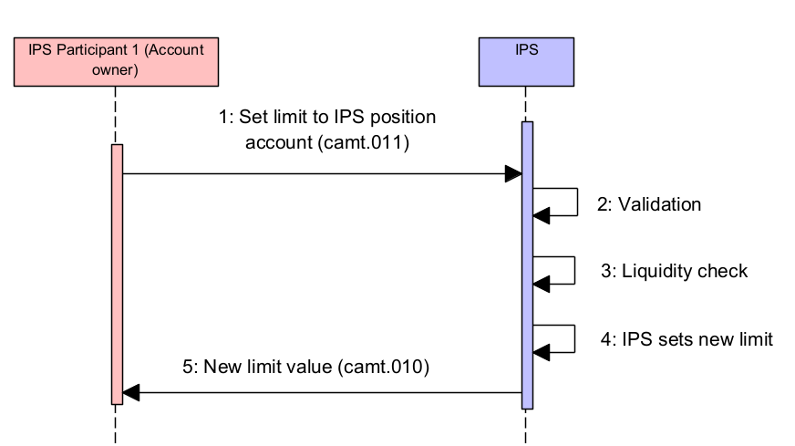
Figure 18. Set limit request for own IPS position account
Table 39. Diagram description. Set limit request for own IPS position account
## | Description | Message type | Sample item
1 | IPS Participant 1 (Account owner) sends request to change account debit cap value. The request contains:  - New debit cap value  - Account code | camt.011 | 4.9.1.1
2 | IPS performs validation that includes:  - Message format validation  - Security check  - Access rights check  - Status of account.  If any validation is failed, then the message is rejected | See IPS rejection section | 5.8
3 | IPS performs Liquidity check:  - new limit value is not less then current Debit position of IPS account) | See IPS rejection section | 5.8
4 | IPS sets new limit value for the specified account.
5 | IPS delivers new limit value to IPS Participant 1 (Account owner) | camt.010 | 4.9.1.2

      - Request to set IPS account limit: camt.011
In below scenario a participant i.e. AAAAPYPX is setting limit on its Position account.

<Document xmlns="urn:iso:std:iso:20022:tech:xsd:camt.011.001.07">
<ModfyLmt>
<MsgHdr>
<!-- Message reference -->
<MsgId>AAAAPYPXAXXX190929100120000001235</MsgId>
<!-- Message creation local date-time -->
<CreDtTm>2019-09-29T14:08:48.232-04:00</CreDtTm>
</MsgHdr>
<LmtDtls>
<LmtId>
<Cur>
<Tp>
<!-- Limit type -->
<Prtry>IPLIMIT</Prtry>
</Tp>
<AcctId>
<Othr>
<!-- Position account code for which to set limit -->
<Id>AAAAPYPX-ACCOUNT-AT-IPS</Id>
</Othr>
</AcctId>
</Cur>
</LmtId>
<NewLmtValSet>
<Amt>
<!-- Limit amount to set with currency code -->
<AmtWthCcy Ccy="PYG">800000.70</AmtWthCcy>
</Amt>
</NewLmtValSet>
</LmtDtls>
</ModfyLmt>
</Document>

      - Reply on successful setting limit: camt.010
<Document xmlns="urn:iso:std:iso:20022:tech:xsd:camt.010.001.08">
<RtrLmt>
<MsgHdr>
<!-- Message reference -->
<MsgId>BCPAPYPXAIPS190929000010000001230</MsgId>
<!-- Message creation local date-time -->
<CreDtTm>2017-11-09T14:08:49.222-04:00</CreDtTm>
<OrgnlBizQry>
<!-- Original message reference -->
<MsgId>AAAAPYPXAXXX190929100120000001235</MsgId>
<!-- Original message type -->
<MsgNmId>camt.011.001.07</MsgNmId>
<!-- Original message creation date-time -->
<CreDtTm>2019-09-29T14:08:48.232-04:00</CreDtTm>
</OrgnlBizQry>
</MsgHdr>
<RptOrErr>
<BizRpt>
<CurLmt>
<LmtId>
<Tp>
<!-- Limit type code -->
<Prtry>IPLIMIT</Prtry>
</Tp>
<!-- Account owner. BICFI for swift-registered BICs. -->
<AcctOwnr>
<FinInstnId>
<BICFI>AAAAPYPX</BICFI>
</FinInstnId>
</AcctOwnr>
<AcctId>
<Othr>
<!-- Account code -->
<Id>AAAAPYPX-ACCOUNT-AT-IPS</Id>
</Othr>
</AcctId>
</LmtId>
<LmtOrErr>
<Lmt>
<!-- Amount of limit set (absolute value) -->
<Amt>
<AmtWthCcy Ccy="PYG">800000.70</AmtWthCcy>
</Amt>
<!-- Used amount of limit (non-negative value) -->
<UsdAmt>
<AmtWthCcy Ccy="PYG">10000.70</AmtWthCcy>
</UsdAmt>
<!-- Actual used percentage of limit amount -->
<UsdPctg>1.25</UsdPctg>
<!-- Remaining amount of limit -->
<RmngAmt>
<AmtWthCcy Ccy="PYG">790000.00</AmtWthCcy>
</RmngAmt>
</Lmt>
</LmtOrErr>
</CurLmt>
</BizRpt>
</RptOrErr>
</RtrLmt>
</Document>

Set limit for managed Indirect Participant IPS position account
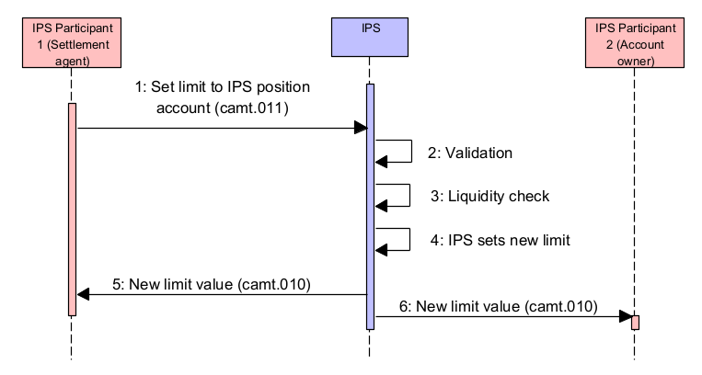
Figure 19. Set limit request for managed Indirect Participant IPS position account
Table 40. Diagram description. Set limit request for managed Indirect Participant IPS position account
## | Description | Message type | Sample item
1 | IPS Participant 1 (Settlement agent) sends request to change account debit cap value. The request contains:  - New debit cap value  - Account code | camt.011 | 4.9.2.1
2 | IPS performs validation that includes:  - Message format validation  - Security check  - Access rights check  - Status of account.  If any validation is failed, then the message is rejected | See IPS rejection section | 5.8
3 | IPS performs Liquidity check:  - new limit value is not less then current Debit position of IPS account) | See IPS rejection section | 5.8
4 | IPS sets new limit value for the specified account. | camt.010 | 4.9.2.2
5 | IPS delivers new limit value to IPS Participant 1 (Settlement agent)
6 | IPS delivers account report to IPS Participat 2 (Account owner) | camt.010 | 4.9.2.2

      - Request to set IP limit: camt.011
In below scenario a Direct participant i.e. AAAAPYPX is setting limit on its Indirect Participant (CCCCPYPX) Position account.
<Document xmlns="urn:iso:std:iso:20022:tech:xsd:camt.011.001.07">
<ModfyLmt>
<MsgHdr>
<!-- Message reference -->
<MsgId>AAAAPYPXAXXX190929100120000001235</MsgId>
<!-- Message creation local date-time -->
<CreDtTm>2019-09-29T14:08:48.232-04:00</CreDtTm>
</MsgHdr>
<LmtDtls>
<LmtId>
<Cur>
<Tp>
<!-- Limit type -->
<Prtry>IPLIMIT</Prtry>
</Tp>
<AcctId>
<Othr>
<!-- Position account code for which to set limit -->
<Id>CCCCPYPX-ACCOUNT-AT-IPS</Id>
</Othr>
</AcctId>
</Cur>
</LmtId>
<NewLmtValSet>
<Amt>
<!-- Limit amount to set with currency code -->
<AmtWthCcy Ccy="PYG">800000.70</AmtWthCcy>
</Amt>
</NewLmtValSet>
</LmtDtls>
</ModfyLmt>
</Document>
      - Reply on successful setting limit: camt.010
<Document xmlns="urn:iso:std:iso:20022:tech:xsd:camt.010.001.08">
<RtrLmt>
<MsgHdr>
<!-- Message reference -->
<MsgId>BCPAPYPXAIPS190929000010000001230</MsgId>
<!-- Message creation local date-time -->
<CreDtTm>2017-11-09T14:08:49.222-04:00</CreDtTm>
<OrgnlBizQry>
<!-- Original message reference -->
<MsgId>AAAAPYPXAXXX190929100120000001235</MsgId>
<!-- Original message type -->
<MsgNmId>camt.011.001.07</MsgNmId>
<!-- Original message creation date-time -->
<CreDtTm>2019-09-29T14:08:48.232-04:00</CreDtTm>
</OrgnlBizQry>
</MsgHdr>
<RptOrErr>
<BizRpt>
<CurLmt>
<LmtId>
<Tp>
<!-- Limit type code -->
<Prtry>IPLIMIT</Prtry>
</Tp>
<!-- Account owner. BICFI for swift-registered BICs. -->
<AcctOwnr>
<FinInstnId>
<BICFI>CCCCPYPX</BICFI>
</FinInstnId>
</AcctOwnr>
<AcctId>
<Othr>
<!-- Account code -->
<Id>CCCCPYPX-ACCOUNT-AT-IPS</Id>
</Othr>
</AcctId>
</LmtId>
<LmtOrErr>
<Lmt>
<!-- Amount of limit set (absolute value) -->
<Amt>
<AmtWthCcy Ccy="PYG">800000.70</AmtWthCcy>
</Amt>
<!-- Used amount of limit (non-negative value) -->
<UsdAmt>
<AmtWthCcy Ccy="PYG">10000.70</AmtWthCcy>
</UsdAmt>
<!-- Actual used percentage of limit amount -->
<UsdPctg>1.25</UsdPctg>
<!-- Remaining amount of limit -->
<RmngAmt>
<AmtWthCcy Ccy="PYG">790000.00</AmtWthCcy>
</RmngAmt>
</Lmt>
</LmtOrErr>
</CurLmt>
</BizRpt>
</RptOrErr>
</RtrLmt>
</Document>

Get limit request
IPS Participant can request the Limit value for own position account:
- Indirect Participant may request report on own IPS account
- Direct Participant may request report on own IPS account and for Indirect Participant’ IPS accounts of managed by this Direct Participant as Settlement agent.

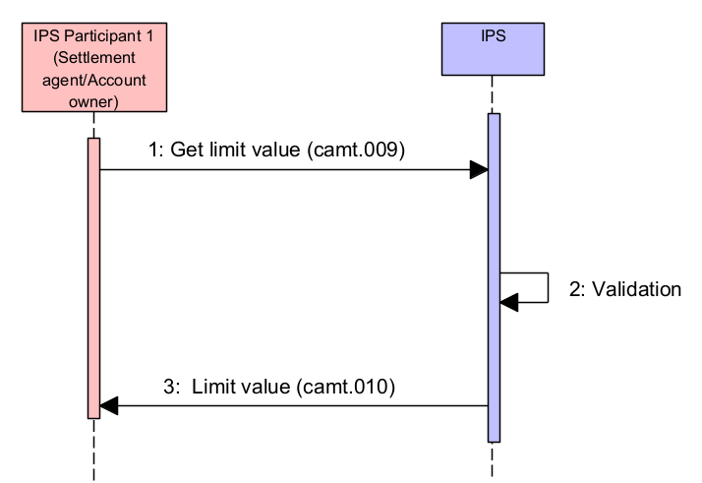
Figure 20. Get limit value request
Table 41. Diagram description. Get limit value request
## | Description | Message type | Sample item
1 | IPS Participant 1 (Settlement agent/Account owner) sends request to get limit value. The request to contain:  - Account code | camt.009 | 4.10.1.1
2 | IPS performs validation that includes:  - Message format validation  - Security check  - Access right check.  If any validation is failed, then the message is rejected | See IPS rejection section | 5.9
3 | IPS delivers Limit value report report to IPS Participant 1 (Settlement agent/Account owner) | camt.010 | 4.10.1.2

      - Get limit value: camt.009
In below scenario a participant i.e. AAAAPYPX is requesting his current IP limit set on its account.
<Document xmlns="urn:iso:std:iso:20022:tech:xsd:camt.009.001.07">
<GetLmt>
<MsgHdr>
<!-- Message reference -->
<MsgId>AAAAPYPXAXXX190929100120000001235</MsgId>
<!-- Message creation local date-time -->
<CreDtTm>2019-09-29T14:08:48.232-04:00</CreDtTm>
</MsgHdr>
<LmtQryDef>
<LmtCrit>
<NewCrit>
<SchCrit>
<AcctId>
<!-- Account code -->
<Othr><Id>AAAAPYPX-ACCOUNT-AT-IPS</Id></Othr>
</AcctId>
<!-- Limit currency code -->
<LmtCcy>PYG</LmtCcy>
</SchCrit>
</NewCrit>
</LmtCrit>
</LmtQryDef>
</GetLmt>
</Document>

      - Limit value report: camt.010
<Document xmlns="urn:iso:std:iso:20022:tech:xsd:camt.010.001.08">
<RtrLmt>
<MsgHdr>
<!-- Message reference -->
<MsgId>BCPAPYPXAIPS190929000010000001230</MsgId>
<!-- Message creation local date-time -->
<CreDtTm>2019-09-29T14:08:49.232-04:00</CreDtTm>
<OrgnlBizQry>
<!-- Original message reference -->
<MsgId>AAAAPYPXAXXX190929100120000001235</MsgId>
<!-- Original message type -->
<MsgNmId>camt.009.001.07</MsgNmId>
<!-- Original message creation date-time -->
<CreDtTm>2019-09-29T14:08:48.232-04:00</CreDtTm>
</OrgnlBizQry>
</MsgHdr>
<RptOrErr>
<BizRpt>
<CurLmt>
<LmtId>
<Tp>
<!-- Limit type code -->
<Prtry>IPLIMIT</Prtry>
</Tp>
<!-- Account owner. BICFI for swift-registered BICs. -->
<AcctOwnr>
<FinInstnId>
<BICFI>AAAAPYPX</BICFI>
</FinInstnId>
</AcctOwnr>
<AcctId>
<!-- Account code -->
<Othr><Id>AAAAPYPX-ACCOUNT-AT-IPS</Id></Othr>
</AcctId>
</LmtId>
<LmtOrErr>
<Lmt>
<!-- Amount of limit set (fixed value) -->
<Amt>
<AmtWthCcy Ccy="PYG">800000.70</AmtWthCcy>
</Amt>
<!-- Used amount of limit (non-negative value) -->
<UsdAmt>
<AmtWthCcy Ccy="PYG">10000.70</AmtWthCcy>
</UsdAmt>
<!-- Actual used percentage of limit amount -->
<UsdPctg>1.25</UsdPctg>
<!-- Remaining amount of limit -->
<RmngAmt>
<AmtWthCcy Ccy="PYG">790000.00</AmtWthCcy>
</RmngAmt>
</Lmt>
</LmtOrErr>
</CurLmt>
</BizRpt>
</RptOrErr>
</RtrLmt>
</Document>

Account report request
IPS Participant can request the Limit value for own position account:
- Indirect Participant may request report on own IPS account;
- Direct Participant may request report on own IPS account and for Indirect Participant’ IPS accounts of managed by this Direct Participant as Settlement agent.

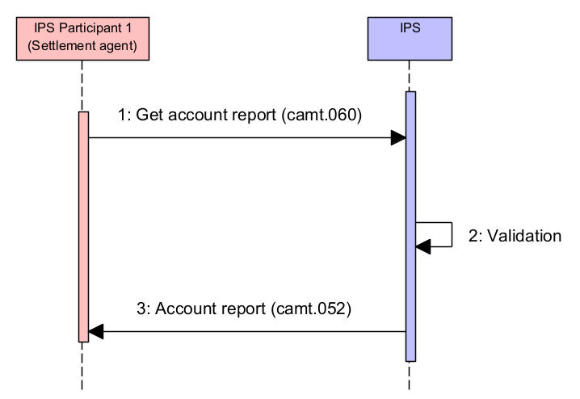
Figure 21. Account report request
Table 42. Diagram description
## | Description | Message type | Sample item
1 | IPS Participant 1 (Settlement agent) sends request to get account report. The request to contain:  - Account code | camt.060 | 4.11.1.1
2 | IPS performs validation that includes:  - Message format validation  - Security check  - Access right check.  If any validation is failed, then the message is rejected | See IPS rejection section | 5.9
3 | IPS delivers account report to IPS Participant 1 (Settlement agent) | camt.052 | 4.11.1.2

      - Request to get account report: camt.060
In below scenario a participant i.e. AAAAPYPX is requesting account report on its account.

<Document xmlns="urn:iso:std:iso:20022:tech:xsd:camt.060.001.06">
<AcctRptgReq>
<GrpHdr>
<!-- Unique message identifier assigned by the message Sender -->
<MsgId>AAAAPYPXAXXX190929100120000001920</MsgId>
<CreDtTm>2019-09-29T16:35:00-04:00</CreDtTm>
</GrpHdr>
<RptgReq>
<!-- Type of the requested report -->
<ReqdMsgNmId>camt.052/BALR</ReqdMsgNmId>
<!-- Account related to the request -->
<Acct><Id><Othr><Id>AAAAPYPX-ACCOUNT-AT-IPS</Id></Othr></Id></Acct>
<!-- Owner of the account related to the request -->
<AcctOwnr>
<Agt>
<FinInstnId>
<BICFI>AAAAPYPX</BICFI>
</FinInstnId>
</Agt>
</AcctOwnr>
</RptgReq>
</AcctRptgReq>
</Document>

      - Account report: camt.052

<Document xmlns="urn:iso:std:iso:20022:tech:xsd:camt.052.001.09">
<BkToCstmrAcctRpt>
<GrpHdr>
<!-- Unique message reference -->
<MsgId>BCPAPYPXAIPS180217000010000001230</MsgId>
<!-- Message creation date time -->
<CreDtTm>2017-09-22T21:33:37.543</CreDtTm>
<OrgnlBizQry>
<!-- Message ID of the request -->
<MsgId>AAAAPYPXAXXX190929100120000001920</MsgId>
<MsgNmId>camt.060.001.06</MsgNmId>
<CreDtTm>2019-09-29T16:35:00-04:00</CreDtTm>
</OrgnlBizQry>
<!-- BALR balance report -->
<AddtlInf>BALR</AddtlInf>
</GrpHdr>
<Rpt>
<!-- Unique account report id (same as MsgId) -->
<Id>BCPAPYPXAIPS180217000010000001230</Id>
<!-- Electronic sequence number. Number of report of this type generated for account. -->
<ElctrncSeqNb>2</ElctrncSeqNb>
<!-- Report creation date time -->
<CreDtTm>2017-09-22T21:33:37.543</CreDtTm>
<Acct>
<!-- Account code -->
<Id>
<Othr><Id>AAAAPYPX-ACCOUNT-AT-IPS</Id></Othr>
</Id>
<!-- Account currency -->
<Ccy>PYG</Ccy>
<Ownr>
<Id>
<!-- Account owner BIC or pseudo-BIC -->
<OrgId>
<AnyBIC>AAAAPYPX</AnyBIC>
</OrgId>
</Id>
</Ownr>
</Acct>
<Bal>
<!-- Balance type: CLBD - Closing booked; -->
<Tp>
<CdOrPrtry>
<Cd>CLBD</Cd>
</CdOrPrtry>
</Tp>

<CdtLine>
<!-- <<false>> means the limit is not included in the balance -->
<Incl>false</Incl>
<Tp>
<!-- Type of Limit-->
<Prtry>IPLIMIT</Prtry>
</Tp>
<!-- Amount of Debit cap -->
<Amt Ccy="PYG">2300.</Amt>
</CdtLine>

<!-- Amount and currency of reported balance of this type -->
<Amt Ccy="PYG">19069.75</Amt>
<!-- Credit/debit indicator -->
<CdtDbtInd>DBIT</CdtDbtInd>
<!-- Date for balance reported -->
<Dt>
<Dt>2017-08-14</Dt>
</Dt>
</Bal>
<Bal>
<TxsSummry>
<!-- Total entries and amount settled within the session -->
<TtlNtries>
<NbOfNtries>12</NbOfNtries>
<!-- Total netto of entries settled within the session -->
<TtlNetNtry>
<Amt>19069.75</Amt>
<!-- Credit/debit indicator -->
<CdtDbtInd>CRDT</CdtDbtInd>
</TtlNetNtry>
</TtlNtries>
<!-- Total credit entries and amount settled within the session -->
<TtlCdtNtries>
<NbOfNtries>2</NbOfNtries>
<Sum>20071.</Sum>
</TtlCdtNtries>
<!-- Total debit entries and amount settled within the session -->
<TtlDbtNtries>
<NbOfNtries>10</NbOfNtries>
<Sum>39140.75</Sum>
</TtlDbtNtries>
</TxsSummry>
<!-- Session Id number (incremental sequence in the system) for which report is generated after codeword /SESSIONID/ -->
<AddtlRptInf>/SESSIONID/34</AddtlRptInf>
</Rpt>
</BkToCstmrAcctRpt>
</Document>

Business day information report
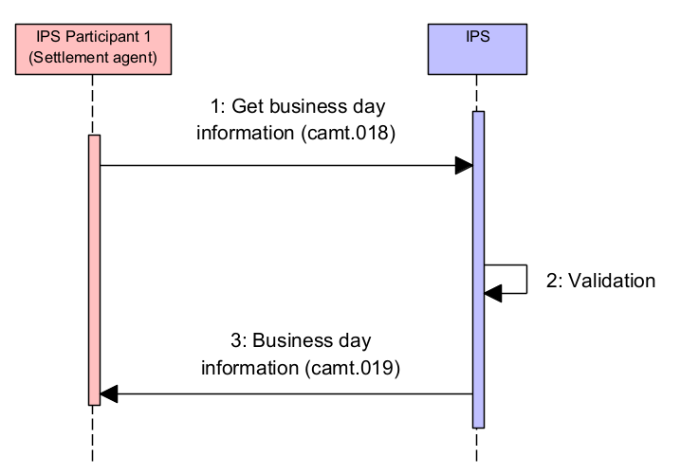
Figure 22. Business day information request
Table 43. Diagram description. Business day information request
## | Description | Message type | Sample item
1 | IPS Participant 1 (Settlement agent) sends request to get business day schedule report. | camt.018 | 4.12.1.1
2 | IPS performs validation that includes:  - Message format validation  - Security check  - Access right check.  If any validation is failed, then the message is rejected | See IPS rejection section | 5.9
3 | IPS delivers business day schedule report to IPS Participant 1 (Settlement agent) | camt.019 | 4.12.1.2

      - Business day information request: camt.018
<Document xmlns="urn:iso:std:iso:20022:tech:xsd:camt.018.001.05">
<GetBizDayInf>
<MsgHdr>
<!-- Query message unique reference -->
<MsgId>AAAAPYPXAXXX190929100120000001235</MsgId>
<!-- Query message creation date-time -->
<CreDtTm>2019-09-29T19:03:37.123-04:00</CreDtTm>
</MsgHdr>
<BizDayInfQryDef>
<Crit>
<NewCrit>
<SchCrit>
<EvtTp>
<Prtry>
<!-- Fixed code-word -->
<Id>GETBUSINESSDAYPERIOD</Id>
</Prtry>
</EvtTp>
</SchCrit>
</NewCrit>
</Crit>
</BizDayInfQryDef>
</GetBizDayInf>
</Document>

      - Return business day information response: camt.019
<Document xmlns="urn:iso:std:iso:20022:tech:xsd:camt.019.001.07">
<RtrBizDayInf>
<MsgHdr>
<!-- Message reference -->
<MsgId>R113914/BDR</MsgId>
<!-- Message creation date-time -->
<CreDtTm>2019-09-29T19:03:38.654-04:00</CreDtTm>
<OrgnlBizQry>
<!-- Original request message reference -->
<MsgId>AAAAPYPXAXXX190929100120000001235</MsgId>
<!-- Original request creation date-time -->
<CreDtTm>2019-09-29T19:03:37.876-04:00</CreDtTm>
</OrgnlBizQry>
</MsgHdr>
<RptOrErr>
<BizRpt>
<SysId>
<MktInfrstrctrId>
<!-- Fixed system identifier -->
<Prtry>IPS</Prtry>
</MktInfrstrctrId>
</SysId>
<BizDayOrErr>
<BizDayInf>
<!-- Business day date -->
<SysDt>
<Dt>2019-09-29</Dt>
</SysDt>
<SysInfPerCcy>
<!-- Business day period information -->
<Evt>
<Tp>
<Prtry>
<!-- Business day period name -->
<Id>EXCHANGE SESSION</Id>
</Prtry>
</Tp>
<!-- Business day period scheduled start time -->
<SchdldTm>2019-09-29T00:00:00</SchdldTm>
<!-- Business day period actual start time -->
<StartTm>2019-09-29T00:00:01</StartTm>
<!-- Business day period actual finish time -->
<EndTm>2019-09-29T09:30:00</EndTm>
</Evt>
<Evt>
<Tp>
<Prtry>
<Id>CUT-OFF AND CLEARING</Id>
</Prtry>
</Tp>
<SchdldTm>2019-09-29T09:30:00</SchdldTm>
<StartTm>2019-09-29T09:30:00</StartTm>
</Evt>
<Evt>
<Tp>
<Prtry>
<Id>EXCHANGE SESSION</Id>
</Prtry>
</Tp>
<SchdldTm>2019-09-29T09:40:00</SchdldTm>
</Evt>
<Evt>
<Tp>
<Prtry>
<Id>CUT-OFF AND CLEARING</Id>
</Prtry>
</Tp>
<SchdldTm>2019-09-29T13:00:00</SchdldTm>
</Evt>
<Evt>
<Tp>
<Prtry>
<Id>EXCHANGE SESSION</Id>
</Prtry>
</Tp>
<SchdldTm>2019-09-29T13:10:00</SchdldTm>
</Evt>
<Evt>
<Tp>
<Prtry>
<Id>CUT-OFF AND CLEARING</Id>
</Prtry>
</Tp>
<SchdldTm>2019-09-29T15:00:00</SchdldTm>
</Evt>
<Evt>
<Tp>
<Prtry>
<Id>EXCHANGE SESSION</Id>
</Prtry>
</Tp>
<SchdldTm>2019-09-29T15:10:00</SchdldTm>
</Evt>
<Evt>
<Tp>
<Prtry>
<Id>CUT-OFF AND CLEARING</Id>
</Prtry>
</Tp>
<SchdldTm>2019-09-29T16:30:00</SchdldTm>
</Evt>
<Evt>
<Tp>
<Prtry>
<Id>EXCHANGE SESSION</Id>
</Prtry>
</Tp>
<SchdldTm>2019-09-29T16:40:00</SchdldTm>
</Evt>
</SysInfPerCcy>
</BizDayInf>
</BizDayOrErr>
</BizRpt>
</RptOrErr>
</RtrBizDayInf>
</Document>

Account Limit Notification on Direct Participant IPS position account
This notification is sent to Direct IPS Participant 1 (Account owner) if:
- Predefined Limit usage threshold is reached (80% is a standard threshold value)
- Limit of IPS account has been changed.

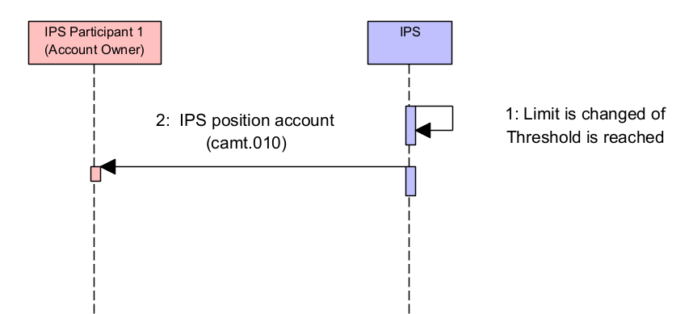
Figure 23. Account Limit Notification on Direct Participant IPS position account
Table 44. Diagram description. Account Limit Notification on Direct Participant IPS position account
## | Description | Message type | Sample item
1 | Limit is changed on IPS position account or used limit threshold on this account is reached (standard threshold value is 80%)
2 | IPS automatically sends notification to IPS Participant 1 (Account owner) | camt.010 | 4.13.1.1
      - Notification on used limit threshold: camt.010
<Document xmlns="urn:iso:std:iso:20022:tech:xsd:camt.010.001.08">
<RtrLmt>
<MsgHdr>
<!-- Message reference -->
<MsgId>BCPAPYPXAIPS190929000010000001230</MsgId>
<!-- Message creation date-time -->
<CreDtTm>2019-09-29T14:08:48.232-04:00</CreDtTm>
</MsgHdr>
<RptOrErr>
<BizRpt>
<CurLmt>
<LmtId>
<Tp>
<!-- Limit type code -->
<Prtry>IPLIMIT</Prtry>
</Tp>
<!-- Account owner. BICFI for swift-registered BICs. -->
<AcctOwnr>
<FinInstnId>
<BICFI>AAAAPYPX</BICFI>
</FinInstnId>
</AcctOwnr>
<AcctId>
<!-- Account code -->
<Othr><Id>AAAAPYPX-ACCOUNT-AT-IPS</Id></Othr>
</AcctId>
</LmtId>
<LmtOrErr>
<Lmt>
<!-- Amount of limit set (fixed value) -->
<Amt>
<AmtWthCcy Ccy="PYG">800000.70</AmtWthCcy>
</Amt>
<!-- Used amount of limit (non-negative value) -->
<UsdAmt>
<AmtWthCcy Ccy="PYG">660000.58</AmtWthCcy>
</UsdAmt>
<!-- Actual used percentage of limit amount -->
<UsdPctg>82.5</UsdPctg>
<!-- Remaining amount of limit-->
<RmngAmt>
<AmtWthCcy Ccy="PYG">140000.12</AmtWthCcy>
</RmngAmt>
</Lmt>
</LmtOrErr>
</CurLmt>
</BizRpt>
</RptOrErr>
</RtrLmt>
</Document>

Account Limit Notification on Indirect Participant IPS position account
This notification is sent to Indirect IPS Participant 1 (Account owner) and Direct IPS Participant 2 (Settlement Agent) if:
- Predefined Limit usage threshold is reached (80% is a standard threshold value)
- Limit of IPS account has been changed.

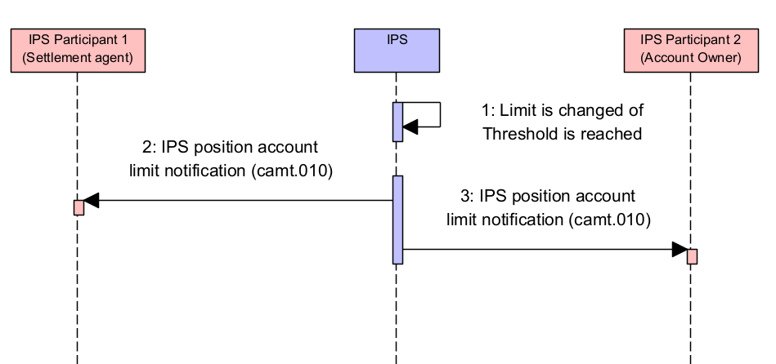
Figure 24. Account Limit Notification on Indirect Participant IPS position account
Table 45. Diagram description. Account Limit Notification on Indirect Participant IPS position account
## | Description | Message type | Sample item
1 | Limit is changed on IPS position account or used limit threshold on this account is reached (standard threshold value is 80%)
2 | IPS automatically sends notification to IPS Participant 1 (Settlement agent) | camt.010 | 4.14.1.1
3 | IPS automatically sends notification to IPS Participant 2 (Account owner) | camt.010 | 4.14.1.1
      - Notification on used limit threshold: camt.010
<Document xmlns="urn:iso:std:iso:20022:tech:xsd:camt.010.001.08">
<RtrLmt>
<MsgHdr>
<!-- Message reference -->
<MsgId>BCPAPYPXAIPS190929000010000001230</MsgId>
<!-- Message creation date-time -->
<CreDtTm>2019-09-29T14:08:48.232-04:00</CreDtTm>
</MsgHdr>
<RptOrErr>
<BizRpt>
<CurLmt>
<LmtId>
<Tp>
<!-- Limit type code -->
<Prtry>IPLIMIT</Prtry>
</Tp>
<!-- Account owner. BICFI for swift-registered BICs. -->
<AcctOwnr>
<FinInstnId>
<BICFI>AAAAPYPX</BICFI>
</FinInstnId>
</AcctOwnr>
<AcctId>
<!-- Account code -->
<Othr><Id>AAAAPYPX-ACCOUNT-AT-IPS</Id></Othr>
</AcctId>
</LmtId>
<LmtOrErr>
<Lmt>
<!-- Amount of limit set (fixed value) -->
<Amt>
<AmtWthCcy Ccy="PYG">800000.70</AmtWthCcy>
</Amt>
<!-- Used amount of limit (non-negative value) -->
<UsdAmt>
<AmtWthCcy Ccy="PYG">660000.58</AmtWthCcy>
</UsdAmt>
<!-- Actual used percentage of limit amount -->
<UsdPctg>82.5</UsdPctg>
<!-- Remaining amount of limit-->
<RmngAmt>
<AmtWthCcy Ccy="PYG">140000.12</AmtWthCcy>
</RmngAmt>
</Lmt>
</LmtOrErr>
</CurLmt>
</BizRpt>
</RptOrErr>
</RtrLmt>
</Document>

Account Limit Notification on Direct Participant Settlement Limit account
This notification is sent to Direct Participant – Account owner if:
- Predefined Limit usage threshold is reached (80% is a standard threshold value)
- Limit of IPS Settlement account has been changed.

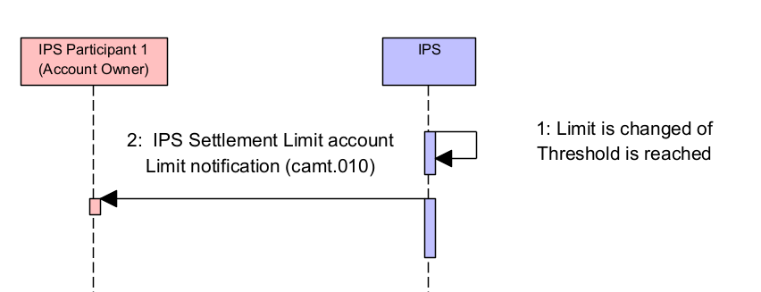
Figure 25. Account Limit Notification on Direct Participant Settlement Limit account
Table 46. Diagram description. Account Limit Notification on Direct Participant Settlement Limit account
## | Description | Message type | Sample item
1 | Limit is changed on Settlement limit account or used limit threshold on this account is reached (standard threshold value is 80%)
2 | IPS sends automatically notification to IPS Participant (Account owner) on event of account limit modification after synchronization with RTGS or after reaching a defined used limit threshold on account (i.e. 80%). | camt.010 | 4.15.1.1
      - Notification on used limit threshold: camt.010
<Document xmlns="urn:iso:std:iso:20022:tech:xsd:camt.010.001.08">
<RtrLmt>
<MsgHdr>
<!-- Message reference -->
<MsgId>BCPAPYPXAIPS190929000010000001230</MsgId>
<!-- Message creation date-time -->
<CreDtTm>2019-09-29T14:08:48.232-04:00</CreDtTm>
</MsgHdr>
<RptOrErr>
<BizRpt>
<CurLmt>
<LmtId>
<Tp>
<!-- Limit type code -->
<Prtry>IPLIMIT</Prtry>
</Tp>
<!-- Account owner. BICFI for swift-registered BICs. -->
<AcctOwnr>
<FinInstnId>
<BICFI>AAAAPYPX</BICFI>
</FinInstnId>
</AcctOwnr>
<AcctId>
<!-- Account code -->
<Othr><Id>AAAAPYPX-ACCOUNT-AT-IPS</Id></Othr>
</AcctId>
</LmtId>
<LmtOrErr>
<Lmt>
<!-- Amount of limit set (fixed value) -->
<Amt>
<AmtWthCcy Ccy="PYG">800000.70</AmtWthCcy>
</Amt>
<!-- Used amount of limit (non-negative value) -->
<UsdAmt>
<AmtWthCcy Ccy="PYG">660000.58</AmtWthCcy>
</UsdAmt>
<!-- Actual used percentage of limit amount -->
<UsdPctg>82.5</UsdPctg>
<!-- Remaining amount of limit-->
<RmngAmt>
<AmtWthCcy Ccy="PYG">140000.12</AmtWthCcy>
</RmngAmt>
</Lmt>
</LmtOrErr>
</CurLmt>
</BizRpt>
</RptOrErr>
</RtrLmt>
</Document>

Account balance report generated by IPS at the End-of-session

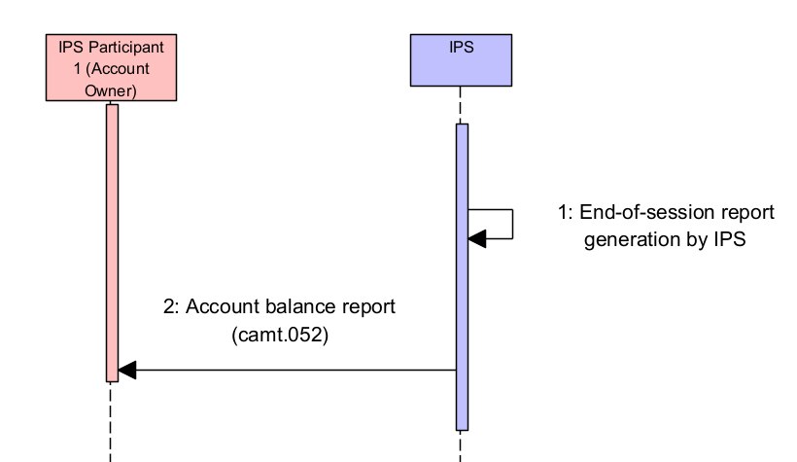
Figure 26. Account balance report generated by IPS at the End-of-session
Table 47. Diagram description. Account balance report generated by IPS at the End-of-session
## | Description | Message type | Sample item
1 | End-of-session report generation by IPS
2 | IPS delivers reports to account owners (direct participants) | camt.052 | 4.16.1.1
      - Account report: camt.052

<Document xmlns="urn:iso:std:iso:20022:tech:xsd:camt.052.001.09">
<BkToCstmrAcctRpt>
<GrpHdr>
<!-- Unique message reference -->
<MsgId>BCPAPYPXAIPS180217000010000001230</MsgId>
<!-- Message creation date time -->
<CreDtTm>2017-09-22T21:33:37.543-04:00</CreDtTm>
<!-- BALR balance report -->
<AddtlInf>BALR</AddtlInf>
</GrpHdr>
<Rpt>
<!-- Unique account report id (same as MsgId) -->
<Id>BCPAPYPXAIPS180217000010000001230</Id>
<!-- Electronic sequence number. Number of report of this type generated for account. -->
<ElctrncSeqNb>2</ElctrncSeqNb>
<!-- Report creation date time -->
<CreDtTm>2017-09-22T21:33:37.543-04:00</CreDtTm>
<Acct>
<!-- Account code -->
<Id>
<Othr><Id>AAAAPYPX-ACCOUNT-AT-IPS</Id></Othr>
</Id>
<!-- Account currency -->
<Ccy>PYG</Ccy>
<Ownr>
<Id>
<!-- Account owner BIC or pseudo-BIC -->
<OrgId>
<AnyBIC>AAAAPYPX</AnyBIC>
</OrgId>
</Id>
</Ownr>
</Acct>
<Bal>
<!-- Balance type: CLBD - Closing booked -->
<Tp>
<CdOrPrtry>
<Cd>CLBD</Cd>
</CdOrPrtry>
</Tp>

<CdtLine>
<!-- <<false>> means the limit is not included in the balance -->
<Incl>false</Incl>
<Tp>
<!-- Type of Limit -->
<Prtry>IPLIMIT</Prtry>
</Tp>
<!-- Amount of Debit cap -->
<Amt Ccy="PYG">2300.</Amt>
</CdtLine>

<!-- Amount and currency of reported balance of this type -->
<Amt Ccy="PYG">19069.75</Amt>
<!-- Credit/debit indicator -->
<CdtDbtInd>DBIT</CdtDbtInd>
<!-- Date for balance reported -->
<Dt>
<Dt>2017-08-14</Dt>
</Dt>
</Bal>
<TxsSummry>
<!-- Total entries and amount settled within the session -->
<TtlNtries>
<NbOfNtries>12</NbOfNtries>
<!-- Total netto of entries settled within the session -->
<TtlNetNtry>
<Amt>19069.75</Amt>
<!-- Credit/debit indicator -->
<CdtDbtInd>CRDT</CdtDbtInd>
</TtlNetNtry>
</TtlNtries>
<!-- Total credit entries and amount settled within the session -->
<TtlCdtNtries>
<NbOfNtries>2</NbOfNtries>
<Sum>20071.</Sum>
</TtlCdtNtries>
<!-- Total debit entries and amount settled within the session -->
<TtlDbtNtries>
<NbOfNtries>10</NbOfNtries>
<Sum>39140.75</Sum>
</TtlDbtNtries>
</TxsSummry>
<!-- Session Id number (incremental sequence in the system) for which report is generated after codeword /SESSIONID/ -->
<AddtlRptInf>/SESSIONID/34</AddtlRptInf>
</Rpt>
</BkToCstmrAcctRpt>
</Document>

Business day information report
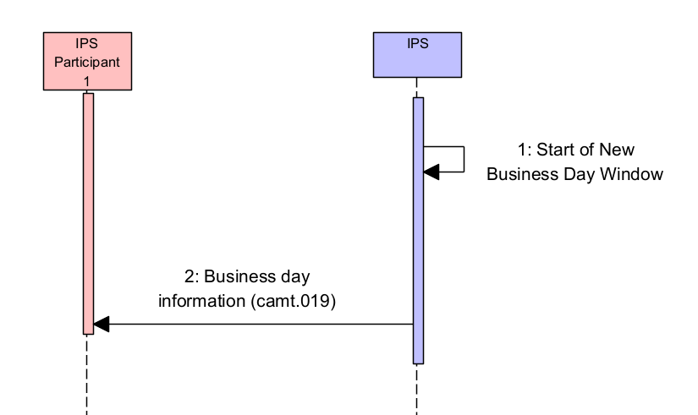
Figure 27. Business day information report
Table 48. Diagram description. Business day information report
## | Description | Message type | Sample item
1 | IPS generates Business day information report at the start of new Business day window
2 | IPS delivers business day schedule report to IPS Participant 1 | camt.019 | 4.17.1.1

      - Business day information report: camt.019
<Document xmlns="urn:iso:std:iso:20022:tech:xsd:camt.019.001.07">
<RtrBizDayInf>
<MsgHdr>
<!-- Message reference -->
<MsgId>R113914/BDR</MsgId>
<!-- Message creation date-time -->
<CreDtTm>2019-09-29T19:03:38.345-04:00</CreDtTm>
<OrgnlBizQry>
<!-- Original request message reference -->
<MsgId>AAAAPYPXAXXX190929100120000001235</MsgId>
<!-- Original request creation date-time -->
<CreDtTm>2019-09-29T19:03:37.345-04:00</CreDtTm>
</OrgnlBizQry>
</MsgHdr>
<RptOrErr>
<BizRpt>
<SysId>
<MktInfrstrctrId>
<!-- Fixed system identifier -->
<Prtry>IPS</Prtry>
</MktInfrstrctrId>
</SysId>
<BizDayOrErr>
<BizDayInf>
<!-- Business day date -->
<SysDt>
<Dt>2019-09-29</Dt>
</SysDt>
<SysInfPerCcy>
<!-- Business day period information -->
<Evt>
<Tp>
<Prtry>
<!-- Business day period name -->
<Id>EXCHANGE SESSION</Id>
</Prtry>
</Tp>
<!-- Business day period scheduled start time -->
<SchdldTm>2019-09-29T00:00:00</SchdldTm>
<!-- Business day period actual start time -->
<StartTm>2019-09-29T00:00:01</StartTm>
<!-- Business day period actual finish time -->
<EndTm>2019-09-29T09:30:00</EndTm>
</Evt>
<Evt>
<Tp>
<Prtry>
<Id>CUT-OFF AND CLEARING</Id>
</Prtry>
</Tp>
<SchdldTm>2019-09-29T09:30:00</SchdldTm>
<StartTm>2019-09-29T09:30:00</StartTm>
</Evt>
<Evt>
<Tp>
<Prtry>
<Id>EXCHANGE SESSION</Id>
</Prtry>
</Tp>
<SchdldTm>2019-09-29T09:40:00</SchdldTm>
</Evt>
<Evt>
<Tp>
<Prtry>
<Id>CUT-OFF AND CLEARING</Id>
</Prtry>
</Tp>
<SchdldTm>2019-09-29T13:00:00</SchdldTm>
</Evt>
<Evt>
<Tp>
<Prtry>
<Id>EXCHANGE SESSION</Id>
</Prtry>
</Tp>
<SchdldTm>2019-09-29T13:10:00</SchdldTm>
</Evt>
<Evt>
<Tp>
<Prtry>
<Id>CUT-OFF AND CLEARING</Id>
</Prtry>
</Tp>
<SchdldTm>2019-09-29T15:00:00</SchdldTm>
</Evt>
<Evt>
<Tp>
<Prtry>
<Id>EXCHANGE SESSION</Id>
</Prtry>
</Tp>
<SchdldTm>2019-09-29T15:10:00</SchdldTm>
</Evt>
<Evt>
<Tp>
<Prtry>
<Id>CUT-OFF AND CLEARING</Id>
</Prtry>
</Tp>
<SchdldTm>2019-09-29T16:30:00</SchdldTm>
</Evt>
<Evt>
<Tp>
<Prtry>
<Id>EXCHANGE SESSION</Id>
</Prtry>
</Tp>
<SchdldTm>2019-09-29T16:40:00</SchdldTm>
</Evt>
</SysInfPerCcy>
</BizDayInf>
</BizDayOrErr>
</BizRpt>
</RptOrErr>
</RtrBizDayInf>
</Document>

System event notifications from IPS
In case when a system event occurs, IPS generates admi.004 message with event code and description.
It can be used to notify about planned maintenance time, need to change user password or others.

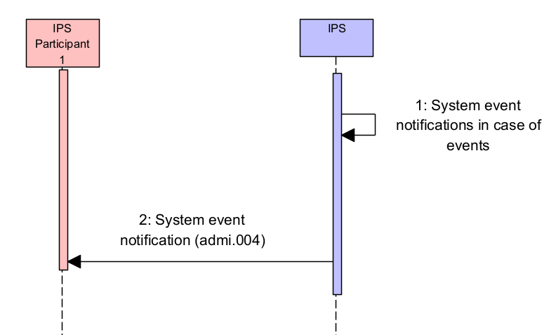
Figure 28. System event notifications from IPS
Table 49. Diagram description. System event notifications from IPS
## | Description | Message type | Sample item
1 | IPS generates System event notifications in case of events
2 | IPS delivers System event notification to IPS Participant(s) | admi.004 | 4.17.1.1

<Document xmlns="urn:iso:std:iso:20022:tech:xsd:admi.004.001.02">
<SysEvtNtfctn>
<EvtInf>
<EvtCd>PASS</EvtCd>
<EvtParam>R10324/ADM</EvtParam>
<EvtDesc>User should change password in 5 days</EvtDesc>
<EvtTm>2018-01-23T16:27:58</EvtTm>
</EvtInf>
</SysEvtNtfctn>
</Document>

Rejection notification issued by IPS
In case of validation error of any type f message IPS issues rejection notification to Participant-Sender of the message.
Depending on type of the message and type of error different notifications are sent.
Sections below describe these types of notification for different message categories.

Rejection of Direct Credit or Return payment
The diagram bellow shows the flow with cases when payment message is rejected by IPS on receiving. The flow is the same for any type of participants. The flow shows cases when the message is rejected because of:
- Critical technical errors
- Major technical errors
- Business validation errors.

Critical technical errors include:
- Message format validation error, e.g. wrong format (verified by xsd schema)
- Wrong digital signature.

Major technical errors include any error during payment message processing which doesn’t allow to create pacs.002 status message.

Business validation errors include any error which allows to create pacs.002 status message:
- Invalid value date
- Lack of funds
- And other business-related conditions
- Payment duplication (payment message is considered as duplicated in case if message reference, sender and value date are the same).

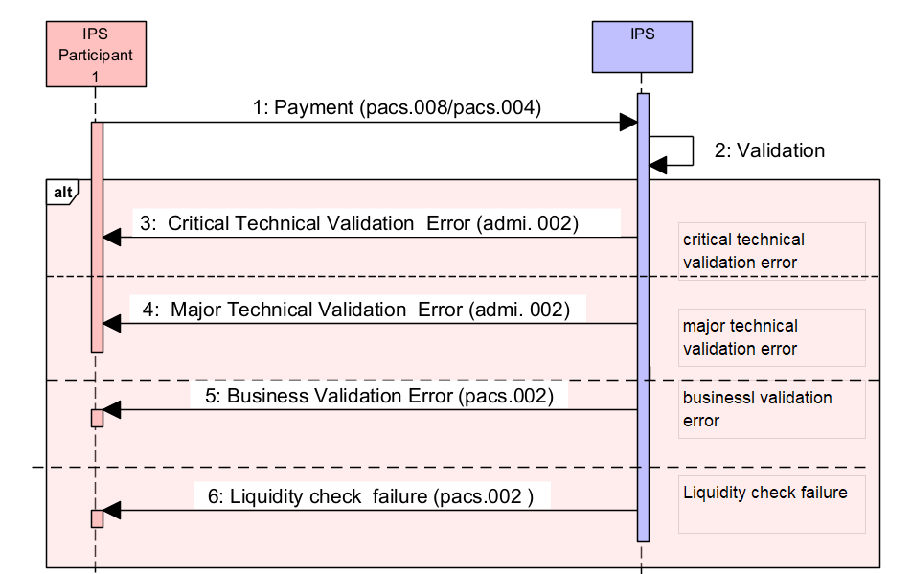
Figure 29. Rejection of Direct Credit or Return payment
Table 50.Diagram description. Rejection of Direct Credit or Return payment
## | Description | Message type | Sample item
1 | Payment message is delivered to IPS | pacs.008  or  pacs.004
2 | IPS performs validation of payment message
3 | In case of critical technical error IPS notifies IPS Participant with administrative error message | admi.002 | 5.1.1
4 | In case of major technical error IPS notifies IPS Participant with validation error message | admi.002 | 5.1.1
5 | In case of business validation error IPS notifies IPS Participant with payment status message | pacs.002/RJCT | 5.1.2
6 | In case of Liquidity check failure IPS notifies IPS Participant with payment status message with a dedicated error codeю  Liquidity check failure happens in case of payment amount exceeds available balance on IPS accout or on Settlement Limit account | pacs.002/RJCT | 5.1.3

Administrative error message and Validation error message: admi.002
Administrative Error message and Validation error message example is provided in Section 6.1.
For these messages Validation error message is the same as Administrative error message.

Business validation error payment status message: pacs.002/RJCT

<!-- -Document--->
<Document xmlns="urn:iso:std:iso:20022:tech:xsd:pacs.002.001.12">
<FIToFIPmtStsRpt>
<GrpHdr>
<!-- Unique message identifier generated by IPS -->
<MsgId>BCPAPYPXAIPS190929000010000001230</MsgId>
<!-- Message creation local date time -->
<CreDtTm>2019-09-29T10:40:44.199-04:00</CreDtTm>
</GrpHdr>
<OrgnlGrpInfAndSts>
<!-- As taken from pacs.008 FIToFICstmrCdtTrf/GrpHdr/MsgId -->
<OrgnlMsgId>AAAAPYPXAXXX190929100120000001230</OrgnlMsgId>
<!-- Type of original message to refer -->
<OrgnlMsgNmId>pacs.008.001.10</OrgnlMsgNmId>
<!-- As taken from pacs.008 FIToFICstmrCdtTrf/GrpHdr/CreDtTm -->
<OrgnlCreDtTm>2019-09-29T10:40:40.232-04:00</OrgnlCreDtTm>
<!-- Transaction processing result. RJCT – Rejected -->
<GrpSts>RJCT</GrpSts>
</OrgnlGrpInfAndSts>
<TxInfAndSts>
<!-- As taken from pacs.008 FIToFICstmrCdtTrf/CdtTrfTxInf/PmtId/EndToEndId -->
<OrgnlEndToEndId>NOTPROVIDED</OrgnlEndToEndId>
<!-- As taken from pacs.008 FIToFICstmrCdtTrf/CdtTrfTxInf/PmtId/TxId -->
<OrgnlTxId>AAAAPYPXAXXX190929100120000001230</OrgnlTxId>
<!-- Transaction processing result. RJCT – Rejected -->
<TxSts>RJCT</TxSts>
<StsRsnInf>
<!-- Error code generated by IPS -->
<Rsn>
<Prtry>EA5</Prtry>
</Rsn>
<!-- Error description and info -->
<AddtlInf>Message is duplicated</AddtlInf>
</StsRsnInf>
<!-- Instructing agent. The IPS system. -->
<InstgAgt>
<FinInstnId>
<BICFI>BCPAPYPXIPS</BICFI>
</FinInstnId>
</InstgAgt>
<!-- Instructed agent. Participant who sent original payment to the system. BICFI for swift-registered BICs. -->
<InstdAgt>
<FinInstnId>
<BICFI>AAAAPYPX</BICFI>
</FinInstnId>
</InstdAgt>
<!-- Instructed agent (payment receiver). BICFI for swift-registered BICs. -->
<OrgnlTxRef>
<!-- Original payment amount and currency -->
<IntrBkSttlmAmt Ccy="PYG">71.12</IntrBkSttlmAmt>
<!-- Settlement date of original payment -->
<IntrBkSttlmDt>2019-09-29</IntrBkSttlmDt>
</OrgnlTxRef>
</TxInfAndSts>
</FIToFIPmtStsRpt>
</Document>

Liquidity check failure payment status message: pacs.002/RJCT

<!-- -Document--->
<Document xmlns="urn:iso:std:iso:20022:tech:xsd:pacs.002.001.12">
<FIToFIPmtStsRpt>
<GrpHdr>
<!-- Unique message identifier generated by IPS -->
<MsgId>BCPAPYPXAIPS190929000010000001230</MsgId>
<!-- Message creation local date time -->
<CreDtTm>2019-09-29T10:40:44.199-04:00</CreDtTm>
</GrpHdr>
<OrgnlGrpInfAndSts>
<!-- As taken from pacs.008 FIToFICstmrCdtTrf/GrpHdr/MsgId -->
<OrgnlMsgId>AAAAPYPXAXXX190929100120000001230</OrgnlMsgId>
<!-- Type of original message to refer -->
<OrgnlMsgNmId>pacs.008.001.10</OrgnlMsgNmId>
<!-- As taken from pacs.008 FIToFICstmrCdtTrf/GrpHdr/CreDtTm -->
<OrgnlCreDtTm>2019-09-29T10:40:40.232-04:00</OrgnlCreDtTm>
<!-- Transaction processing result. RJCT – Rejected -->
<GrpSts>RJCT</GrpSts>
</OrgnlGrpInfAndSts>
<TxInfAndSts>
<!-- As taken from pacs.008 FIToFICstmrCdtTrf/CdtTrfTxInf/PmtId/EndToEndId -->
<OrgnlEndToEndId>NOTPROVIDED</OrgnlEndToEndId>
<!-- As taken from pacs.008 FIToFICstmrCdtTrf/CdtTrfTxInf/PmtId/TxId -->
<OrgnlTxId>AAAAPYPXAXXX190929100120000001230</OrgnlTxId>
<!-- Transaction processing result. RJCT – Rejected -->
<TxSts>RJCT</TxSts>
<StsRsnInf>
<!-- Error code generated by IPS -->
<Rsn>
<Prtry>EP183</Prtry>
</Rsn>
<!-- Error description and info -->
<AddtlInf>Lack of funds</AddtlInf>
</StsRsnInf>
<!-- Instructing agent. The IPS system. -->
<InstgAgt>
<FinInstnId>
<BICFI>BCPAPYPXIPS</BICFI>
</FinInstnId>
</InstgAgt>
<!-- Instructed agent. Participant who sent original payment to the system. BICFI for swift-registered BICs. -->
<InstdAgt>
<FinInstnId>
<BICFI>AAAAPYPX</BICFI>
</FinInstnId>
</InstdAgt>
<!-- Instructed agent (payment receiver). BICFI for swift-registered BICs. -->
<OrgnlTxRef>
<!-- Original payment amount and currency -->
<IntrBkSttlmAmt Ccy="PYG">71.12</IntrBkSttlmAmt>
<!-- Settlement date of original payment -->
<IntrBkSttlmDt>2019-09-29</IntrBkSttlmDt>
</OrgnlTxRef>
</TxInfAndSts>
</FIToFIPmtStsRpt>
</Document>

Rejection of Payment authorization request
This section describes error flow in case of validation errors during processing of Payment authorization request from IPS Participant (Creditor).

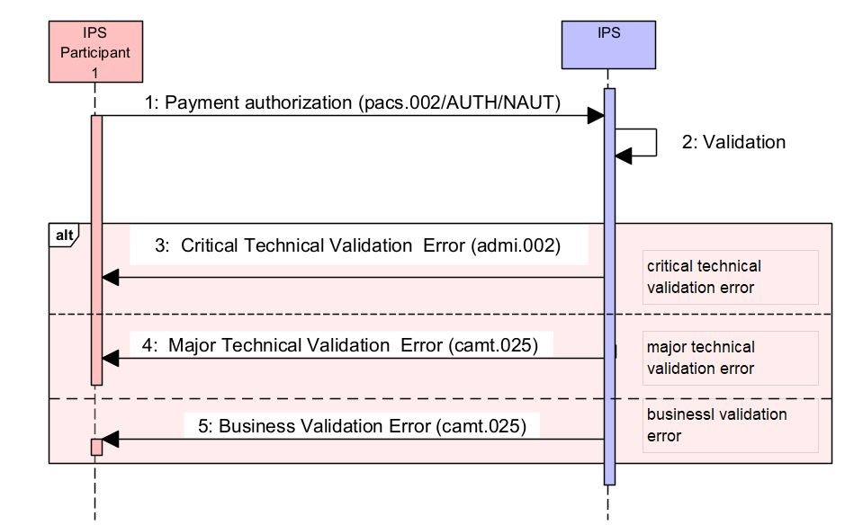
Figure 30. Rejection of Payment authorization request
Table 51. Diagram description. Rejection of Payment authorization request
## | Description | Message type | Sample item
1 | IPS Participant (Creditor agent) sends Payment Authorization message to IPS (positive or negative) | pacs.002
2 | Validation
3 | In case of critical technical error IPS notifies IPS Participant with administrative error message | admi.002 | 5.2.1
4 | In case of major technical error IPS notifies IPS Participant with validation error message | camt.025/ERRC | 5.2.2
5 | In case of business validation error IPS notifies IPS Participant with validation error message | camt.025/ERRC | 5.2.2

Administrative error message: admi.002
Administrative Error message example is provided in Section 6.1.

Validation error and Business validation error message: camt.025/ERRC
Validation error message example is provided in Section 6.2.
For these messages Business validation error message is the same as Validation error message.

Rejection of Request for return and Rejection of Decline for Request for return
This section describes error flow in case of validation errors during processing of Request for return.
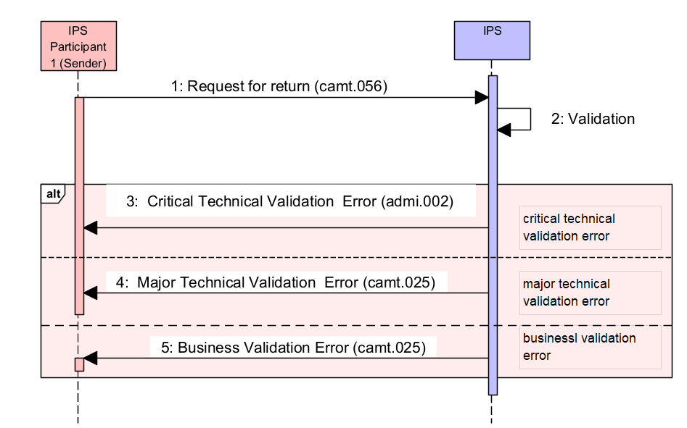
Figure 31. Rejection of Request for return and Rejection of Decline for Request for return
Table 52. Diagram description. Rejection of Request for return and Rejection of Decline for Request for return
## | Description | Message type | Sample item
1 | IPS Participant send a message to IPS. | camt.056
2 | IPS performs a validation of incoming message
3 | In case of critical technical error IPS notifies IPS Participant with administrative error message | admi.002 | 5.3.1
4 | In case of major technical error IPS notifies IPS Participant with validation error message | camt.025/ERRC | 5.3.2
5 | In case of business validation error IPS notifies IPS Participant with validation error message | camt.025/ERRC | 5.3.2

Administrative error message: admi.002
Administrative Error message example is provided in Section 6.1.

Validation error and Business validation error message: camt.025/ERRC
Validation error message example is provided in Section 6.2.
For these messages Business validation error message is the same as validation error message.

Rejection of Request to pay
This section describes error flow in case of validation errors during processing of Request to pay.
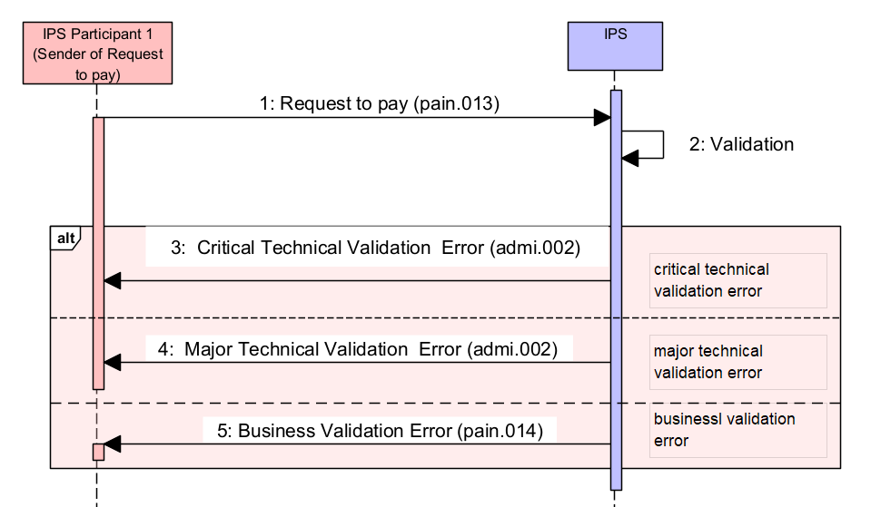
Figure 32. Rejection of Request to pay
Table 53. Diagram description. Rejection of Request to pay
## | Description | Message type | Sample item
1 | IPS Participant sends a Request to Pay message to IPS. | pain.013
2 | IPS performs a validation of incoming message
3 | In case of critical technical error IPS notifies IPS Participant with administrative error message | admi.002 | 5.4.1
4 | In case of major technical error IPS notifies IPS Participant with validation error message | admi.002 | 5.4.1
5 | In case of business validation error IPS notifies IPS Participant with validation error message | pain.014 | 5.4.2

Administrative error message and Validation error message: admi.002
Administrative Error message and Validation error message example is provided in Section 6.1.
For these messages Validation error message is the same as Administrative error message.

Business Validation error message: pain.014
Validation error message example
<!-- Document -->
<Document xmlns="urn:iso:std:iso:20022:tech:xsd:pain.014.001.09">
<CdtrPmtActvtnReqStsRpt>
<GrpHdr>
<!--Unique message identifier generated by IPS -->
<MsgId> BCPAPYPXAIPS190929100010000000144</MsgId>
<!--Message creation date time -->
<CreDtTm>2019-09-29T18:18:01.015-04:00</CreDtTm>
<!-- Party which sent pain.013. AnyBIC for swift-registered BICs. Othr/Id – for pseudo-BIC codes (non-swift registered)-->
<InitgPty>
<Id>
<OrgId>
<AnyBIC>BBBBPYPX</AnyBIC>
</OrgId>
</Id>
</InitgPty>

</GrpHdr>
<!-- References to original pain.013 request -->
<OrgnlGrpInfAndSts>
<!-- Original Message Id from pain.013 -->
<OrgnlMsgId>BBBBPYPXAXXX190929100010000000101</OrgnlMsgId>
<!-- pain.013 full message type -->
<OrgnlMsgNmId>pain.013.001.09</OrgnlMsgNmId>
<!-- pain.013 creation date/time -->
<OrgnlCreDtTm>2019-09-29T09:30:47-04:00</OrgnlCreDtTm>
<!--status of pain.013 -->
<GrpSts>RJCT</GrpSts>

<StsRsnInf>
<Orgtr>
<Id>
<OrgId>
<AnyBIC>BCPAPYPXAIPS</AnyBIC>
</OrgId>
</Id>
</Orgtr>
<!--Reason of rejection -->
<Rsn>
<Prtry>RR01</Prtry>
</Rsn>
<!--Description of rejection -->
<AddtlInf>Missing Debtor Account or</AddtlInf>
<AddtlInf>Identification</AddtlInf>
</StsRsnInf>
</OrgnlGrpInfAndSts>
</CdtrPmtActvtnReqStsRpt>
</Document>

Rejection of Rejection for Request to pay
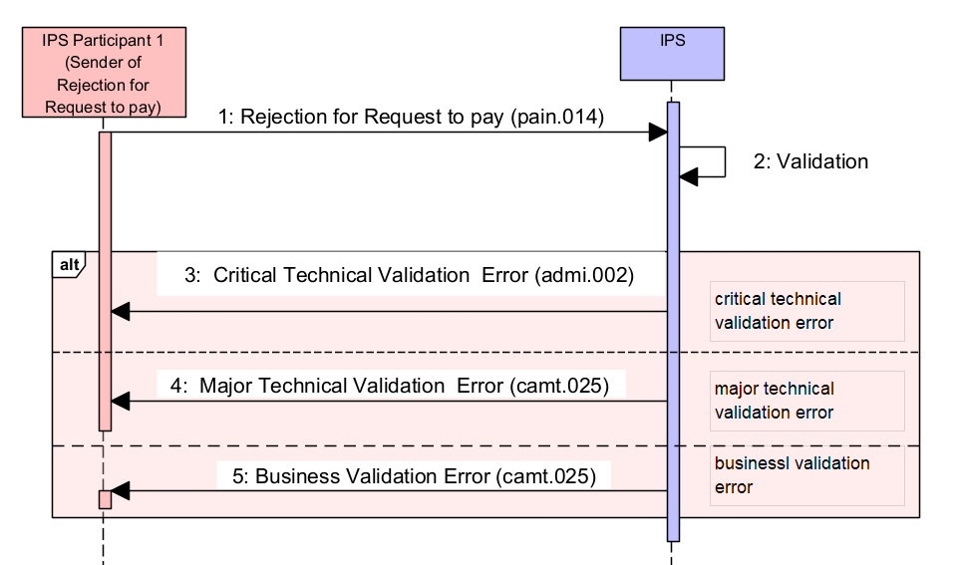
Figure 33. Rejection of Rejection for Request to pay
Table 54. Diagram description. Rejection of Rejection for Request to pay
## | Description | Message type | Sample item
1 | IPS Participant 1 sends a message to IPS. This message informs that Participant rejects Request to Pay received by this Participant earlier | pain.013
2 | IPS performs a validation of incoming message
3 | In case of critical technical error IPS notifies IPS Participant with administrative error message | admi.002 | 5.5.1
4 | In case of major technical error IPS notifies IPS Participant with validation error message | camt.025/ERRC | 5.5.2
5 | In case of business validation error IPS notifies IPS Participant with validation error message | camt.025/ERRC | 5.5.2

Administrative error message: admi.002
Administrative Error message example is provided in Section 6.1.

Validation error and Business validation error message: camt.025/ERRC
Validation error message and Business validation error example is provided in Section 6.2.
For these messages Business validation error message is the same as Validation error message.

Rejection of Payment initiation request
This section describes error flow in case of validation errors during processing of Payment Initiation request.

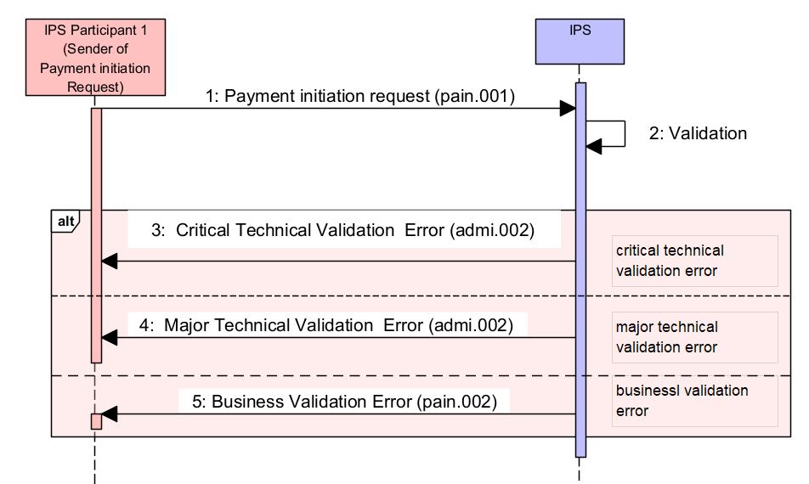
Figure 34. Rejection of Payment initiation request
Table 55. Diagram description. Rejection of Payment initiation request
## | Description | Message type | Sample item
1 | IPS Participant sends a Payment Initiation request message to IPS. | pain.001
2 | IPS performs a validation of incoming message
3 | In case of critical technical error IPS notifies IPS Participant with administrative error message | admi.002 | 5.6.1
4 | In case of major technical error or business validation error IPS notifies IPS Participant with validation error message | admi.002 | 5.6.1
5 | In case of business validation error IPS notifies IPS Participant with validation error message | pain.002 | 5.6.2

Administrative error message and Validation error message : admi.002
Administrative Error message and Validation error message example is provided in Section 6.1.
For these messages Validation error message is the same as Administrative error message.

Business validation error message: pain.002
Validation error message.
<Document xmlns="urn:iso:std:iso:20022:tech:xsd:pain.002.001.12">
<CstmrPmtStsRpt>
<GrpHdr>
<!-- Unique message identifier generated by IPS -->
<MsgId>BCPAPYPXAIPS190929100010000000123</MsgId>
<!-- Message creation date time -->
<CreDtTm>2019-09-29T18:18:00.543-04:00</CreDtTm>
<!-- Party whos sending pain.001 -->
<InitgPty>
<Id>
<OrgId>
<AnyBIC>FFFFPYPX</AnyBIC>
</OrgId>
</Id>
</InitgPty>
</GrpHdr>
<!-- References to original pain.001 request -->
<OrgnlGrpInfAndSts>
<!-- Original Message Id from pain.001 -->
<OrgnlMsgId>FFFFPYPXAXXX190929100120000001235</OrgnlMsgId>
<!-- pain.001 full message type -->
<OrgnlMsgNmId>pain.001.001.11</OrgnlMsgNmId>
<!-- pain.001 creation date/time -->
<OrgnlCreDtTm>2019-09-29T09:30:47.432-04:00</OrgnlCreDtTm>
<!-- Status of pain.001 request. ACSP - Accepted Settlement is Pending, RJCT - Rejected -->
<GrpSts>RJCT</GrpSts>
<StsRsnInf>
<!-- Reject reason code as per agreed between participants and registered in Central systems dictionary -->
<Rsn>
<Prtry>EA15</Prtry>
</Rsn>
<!-- Reject reason additional information -->
<AddtlInf>Account code not found</AddtlInf>
</StsRsnInf>
</OrgnlGrpInfAndSts>
<OrgnlPmtInfAndSts>
<!-- From the same element of the original message to which the pain.002 is in response. -->
<OrgnlPmtInfId>FFFFPYPXAXXX190929100120000001235</OrgnlPmtInfId>
<TxInfAndSts>
<!-- Original instruction identification from related pacs.008 payment -->
<OrgnlInstrId>PAYMFROMMERCHANT</OrgnlInstrId>
<!-- Original end-to-end identification from related pacs.008 payment -->
<OrgnlEndToEndId>PAYM0001</OrgnlEndToEndId>
<!-- Status of payment related to pain.001 request. ACSP - Accepted Settlement is Pending, RJCT - Rejected -->
<TxSts>RJCT</TxSts>
<StsRsnInf>
<!-- Reject reason code as per agreed between participants and registered in Central systems dictionary -->
<Rsn>
<Prtry>EA15</Prtry>
</Rsn>
<!-- Reject reason additional information -->
<AddtlInf>Account code not found</AddtlInf>
</StsRsnInf>
<OrgnlTxRef>
<!-- Effective payment amount and currency related to pain.001 -->
<IntrBkSttlmAmt Ccy="PYG">850.5</IntrBkSttlmAmt>
<!-- Requested payment execution date as specified in pain.001 -->
<ReqdExctnDt>
<Dt>2019-09-29</Dt>
</ReqdExctnDt>
<!-- Requested payment instrument type as specified in pain.001 -->
<PmtTpInf>
<LclInstrm>
<Prtry>CSCT</Prtry>
</LclInstrm>
</PmtTpInf>
<!-- Payment method: TRF - Credit transfer -->
<PmtMtd>TRF</PmtMtd>
</OrgnlTxRef>
</TxInfAndSts>
</OrgnlPmtInfAndSts>
</CstmrPmtStsRpt>
</Document>

Rejection of Rejection for Payment initiation request
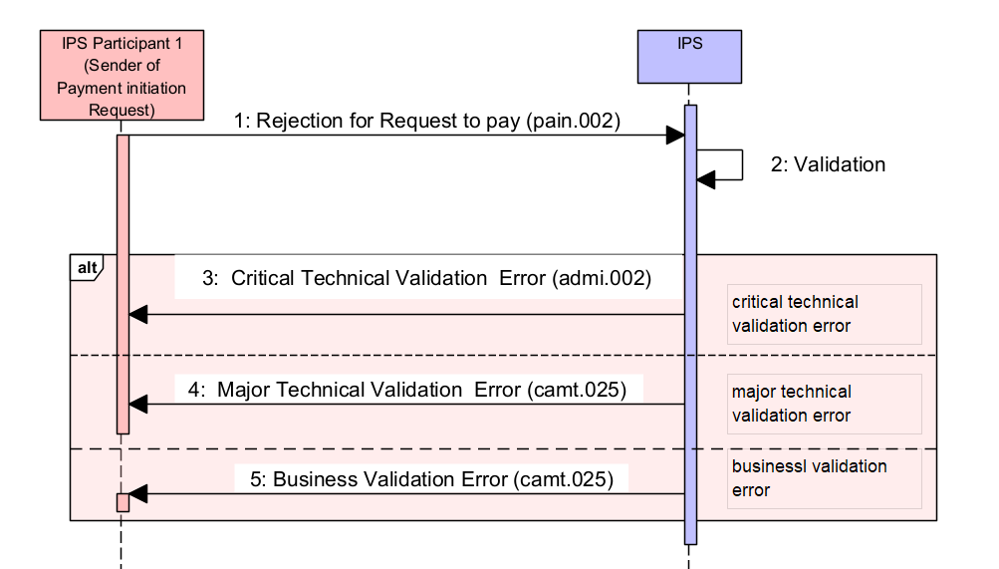
Figure 35. Rejection of Rejection for Payment initiation request
Table 56. Diagram description. Rejection of Rejection for Payment initiation request
## | Description | Message type | Sample item
1 | IPS Participant 1 sends a message to IPS. This message informs that Participant rejects Payment Initition Request received by this Participant earlier | pain.002
2 | IPS performs a validation of incoming message
3 | In case of critical technical error IPS notifies IPS Participant with administrative error message | admi.002 | 5.7.1
4 | In case of major technical error IPS notifies IPS Participant with validation error message | camt.025/ERRC | 5.7.2
5 | In case of business validation error IPS notifies IPS Participant with validation error message | camt.025/ERRC | 5.7.2

Administrative error message: admi.002
Administrative Error message example is provided in Section 6.1.

Validation error and Business validation error message: camt.025/ERRC
Validation error and Business validation error message message example is provided in Section 6.2.
For these messages Business validation error message is the same as validation error message.

Rejection of Set limit request
This section describes error flow in case of validation errors during processing of any of the following requests:
- Set limit
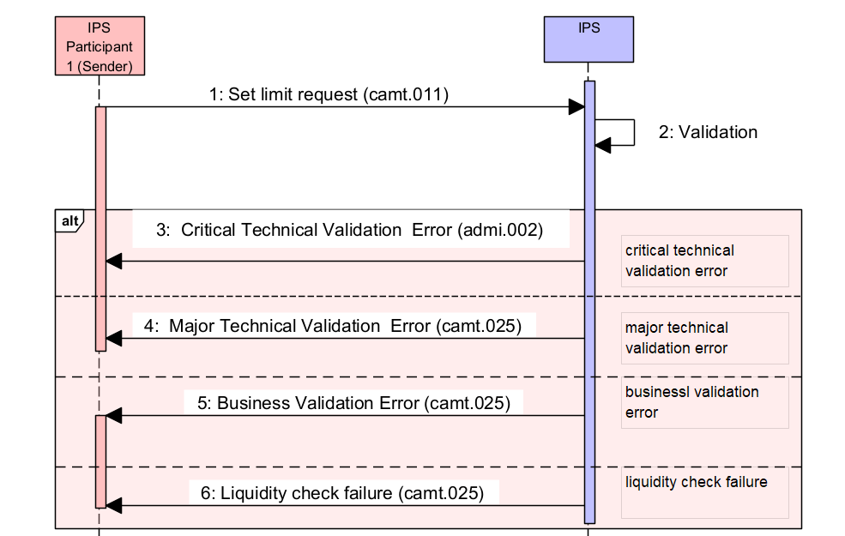
Figure 36. Rejection of Set limit request
Table 57. Diagram description. Rejection of Set limit request
## | Description | Message type | Sample item
1 | IPS Participant (Creditor agent) sends a request message to IPS | camt.011
2 | Validation
3 | In case of critical technical error IPS notifies IPS Participant with administrative error message | admi.002 | 5.8.1
4 | In case of major technical error or business validation error IPS notifies IPS Participant with validation error message | camt.025/ERRC | 5.8.2
5 | In case of business validation error IPS notifies IPS Participant with validation error message | camt.025/ERRC | 5.8.2
6 | Liquidity check faire happens in case of new limit value is less then Account Debit position (balance) | camt.025/ERRC | 5.8.3

Administrative error message: admi.002
Administrative Error message example is provided in Section 6.1.

Validation error message and Business validation error message: camt.025/ERRC
Validation error message example is provided in Section 6.2.
For these messages Business validation error message is the same as Validation error message.

Liqudity check failure message: camt.025/ERRC
<Document xmlns="urn:iso:std:iso:20022:tech:xsd:camt.025.001.05">
<Rct>
<MsgHdr>
<!-- Message reference -->
<MsgId>BCPAPYPXAIPS180217000010000001230</MsgId>
<!-- Message creation date time -->
<CreDtTm>2019-09-29T14:08:49.232-04:00</CreDtTm>
</MsgHdr>
<RctDtls>
<OrgnlMsgId>
<!-- Original message reference -->
<MsgId>AAAAPYPXAXXX180217100120000001235</MsgId>
<!-- Original MX message type / MT analogue -->
<MsgNmId>camt.011.001.07</MsgNmId>
<!-- Original sender BIC -->
<OrgtrNm>AAAAPYPX</OrgtrNm>
</OrgnlMsgId>
<ReqHdlg>
<StsCd>ERRC</StsCd>
<!-- Error code and details -->
<Desc>EP148
New debit cap value is less than used</Desc>
</ReqHdlg>
</RctDtls>
</Rct>
</Document>

Rejection of Get limit request, Account report request, Business Day information request, Payment status request, Payment copy request
This section describes error flow in case of validation errors during processing of any of the following requests:
- Get Limit
- Account report
- Business Day information report
- Payment status request
- Payment Copy request.

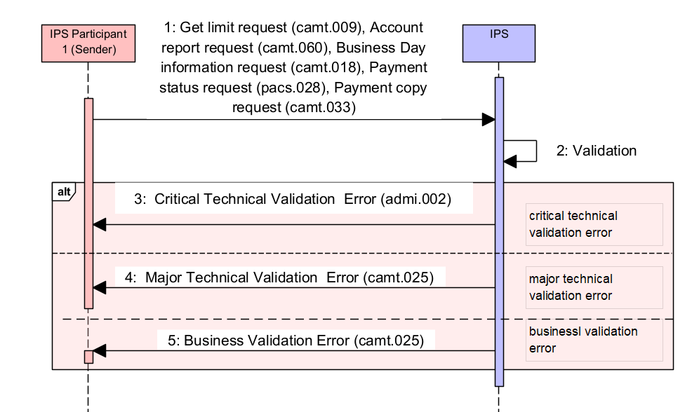
Figure 37. Rejection of Get limit request, Account report request, Business Day information request, Payment status request, Payment copy request
Table 58. Diagram description. Rejection of Get limit request, Account report request, Business Day information request, Payment status request, Payment copy request
## | Description | Message type | Sample item
1 | IPS Participant (Creditor agent) sends a request message to IPS | camt.009  camt.060  camt.018  pacs.028  camt.033
2 | Validation
3 | In case of critical technical error IPS notifies IPS Participant with administrative error message | admi.002 | 5.9.1
4 | In case of major technical error or business validation error IPS notifies IPS Participant with validation error message | camt.025/ERRC | 5.9.2
5 | In case of business validation error IPS notifies IPS Participant with validation error message | camt.025/ERRC | 5.9.2

Administrative error message: admi.002
Administrative Error message example is provided in Section 6.1.

Validation error message and Business validation error message: camt.025/ERRC
Validation error message example is provided in Section 6.2.
For these messages Business validation error message is the same as Validation error message.

Technical and validation error notifications

Critical technical error notification admi.002
In case when a critical technical error occurs at processing of incoming message on IPS side as a response to sender is generated admi.002 message with error code and description.

<Document xmlns="urn:iso:std:iso:20022:tech:xsd:admi.002.001.01">
<admi.002.001.01>
<RltdRef>
<Ref>STAT103/005</Ref>
</RltdRef>
<Rsn>
<RjctgPtyRsn>EA1</RjctgPtyRsn>
<RjctnDtTm>2019-09-29T13:28:40.928-04:00</RjctnDtTm>
<RsnDesc>Text block has invalid format</RsnDesc>
<AddtlData>Invalid MX input: [51,19] cvc-complex-type.2.4.b: The content of element 'OrgnlTxRef' is not complete. One of '{"urn:iso:std:iso:20022:tech:xsd:pacs.028.001.05":IntrBkSttlmDt}' is expected.</AddtlData>
</Rsn>
</admi.002.001.01>
</Document>

Error notification camt.025
Camt.025 message is generated in case of validation or business validation error occurs during request processing.

<Document xmlns="urn:iso:std:iso:20022:tech:xsd:camt.025.001.05">
<Rct>
<MsgHdr>
<!-- Message reference -->
<MsgId>BCPAPYPXAIPS180217000020000006971</MsgId>
<!-- Message creation date time -->
<CreDtTm>2019-09-29T10:40:44.119-04:00</CreDtTm>
</MsgHdr>
<RctDtls>
<OrgnlMsgId>
<!-- Original message reference -->
<MsgId>BBBBPYPXAXXX190929000010000001230</MsgId>
<!-- Original MX message type -->
<MsgNmId>pacs.002.001.12</MsgNmId>
<!-- Original sender BIC -->
<OrgtrNm>BBBBPYPX</OrgtrNm>
</OrgnlMsgId>
<ReqHdlg>
<StsCd>ERRC</StsCd>
<!-- Error code and details -->
<Desc>EA113
This document has been already authorized or rejected</Desc>
</ReqHdlg>
</RctDtls>
</Rct>
</Document>

